**MUSICAL INSTRUMENT CLASSIFICATION USING DEEP LEARNING TECHNIQUES**

**A PROJECT REPORT**

***Submitted by***

**JUMANA BEGUM J (2019103022)**

**SAMREEN AYESHA S (2019103055)**

**JESIMA A (2019103529)**

***for the course***

**CS 6301 – MACHINE LEARNING**



**DEPARTMENT OF COMPUTER SCIENCE AND ENGINEERING, COLLEGE OF ENGINEERING, GUINDY**

**ANNA UNIVERSITY**

**CHENNAI 600 025**

**JUNE 2022**

**ABSTRACT:**

Musical Information Retrieval is the interdisciplinary science of retrieving information from music. It is a new field of research; its objective is extracting data and metadata from musical recordings. Effective audio processing can improve speed, reduce errors, and sometimes increase the accuracy of detecting the musical instrument. One of the main tools used for classification tasks in recent years is deep learning. The three deep learning techniques proposed here are Convolutional Neural Network (CNN), Recurrent Neural Network – LSTM (RNN-LSTM) and Deep Belief Network (DBN).

**DATASET:** Musical Instrument Classification based on Audio Samples.

* The dataset has 1,020 audio samples of 10 seconds each which are classified into 17 musical instruments.
* The dataset is balanced (60 samples for each instrument).

Reference link: <https://drive.google.com/drive/folders/1X6BuQLI-mAKJmjZNKBxvllfEGseh6a8x?usp=sharing>

1. **CNN:**

**FEATURE EXTRACTION METHOD:**

**CODE:**

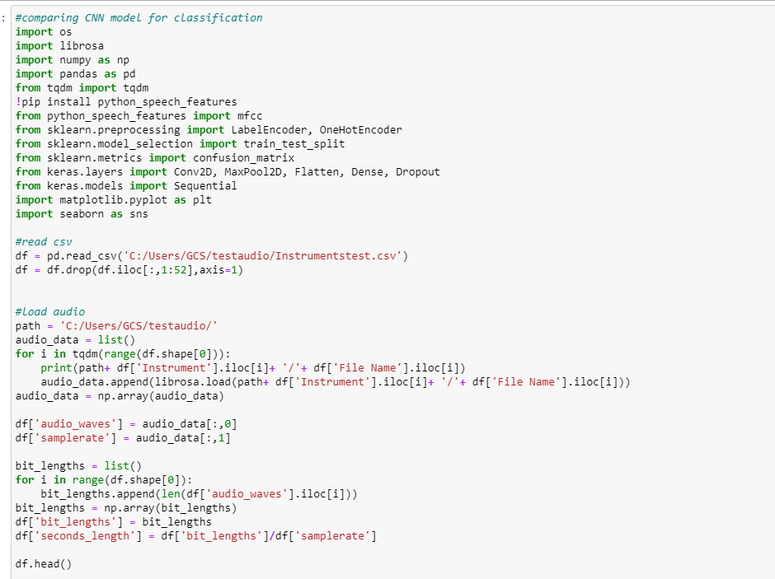

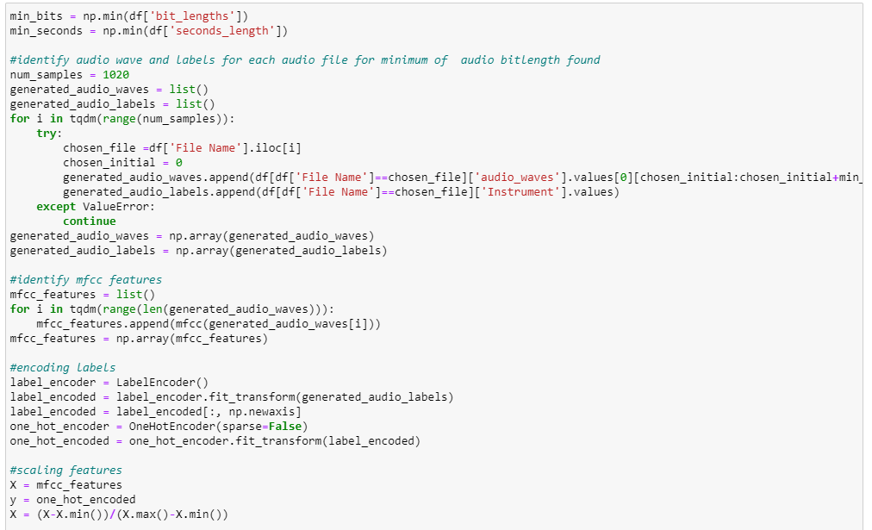

**OUTPUT:**

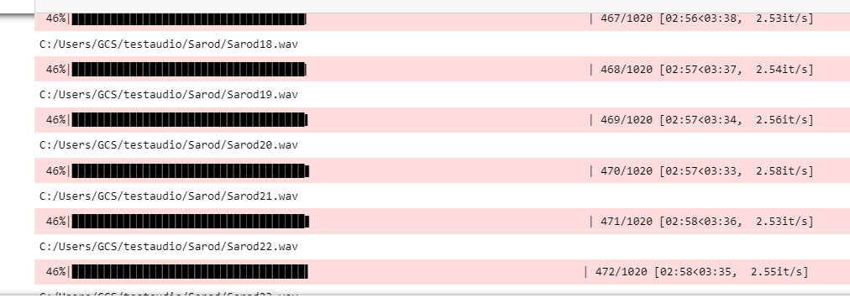



**METHODOLOGY**

The input audio signal is loaded using the librosa package.The input audio signal’s audio waves are clipped to minimum of the audio length found in the dataset.The audio labels are obtained from the name of the audio file. MFCC features are extracted from the audio waves and it is scaled.The audio labels are one hot encoded.The MFCC features and one hot encoded audio labels are X and Y respectively and they are split into train and test sets.

CNN model is built with different variations like 2,4,6 layers with different dropouts added after each output dense layer with 128 and 256 nodes in the output dense layer.

X train and X test are used to train the model.Y train and Y test are used to validate the CNN model.

The training of the CNN models happens for 20 epochs with accuracy , loss , validation accuracy and validation loss as metric,

**BLOCK DIAGRAM**

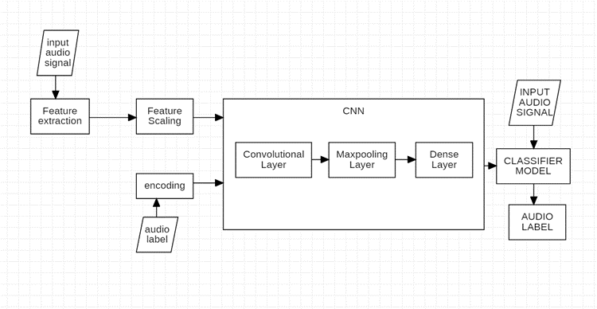

**IMPLEMENTATION**

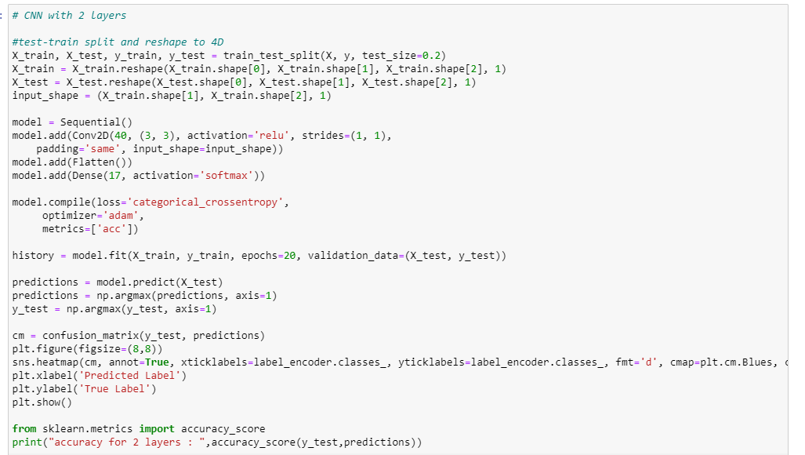

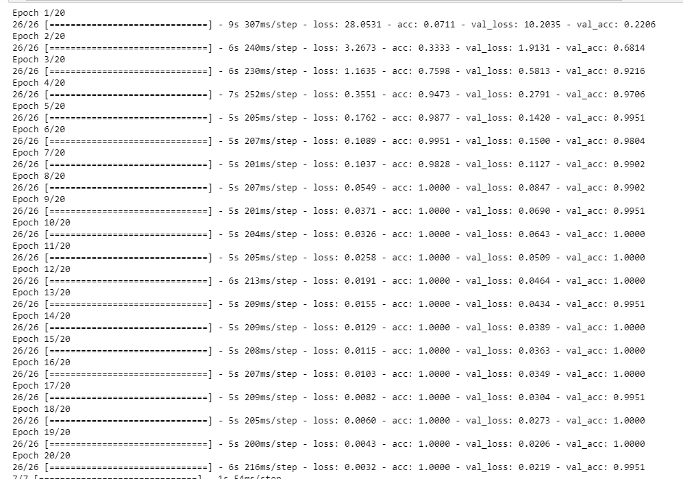

**RESULTS**

| **Sno** | **No of Layers** | **No of Nodes in output dense layer** | **Dropout** | **Accuracy** |
| --- | --- | --- | --- | --- |
| **1** | **2** | **17** | **-** | **0.9951** |
| **2** | **2** | **17** | **0.05** | **0.196** |
| **3** | **2** | **17** | **0.1** | **0.9951** |
| **4** | **2** | **17** | **0.2** | **0.9803** |
| **5** | **4** | **128** | **-** | **0.299** |
| **6** | **4** | **128** | **0.05** | **0.2205** |
| **7** | **4** | **128** | **0.1** | **0.2401** |
| **8** | **4** | **128** | **0.2** | **0.769** |
| **9** | **4** | **256** | **0.05** | **0.985** |
| **10** | **4** | **256** | **0.1** | **0.975** |
| **11** | **4** | **256** | **0.2** | **0.9705** |
| **12** | **6** | **128** | **-** | **0.9852** |
| **13** | **6** | **128** | **0.05** | **0.9950** |
| **14** | **6** | **128** | **0.1** | **0.9705** |
| **15** | **6** | **128** | **0.2** | **0.9705** |
| **16** | **6** | **256** | **0.05** | **0.9950** |
| **17** | **6** | **256** | **0.1** | **0.9509** |
| **18** | **6** | **256** | **0.2** | **0.9509** |

**EPOCHS:**

**1)**

**Epoch 1/20**

**26/26 [==============================] - 23s 875ms/step - loss: 2.6034 - acc: 0.1777 - val_loss: 1.9584 - val_acc: 0.3284**

**Epoch 2/20**

**26/26 [==============================] - 20s 757ms/step - loss: 1.4234 - acc: 0.5625 - val_loss: 1.2063 - val_acc: 0.5784**

**Epoch 3/20**

**26/26 [==============================] - 20s 760ms/step - loss: 0.6567 - acc: 0.8113 - val_loss: 0.5226 - val_acc: 0.8676**

**Epoch 4/20**

**26/26 [==============================] - 19s 732ms/step - loss: 0.3254 - acc: 0.9056 - val_loss: 0.4464 - val_acc: 0.8676**

**Epoch 5/20**

**26/26 [==============================] - 19s 734ms/step - loss: 0.1990 - acc: 0.9620 - val_loss: 0.2265 - val_acc: 0.9461**

**Epoch 6/20**

**26/26 [==============================] - 19s 741ms/step - loss: 0.1003 - acc: 0.9804 - val_loss: 0.2880 - val_acc: 0.8824**

**Epoch 7/20**

**26/26 [==============================] - 19s 730ms/step - loss: 0.0950 - acc: 0.9853 - val_loss: 0.2015 - val_acc: 0.9412**

**Epoch 8/20**

**26/26 [==============================] - 19s 727ms/step - loss: 0.0401 - acc: 0.9988 - val_loss: 0.1753 - val_acc: 0.9265**

**Epoch 9/20**

**26/26 [==============================] - 19s 730ms/step - loss: 0.0186 - acc: 1.0000 - val_loss: 0.0979 - val_acc: 0.9657**

**Epoch 10/20**

**26/26 [==============================] - 19s 727ms/step - loss: 0.0120 - acc: 1.0000 - val_loss: 0.0777 - val_acc: 0.9755**

**Epoch 11/20**

**26/26 [==============================] - 19s 746ms/step - loss: 0.0083 - acc: 1.0000 - val_loss: 0.0809 - val_acc: 0.9804**

**Epoch 12/20**

**26/26 [==============================] - 19s 744ms/step - loss: 0.0065 - acc: 1.0000 - val_loss: 0.0693 - val_acc: 0.9804**

**Epoch 13/20**

**26/26 [==============================] - 19s 738ms/step - loss: 0.0055 - acc: 1.0000 - val_loss: 0.0715 - val_acc: 0.9755**

**Epoch 14/20**

**26/26 [==============================] - 19s 736ms/step - loss: 0.0041 - acc: 1.0000 - val_loss: 0.0692 - val_acc: 0.9804**

**Epoch 15/20**

**26/26 [==============================] - 19s 743ms/step - loss: 0.0037 - acc: 1.0000 - val_loss: 0.0687 - val_acc: 0.9755**

**Epoch 16/20**

**26/26 [==============================] - 19s 731ms/step - loss: 0.0030 - acc: 1.0000 - val_loss: 0.0609 - val_acc: 0.9804**

**Epoch 17/20**

**26/26 [==============================] - 19s 736ms/step - loss: 0.0026 - acc: 1.0000 - val_loss: 0.0668 - val_acc: 0.9804**

**Epoch 18/20**

**26/26 [==============================] - 19s 744ms/step - loss: 0.0025 - acc: 1.0000 - val_loss: 0.0654 - val_acc: 0.9755**

**Epoch 19/20**

**26/26 [==============================] - 19s 718ms/step - loss: 0.0022 - acc: 1.0000 - val_loss: 0.0608 - val_acc: 0.9804**

**Epoch 20/20**

**26/26 [==============================] - 19s 712ms/step - loss: 0.0020 - acc: 1.0000 - val_loss: 0.0600 - val_acc: 0.9755**

**7/7 [==============================] - 1s 84ms/step**

**2)**

**Epoch 1/20**

**26/26 [==============================] - 19s 708ms/step - loss: 2.8214 - acc: 0.0809 - val_loss: 2.7448 - val_acc: 0.1029**

**Epoch 2/20**

**26/26 [==============================] - 18s 691ms/step - loss: 2.5146 - acc: 0.2034 - val_loss: 2.1445 - val_acc: 0.4608**

**Epoch 3/20**

**26/26 [==============================] - 18s 694ms/step - loss: 1.6607 - acc: 0.5404 - val_loss: 1.3396 - val_acc: 0.7010**

**Epoch 4/20**

**26/26 [==============================] - 18s 691ms/step - loss: 0.9209 - acc: 0.7806 - val_loss: 1.0457 - val_acc: 0.5931**

**Epoch 5/20**

**26/26 [==============================] - 19s 715ms/step - loss: 0.6260 - acc: 0.8395 - val_loss: 0.6779 - val_acc: 0.7794**

**Epoch 6/20**

**26/26 [==============================] - 18s 700ms/step - loss: 0.3775 - acc: 0.9105 - val_loss: 0.3905 - val_acc: 0.9216**

**Epoch 7/20**

**26/26 [==============================] - 18s 710ms/step - loss: 0.2521 - acc: 0.9350 - val_loss: 0.3625 - val_acc: 0.8922**

**Epoch 8/20**

**26/26 [==============================] - 18s 703ms/step - loss: 0.2122 - acc: 0.9522 - val_loss: 0.2730 - val_acc: 0.9265**

**Epoch 9/20**

**26/26 [==============================] - 18s 708ms/step - loss: 0.1615 - acc: 0.9681 - val_loss: 0.2458 - val_acc: 0.9510**

**Epoch 10/20**

**26/26 [==============================] - 18s 701ms/step - loss: 0.0945 - acc: 0.9914 - val_loss: 0.2179 - val_acc: 0.9461**

**Epoch 11/20**

**26/26 [==============================] - 18s 698ms/step - loss: 0.0595 - acc: 0.9963 - val_loss: 0.1603 - val_acc: 0.9657**

**Epoch 12/20**

**26/26 [==============================] - 18s 706ms/step - loss: 0.0592 - acc: 0.9926 - val_loss: 0.1514 - val_acc: 0.9706**

**Epoch 13/20**

**26/26 [==============================] - 18s 697ms/step - loss: 0.0367 - acc: 1.0000 - val_loss: 0.1273 - val_acc: 0.9853**

**Epoch 14/20**

**26/26 [==============================] - 18s 701ms/step - loss: 0.0350 - acc: 0.9963 - val_loss: 0.1362 - val_acc: 0.9559**

**Epoch 15/20**

**26/26 [==============================] - 18s 699ms/step - loss: 0.0230 - acc: 1.0000 - val_loss: 0.0958 - val_acc: 0.9853**

**Epoch 16/20**

**26/26 [==============================] - 18s 697ms/step - loss: 0.0176 - acc: 1.0000 - val_loss: 0.0849 - val_acc: 0.9853**

**Epoch 17/20**

**26/26 [==============================] - 18s 707ms/step - loss: 0.0126 - acc: 1.0000 - val_loss: 0.0839 - val_acc: 0.9804**

**Epoch 18/20**

**26/26 [==============================] - 19s 726ms/step - loss: 0.0111 - acc: 1.0000 - val_loss: 0.0707 - val_acc: 0.9853**

**Epoch 19/20**

**26/26 [==============================] - 20s 781ms/step - loss: 0.0089 - acc: 1.0000 - val_loss: 0.0656 - val_acc: 0.9902**

**Epoch 20/20**

**26/26 [==============================] - 20s 753ms/step - loss: 0.0076 - acc: 1.0000 - val_loss: 0.0658 - val_acc: 0.9902**

**7/7 [==============================] - 1s 87ms/step**

**3)**

**Epoch 1/20**

**26/26 [==============================] - 20s 750ms/step - loss: 2.7609 - acc: 0.1446 - val_loss: 2.3565 - val_acc: 0.3088**

**Epoch 2/20**

**26/26 [==============================] - 19s 719ms/step - loss: 1.7009 - acc: 0.5196 - val_loss: 1.2368 - val_acc: 0.6863**

**Epoch 3/20**

**26/26 [==============================] - 19s 730ms/step - loss: 0.7227 - acc: 0.8284 - val_loss: 0.6919 - val_acc: 0.8824**

**Epoch 4/20**

**26/26 [==============================] - 19s 725ms/step - loss: 0.4580 - acc: 0.8836 - val_loss: 0.5551 - val_acc: 0.8824**

**Epoch 5/20**

**26/26 [==============================] - 19s 718ms/step - loss: 0.2566 - acc: 0.9400 - val_loss: 0.2723 - val_acc: 0.9412**

**Epoch 6/20**

**26/26 [==============================] - 19s 718ms/step - loss: 0.1292 - acc: 0.9816 - val_loss: 0.2276 - val_acc: 0.9510**

**Epoch 7/20**

**26/26 [==============================] - 19s 723ms/step - loss: 0.0840 - acc: 0.9865 - val_loss: 0.1700 - val_acc: 0.9510**

**Epoch 8/20**

**26/26 [==============================] - 19s 720ms/step - loss: 0.0515 - acc: 0.9975 - val_loss: 0.1426 - val_acc: 0.9706**

**Epoch 9/20**

**26/26 [==============================] - 19s 721ms/step - loss: 0.0379 - acc: 0.9988 - val_loss: 0.1420 - val_acc: 0.9706**

**Epoch 10/20**

**26/26 [==============================] - 19s 715ms/step - loss: 0.0286 - acc: 0.9988 - val_loss: 0.1554 - val_acc: 0.9608**

**Epoch 11/20**

**26/26 [==============================] - 19s 715ms/step - loss: 0.0257 - acc: 0.9963 - val_loss: 0.0799 - val_acc: 0.9853**

**Epoch 12/20**

**26/26 [==============================] - 19s 720ms/step - loss: 0.0138 - acc: 1.0000 - val_loss: 0.0644 - val_acc: 0.9902**

**Epoch 13/20**

**26/26 [==============================] - 19s 724ms/step - loss: 0.0146 - acc: 1.0000 - val_loss: 0.0641 - val_acc: 0.9902**

**Epoch 14/20**

**26/26 [==============================] - 19s 715ms/step - loss: 0.0093 - acc: 1.0000 - val_loss: 0.0632 - val_acc: 0.9853**

**Epoch 15/20**

**26/26 [==============================] - 19s 715ms/step - loss: 0.0070 - acc: 1.0000 - val_loss: 0.0533 - val_acc: 0.9951**

**Epoch 16/20**

**26/26 [==============================] - 19s 718ms/step - loss: 0.0057 - acc: 1.0000 - val_loss: 0.0548 - val_acc: 0.9804**

**Epoch 17/20**

**26/26 [==============================] - 19s 716ms/step - loss: 0.0045 - acc: 1.0000 - val_loss: 0.0708 - val_acc: 0.9804**

**Epoch 18/20**

**26/26 [==============================] - 19s 713ms/step - loss: 0.0036 - acc: 1.0000 - val_loss: 0.0491 - val_acc: 0.9902**

**Epoch 19/20**

**26/26 [==============================] - 19s 728ms/step - loss: 0.0032 - acc: 1.0000 - val_loss: 0.0559 - val_acc: 0.9902**

**Epoch 20/20**

**26/26 [==============================] - 20s 760ms/step - loss: 0.0029 - acc: 1.0000 - val_loss: 0.0568 - val_acc: 0.9853**

**7/7 [==============================] - 1s 80ms/step**

**4)**

**Epoch 1/20**

**26/26 [==============================] - 20s 752ms/step - loss: 2.7776 - acc: 0.1434 - val_loss: 2.5612 - val_acc: 0.2255**

**Epoch 2/20**

**26/26 [==============================] - 19s 731ms/step - loss: 1.9435 - acc: 0.4620 - val_loss: 1.4274 - val_acc: 0.7059**

**Epoch 3/20**

**26/26 [==============================] - 19s 726ms/step - loss: 0.8532 - acc: 0.7806 - val_loss: 0.6846 - val_acc: 0.8088**

**Epoch 4/20**

**26/26 [==============================] - 19s 732ms/step - loss: 0.4381 - acc: 0.8971 - val_loss: 0.3820 - val_acc: 0.9363**

**Epoch 5/20**

**26/26 [==============================] - 20s 752ms/step - loss: 0.1936 - acc: 0.9730 - val_loss: 0.2048 - val_acc: 0.9853**

**Epoch 6/20**

**26/26 [==============================] - 19s 728ms/step - loss: 0.1036 - acc: 0.9828 - val_loss: 0.1919 - val_acc: 0.9608**

**Epoch 7/20**

**26/26 [==============================] - 18s 703ms/step - loss: 0.0599 - acc: 0.9963 - val_loss: 0.1089 - val_acc: 1.0000**

**Epoch 8/20**

**26/26 [==============================] - 18s 703ms/step - loss: 0.0311 - acc: 0.9988 - val_loss: 0.0992 - val_acc: 0.9706**

**Epoch 9/20**

**26/26 [==============================] - 18s 705ms/step - loss: 0.0214 - acc: 0.9988 - val_loss: 0.0709 - val_acc: 1.0000**

**Epoch 10/20**

**26/26 [==============================] - 18s 702ms/step - loss: 0.0137 - acc: 1.0000 - val_loss: 0.0741 - val_acc: 0.9902**

**Epoch 11/20**

**26/26 [==============================] - 18s 705ms/step - loss: 0.0166 - acc: 1.0000 - val_loss: 0.0678 - val_acc: 0.9902**

**Epoch 12/20**

**26/26 [==============================] - 20s 751ms/step - loss: 0.0098 - acc: 1.0000 - val_loss: 0.0543 - val_acc: 0.9804**

**Epoch 13/20**

**26/26 [==============================] - 20s 764ms/step - loss: 0.0055 - acc: 1.0000 - val_loss: 0.0473 - val_acc: 0.9951**

**Epoch 14/20**

**26/26 [==============================] - 20s 769ms/step - loss: 0.0043 - acc: 1.0000 - val_loss: 0.0484 - val_acc: 0.9853**

**Epoch 15/20**

**26/26 [==============================] - 21s 792ms/step - loss: 0.0037 - acc: 1.0000 - val_loss: 0.0413 - val_acc: 0.9951**

**Epoch 16/20**

**26/26 [==============================] - 20s 768ms/step - loss: 0.0032 - acc: 1.0000 - val_loss: 0.0385 - val_acc: 0.9951**

**Epoch 17/20**

**26/26 [==============================] - 20s 766ms/step - loss: 0.0029 - acc: 1.0000 - val_loss: 0.0409 - val_acc: 0.9902**

**Epoch 18/20**

**26/26 [==============================] - 20s 776ms/step - loss: 0.0023 - acc: 1.0000 - val_loss: 0.0404 - val_acc: 0.9902**

**Epoch 19/20**

**26/26 [==============================] - 20s 775ms/step - loss: 0.0020 - acc: 1.0000 - val_loss: 0.0406 - val_acc: 0.9853**

**Epoch 20/20**

**26/26 [==============================] - 20s 765ms/step - loss: 0.0018 - acc: 1.0000 - val_loss: 0.0382 - val_acc: 0.9853**

**7/7 [==============================] - 1s 87ms/step**

**5)**

**Epoch 1/20**

**26/26 [==============================] - 21s 796ms/step - loss: 3.2300 - acc: 0.0637 - val_loss: 2.8229 - val_acc: 0.1176**

**Epoch 2/20**

**26/26 [==============================] - 20s 771ms/step - loss: 2.6881 - acc: 0.1434 - val_loss: 2.5127 - val_acc: 0.2647**

**Epoch 3/20**

**26/26 [==============================] - 20s 766ms/step - loss: 2.1087 - acc: 0.3309 - val_loss: 1.7350 - val_acc: 0.4951**

**Epoch 4/20**

**26/26 [==============================] - 21s 794ms/step - loss: 1.3801 - acc: 0.5809 - val_loss: 1.1825 - val_acc: 0.7402**

**Epoch 5/20**

**26/26 [==============================] - 20s 776ms/step - loss: 0.8746 - acc: 0.7610 - val_loss: 0.8826 - val_acc: 0.7304**

**Epoch 6/20**

**26/26 [==============================] - 20s 780ms/step - loss: 0.6816 - acc: 0.7978 - val_loss: 0.6829 - val_acc: 0.8431**

**Epoch 7/20**

**26/26 [==============================] - 20s 772ms/step - loss: 0.4446 - acc: 0.8958 - val_loss: 0.5078 - val_acc: 0.8971**

**Epoch 8/20**

**26/26 [==============================] - 20s 777ms/step - loss: 0.3906 - acc: 0.8885 - val_loss: 0.4977 - val_acc: 0.8676**

**Epoch 9/20**

**26/26 [==============================] - 20s 785ms/step - loss: 0.2652 - acc: 0.9216 - val_loss: 0.3912 - val_acc: 0.9069**

**Epoch 10/20**

**26/26 [==============================] - 20s 789ms/step - loss: 0.1772 - acc: 0.9620 - val_loss: 0.2712 - val_acc: 0.9657**

**Epoch 11/20**

**26/26 [==============================] - 20s 773ms/step - loss: 0.1142 - acc: 0.9877 - val_loss: 0.2480 - val_acc: 0.9461**

**Epoch 12/20**

**26/26 [==============================] - 20s 777ms/step - loss: 0.0886 - acc: 0.9877 - val_loss: 0.2971 - val_acc: 0.9167**

**Epoch 13/20**

**26/26 [==============================] - 20s 778ms/step - loss: 0.0689 - acc: 0.9939 - val_loss: 0.1689 - val_acc: 0.9510**

**Epoch 14/20**

**26/26 [==============================] - 20s 778ms/step - loss: 0.0426 - acc: 0.9975 - val_loss: 0.1272 - val_acc: 0.9755**

**Epoch 15/20**

**26/26 [==============================] - 20s 780ms/step - loss: 0.0286 - acc: 0.9975 - val_loss: 0.1349 - val_acc: 0.9657**

**Epoch 16/20**

**26/26 [==============================] - 20s 782ms/step - loss: 0.0254 - acc: 0.9988 - val_loss: 0.1362 - val_acc: 0.9657**

**Epoch 17/20**

**26/26 [==============================] - 20s 775ms/step - loss: 0.0277 - acc: 0.9963 - val_loss: 0.1010 - val_acc: 0.9706**

**Epoch 18/20**

**26/26 [==============================] - 20s 777ms/step - loss: 0.0143 - acc: 1.0000 - val_loss: 0.0944 - val_acc: 0.9755**

**Epoch 19/20**

**26/26 [==============================] - 20s 783ms/step - loss: 0.0141 - acc: 1.0000 - val_loss: 0.0853 - val_acc: 0.9853**

**Epoch 20/20**

**26/26 [==============================] - 20s 777ms/step - loss: 0.0107 - acc: 1.0000 - val_loss: 0.0812 - val_acc: 0.9804**

**7/7 [==============================] - 1s 90ms/step**

**6)**

**Epoch 1/20**

**26/26 [==============================] - 13s 473ms/step - loss: 2.8477 - acc: 0.0748 - val_loss: 2.7455 - val_acc: 0.1225**

**Epoch 2/20**

**26/26 [==============================] - 12s 466ms/step - loss: 2.4404 - acc: 0.2843 - val_loss: 1.9969 - val_acc: 0.4755**

**Epoch 3/20**

**26/26 [==============================] - 12s 456ms/step - loss: 1.4274 - acc: 0.5895 - val_loss: 1.0668 - val_acc: 0.6520**

**Epoch 4/20**

**26/26 [==============================] - 12s 457ms/step - loss: 0.7737 - acc: 0.7794 - val_loss: 0.5910 - val_acc: 0.7794**

**Epoch 5/20**

**26/26 [==============================] - 13s 489ms/step - loss: 0.4539 - acc: 0.8713 - val_loss: 0.4263 - val_acc: 0.8676**

**Epoch 6/20**

**26/26 [==============================] - 12s 476ms/step - loss: 0.2768 - acc: 0.9363 - val_loss: 0.2830 - val_acc: 0.9216**

**Epoch 7/20**

**26/26 [==============================] - 12s 464ms/step - loss: 0.1367 - acc: 0.9890 - val_loss: 0.1845 - val_acc: 0.9559**

**Epoch 8/20**

**26/26 [==============================] - 12s 460ms/step - loss: 0.0804 - acc: 0.9939 - val_loss: 0.1485 - val_acc: 0.9608**

**Epoch 9/20**

**26/26 [==============================] - 12s 459ms/step - loss: 0.0831 - acc: 0.9779 - val_loss: 0.1536 - val_acc: 0.9657**

**Epoch 10/20**

**26/26 [==============================] - 12s 460ms/step - loss: 0.0492 - acc: 0.9939 - val_loss: 0.1297 - val_acc: 0.9559**

**Epoch 11/20**

**26/26 [==============================] - 12s 473ms/step - loss: 0.0442 - acc: 0.9914 - val_loss: 0.1375 - val_acc: 0.9608**

**Epoch 12/20**

**26/26 [==============================] - 12s 475ms/step - loss: 0.0215 - acc: 1.0000 - val_loss: 0.1063 - val_acc: 0.9657**

**Epoch 13/20**

**26/26 [==============================] - 12s 464ms/step - loss: 0.0119 - acc: 1.0000 - val_loss: 0.1012 - val_acc: 0.9706**

**Epoch 14/20**

**26/26 [==============================] - 12s 462ms/step - loss: 0.0083 - acc: 1.0000 - val_loss: 0.0839 - val_acc: 0.9706**

**Epoch 15/20**

**26/26 [==============================] - 12s 458ms/step - loss: 0.0067 - acc: 1.0000 - val_loss: 0.0904 - val_acc: 0.9706**

**Epoch 16/20**

**26/26 [==============================] - 12s 476ms/step - loss: 0.0058 - acc: 1.0000 - val_loss: 0.0873 - val_acc: 0.9706**

**Epoch 17/20**

**26/26 [==============================] - 12s 463ms/step - loss: 0.0047 - acc: 1.0000 - val_loss: 0.0783 - val_acc: 0.9706**

**Epoch 18/20**

**26/26 [==============================] - 12s 458ms/step - loss: 0.0037 - acc: 1.0000 - val_loss: 0.0851 - val_acc: 0.9755**

**Epoch 19/20**

**26/26 [==============================] - 12s 460ms/step - loss: 0.0028 - acc: 1.0000 - val_loss: 0.0855 - val_acc: 0.9706**

**Epoch 20/20**

**26/26 [==============================] - 12s 458ms/step - loss: 0.0022 - acc: 1.0000 - val_loss: 0.0872 - val_acc: 0.9755**

**7/7 [==============================] - 1s 88ms/step**

**7)**

**Epoch 1/20**

**26/26 [==============================] - 23s 875ms/step - loss: 2.6034 - acc: 0.1777 - val_loss: 1.9584 - val_acc: 0.3284**

**Epoch 2/20**

**26/26 [==============================] - 20s 757ms/step - loss: 1.4234 - acc: 0.5625 - val_loss: 1.2063 - val_acc: 0.5784**

**Epoch 3/20**

**26/26 [==============================] - 20s 760ms/step - loss: 0.6567 - acc: 0.8113 - val_loss: 0.5226 - val_acc: 0.8676**

**Epoch 4/20**

**26/26 [==============================] - 19s 732ms/step - loss: 0.3254 - acc: 0.9056 - val_loss: 0.4464 - val_acc: 0.8676**

**Epoch 5/20**

**26/26 [==============================] - 19s 734ms/step - loss: 0.1990 - acc: 0.9620 - val_loss: 0.2265 - val_acc: 0.9461**

**Epoch 6/20**

**26/26 [==============================] - 19s 741ms/step - loss: 0.1003 - acc: 0.9804 - val_loss: 0.2880 - val_acc: 0.8824**

**Epoch 7/20**

**26/26 [==============================] - 19s 730ms/step - loss: 0.0950 - acc: 0.9853 - val_loss: 0.2015 - val_acc: 0.9412**

**Epoch 8/20**

**26/26 [==============================] - 19s 727ms/step - loss: 0.0401 - acc: 0.9988 - val_loss: 0.1753 - val_acc: 0.9265**

**Epoch 9/20**

**26/26 [==============================] - 19s 730ms/step - loss: 0.0186 - acc: 1.0000 - val_loss: 0.0979 - val_acc: 0.9657**

**Epoch 10/20**

**26/26 [==============================] - 19s 727ms/step - loss: 0.0120 - acc: 1.0000 - val_loss: 0.0777 - val_acc: 0.9755**

**Epoch 11/20**

**26/26 [==============================] - 19s 746ms/step - loss: 0.0083 - acc: 1.0000 - val_loss: 0.0809 - val_acc: 0.9804**

**Epoch 12/20**

**26/26 [==============================] - 19s 744ms/step - loss: 0.0065 - acc: 1.0000 - val_loss: 0.0693 - val_acc: 0.9804**

**Epoch 13/20**

**26/26 [==============================] - 19s 738ms/step - loss: 0.0055 - acc: 1.0000 - val_loss: 0.0715 - val_acc: 0.9755**

**Epoch 14/20**

**26/26 [==============================] - 19s 736ms/step - loss: 0.0041 - acc: 1.0000 - val_loss: 0.0692 - val_acc: 0.9804**

**Epoch 15/20**

**26/26 [==============================] - 19s 743ms/step - loss: 0.0037 - acc: 1.0000 - val_loss: 0.0687 - val_acc: 0.9755**

**Epoch 16/20**

**26/26 [==============================] - 19s 731ms/step - loss: 0.0030 - acc: 1.0000 - val_loss: 0.0609 - val_acc: 0.9804**

**Epoch 17/20**

**26/26 [==============================] - 19s 736ms/step - loss: 0.0026 - acc: 1.0000 - val_loss: 0.0668 - val_acc: 0.9804**

**Epoch 18/20**

**26/26 [==============================] - 19s 744ms/step - loss: 0.0025 - acc: 1.0000 - val_loss: 0.0654 - val_acc: 0.9755**

**Epoch 19/20**

**26/26 [==============================] - 19s 718ms/step - loss: 0.0022 - acc: 1.0000 - val_loss: 0.0608 - val_acc: 0.9804**

**Epoch 20/20**

**26/26 [==============================] - 19s 712ms/step - loss: 0.0020 - acc: 1.0000 - val_loss: 0.0600 - val_acc: 0.9755**

**7/7 [==============================] - 1s 84ms/step**

**8)**

**Epoch 1/20**

**26/26 [==============================] - 19s 708ms/step - loss: 2.8214 - acc: 0.0809 - val_loss: 2.7448 - val_acc: 0.1029**

**Epoch 2/20**

**26/26 [==============================] - 18s 691ms/step - loss: 2.5146 - acc: 0.2034 - val_loss: 2.1445 - val_acc: 0.4608**

**Epoch 3/20**

**26/26 [==============================] - 18s 694ms/step - loss: 1.6607 - acc: 0.5404 - val_loss: 1.3396 - val_acc: 0.7010**

**Epoch 4/20**

**26/26 [==============================] - 18s 691ms/step - loss: 0.9209 - acc: 0.7806 - val_loss: 1.0457 - val_acc: 0.5931**

**Epoch 5/20**

**26/26 [==============================] - 19s 715ms/step - loss: 0.6260 - acc: 0.8395 - val_loss: 0.6779 - val_acc: 0.7794**

**Epoch 6/20**

**26/26 [==============================] - 18s 700ms/step - loss: 0.3775 - acc: 0.9105 - val_loss: 0.3905 - val_acc: 0.9216**

**Epoch 7/20**

**26/26 [==============================] - 18s 710ms/step - loss: 0.2521 - acc: 0.9350 - val_loss: 0.3625 - val_acc: 0.8922**

**Epoch 8/20**

**26/26 [==============================] - 18s 703ms/step - loss: 0.2122 - acc: 0.9522 - val_loss: 0.2730 - val_acc: 0.9265**

**Epoch 9/20**

**26/26 [==============================] - 18s 708ms/step - loss: 0.1615 - acc: 0.9681 - val_loss: 0.2458 - val_acc: 0.9510**

**Epoch 10/20**

**26/26 [==============================] - 18s 701ms/step - loss: 0.0945 - acc: 0.9914 - val_loss: 0.2179 - val_acc: 0.9461**

**Epoch 11/20**

**26/26 [==============================] - 18s 698ms/step - loss: 0.0595 - acc: 0.9963 - val_loss: 0.1603 - val_acc: 0.9657**

**Epoch 12/20**

**26/26 [==============================] - 18s 706ms/step - loss: 0.0592 - acc: 0.9926 - val_loss: 0.1514 - val_acc: 0.9706**

**Epoch 13/20**

**26/26 [==============================] - 18s 697ms/step - loss: 0.0367 - acc: 1.0000 - val_loss: 0.1273 - val_acc: 0.9853**

**Epoch 14/20**

**26/26 [==============================] - 18s 701ms/step - loss: 0.0350 - acc: 0.9963 - val_loss: 0.1362 - val_acc: 0.9559**

**Epoch 15/20**

**26/26 [==============================] - 18s 699ms/step - loss: 0.0230 - acc: 1.0000 - val_loss: 0.0958 - val_acc: 0.9853**

**Epoch 16/20**

**26/26 [==============================] - 18s 697ms/step - loss: 0.0176 - acc: 1.0000 - val_loss: 0.0849 - val_acc: 0.9853**

**Epoch 17/20**

**26/26 [==============================] - 18s 707ms/step - loss: 0.0126 - acc: 1.0000 - val_loss: 0.0839 - val_acc: 0.9804**

**Epoch 18/20**

**26/26 [==============================] - 19s 726ms/step - loss: 0.0111 - acc: 1.0000 - val_loss: 0.0707 - val_acc: 0.9853**

**Epoch 19/20**

**26/26 [==============================] - 20s 781ms/step - loss: 0.0089 - acc: 1.0000 - val_loss: 0.0656 - val_acc: 0.9902**

**Epoch 20/20**

**26/26 [==============================] - 20s 753ms/step - loss: 0.0076 - acc: 1.0000 - val_loss: 0.0658 - val_acc: 0.9902**

**7/7 [==============================] - 1s 87ms/step**

**9)**

**Epoch 1/20**

**26/26 [==============================] - 20s 750ms/step - loss: 2.7609 - acc: 0.1446 - val_loss: 2.3565 - val_acc: 0.3088**

**Epoch 2/20**

**26/26 [==============================] - 19s 719ms/step - loss: 1.7009 - acc: 0.5196 - val_loss: 1.2368 - val_acc: 0.6863**

**Epoch 3/20**

**26/26 [==============================] - 19s 730ms/step - loss: 0.7227 - acc: 0.8284 - val_loss: 0.6919 - val_acc: 0.8824**

**Epoch 4/20**

**26/26 [==============================] - 19s 725ms/step - loss: 0.4580 - acc: 0.8836 - val_loss: 0.5551 - val_acc: 0.8824**

**Epoch 5/20**

**26/26 [==============================] - 19s 718ms/step - loss: 0.2566 - acc: 0.9400 - val_loss: 0.2723 - val_acc: 0.9412**

**Epoch 6/20**

**26/26 [==============================] - 19s 718ms/step - loss: 0.1292 - acc: 0.9816 - val_loss: 0.2276 - val_acc: 0.9510**

**Epoch 7/20**

**26/26 [==============================] - 19s 723ms/step - loss: 0.0840 - acc: 0.9865 - val_loss: 0.1700 - val_acc: 0.9510**

**Epoch 8/20**

**26/26 [==============================] - 19s 720ms/step - loss: 0.0515 - acc: 0.9975 - val_loss: 0.1426 - val_acc: 0.9706**

**Epoch 9/20**

**26/26 [==============================] - 19s 721ms/step - loss: 0.0379 - acc: 0.9988 - val_loss: 0.1420 - val_acc: 0.9706**

**Epoch 10/20**

**26/26 [==============================] - 19s 715ms/step - loss: 0.0286 - acc: 0.9988 - val_loss: 0.1554 - val_acc: 0.9608**

**Epoch 11/20**

**26/26 [==============================] - 19s 715ms/step - loss: 0.0257 - acc: 0.9963 - val_loss: 0.0799 - val_acc: 0.9853**

**Epoch 12/20**

**26/26 [==============================] - 19s 720ms/step - loss: 0.0138 - acc: 1.0000 - val_loss: 0.0644 - val_acc: 0.9902**

**Epoch 13/20**

**26/26 [==============================] - 19s 724ms/step - loss: 0.0146 - acc: 1.0000 - val_loss: 0.0641 - val_acc: 0.9902**

**Epoch 14/20**

**26/26 [==============================] - 19s 715ms/step - loss: 0.0093 - acc: 1.0000 - val_loss: 0.0632 - val_acc: 0.9853**

**Epoch 15/20**

**26/26 [==============================] - 19s 715ms/step - loss: 0.0070 - acc: 1.0000 - val_loss: 0.0533 - val_acc: 0.9951**

**Epoch 16/20**

**26/26 [==============================] - 19s 718ms/step - loss: 0.0057 - acc: 1.0000 - val_loss: 0.0548 - val_acc: 0.9804**

**Epoch 17/20**

**26/26 [==============================] - 19s 716ms/step - loss: 0.0045 - acc: 1.0000 - val_loss: 0.0708 - val_acc: 0.9804**

**Epoch 18/20**

**26/26 [==============================] - 19s 713ms/step - loss: 0.0036 - acc: 1.0000 - val_loss: 0.0491 - val_acc: 0.9902**

**Epoch 19/20**

**26/26 [==============================] - 19s 728ms/step - loss: 0.0032 - acc: 1.0000 - val_loss: 0.0559 - val_acc: 0.9902**

**Epoch 20/20**

**26/26 [==============================] - 20s 760ms/step - loss: 0.0029 - acc: 1.0000 - val_loss: 0.0568 - val_acc: 0.9853**

**7/7 [==============================] - 1s 80ms/step**

**10)**

**Epoch 1/20**

**26/26 [==============================] - 20s 752ms/step - loss: 2.7776 - acc: 0.1434 - val_loss: 2.5612 - val_acc: 0.2255**

**Epoch 2/20**

**26/26 [==============================] - 19s 731ms/step - loss: 1.9435 - acc: 0.4620 - val_loss: 1.4274 - val_acc: 0.7059**

**Epoch 3/20**

**26/26 [==============================] - 19s 726ms/step - loss: 0.8532 - acc: 0.7806 - val_loss: 0.6846 - val_acc: 0.8088**

**Epoch 4/20**

**26/26 [==============================] - 19s 732ms/step - loss: 0.4381 - acc: 0.8971 - val_loss: 0.3820 - val_acc: 0.9363**

**Epoch 5/20**

**26/26 [==============================] - 20s 752ms/step - loss: 0.1936 - acc: 0.9730 - val_loss: 0.2048 - val_acc: 0.9853**

**Epoch 6/20**

**26/26 [==============================] - 19s 728ms/step - loss: 0.1036 - acc: 0.9828 - val_loss: 0.1919 - val_acc: 0.9608**

**Epoch 7/20**

**26/26 [==============================] - 18s 703ms/step - loss: 0.0599 - acc: 0.9963 - val_loss: 0.1089 - val_acc: 1.0000**

**Epoch 8/20**

**26/26 [==============================] - 18s 703ms/step - loss: 0.0311 - acc: 0.9988 - val_loss: 0.0992 - val_acc: 0.9706**

**Epoch 9/20**

**26/26 [==============================] - 18s 705ms/step - loss: 0.0214 - acc: 0.9988 - val_loss: 0.0709 - val_acc: 1.0000**

**Epoch 10/20**

**26/26 [==============================] - 18s 702ms/step - loss: 0.0137 - acc: 1.0000 - val_loss: 0.0741 - val_acc: 0.9902**

**Epoch 11/20**

**26/26 [==============================] - 18s 705ms/step - loss: 0.0166 - acc: 1.0000 - val_loss: 0.0678 - val_acc: 0.9902**

**Epoch 12/20**

**26/26 [==============================] - 20s 751ms/step - loss: 0.0098 - acc: 1.0000 - val_loss: 0.0543 - val_acc: 0.9804**

**Epoch 13/20**

**26/26 [==============================] - 20s 764ms/step - loss: 0.0055 - acc: 1.0000 - val_loss: 0.0473 - val_acc: 0.9951**

**Epoch 14/20**

**26/26 [==============================] - 20s 769ms/step - loss: 0.0043 - acc: 1.0000 - val_loss: 0.0484 - val_acc: 0.9853**

**Epoch 15/20**

**26/26 [==============================] - 21s 792ms/step - loss: 0.0037 - acc: 1.0000 - val_loss: 0.0413 - val_acc: 0.9951**

**Epoch 16/20**

**26/26 [==============================] - 20s 768ms/step - loss: 0.0032 - acc: 1.0000 - val_loss: 0.0385 - val_acc: 0.9951**

**Epoch 17/20**

**26/26 [==============================] - 20s 766ms/step - loss: 0.0029 - acc: 1.0000 - val_loss: 0.0409 - val_acc: 0.9902**

**Epoch 18/20**

**26/26 [==============================] - 20s 776ms/step - loss: 0.0023 - acc: 1.0000 - val_loss: 0.0404 - val_acc: 0.9902**

**Epoch 19/20**

**26/26 [==============================] - 20s 775ms/step - loss: 0.0020 - acc: 1.0000 - val_loss: 0.0406 - val_acc: 0.9853**

**Epoch 20/20**

**26/26 [==============================] - 20s 765ms/step - loss: 0.0018 - acc: 1.0000 - val_loss: 0.0382 - val_acc: 0.9853**

**7/7 [==============================] - 1s 87ms/step**

**11)**

**Epoch 1/20**

**26/26 [==============================] - 21s 796ms/step - loss: 3.2300 - acc: 0.0637 - val_loss: 2.8229 - val_acc: 0.1176**

**Epoch 2/20**

**26/26 [==============================] - 20s 771ms/step - loss: 2.6881 - acc: 0.1434 - val_loss: 2.5127 - val_acc: 0.2647**

**Epoch 3/20**

**26/26 [==============================] - 20s 766ms/step - loss: 2.1087 - acc: 0.3309 - val_loss: 1.7350 - val_acc: 0.4951**

**Epoch 4/20**

**26/26 [==============================] - 21s 794ms/step - loss: 1.3801 - acc: 0.5809 - val_loss: 1.1825 - val_acc: 0.7402**

**Epoch 5/20**

**26/26 [==============================] - 20s 776ms/step - loss: 0.8746 - acc: 0.7610 - val_loss: 0.8826 - val_acc: 0.7304**

**Epoch 6/20**

**26/26 [==============================] - 20s 780ms/step - loss: 0.6816 - acc: 0.7978 - val_loss: 0.6829 - val_acc: 0.8431**

**Epoch 7/20**

**26/26 [==============================] - 20s 772ms/step - loss: 0.4446 - acc: 0.8958 - val_loss: 0.5078 - val_acc: 0.8971**

**Epoch 8/20**

**26/26 [==============================] - 20s 777ms/step - loss: 0.3906 - acc: 0.8885 - val_loss: 0.4977 - val_acc: 0.8676**

**Epoch 9/20**

**26/26 [==============================] - 20s 785ms/step - loss: 0.2652 - acc: 0.9216 - val_loss: 0.3912 - val_acc: 0.9069**

**Epoch 10/20**

**26/26 [==============================] - 20s 789ms/step - loss: 0.1772 - acc: 0.9620 - val_loss: 0.2712 - val_acc: 0.9657**

**Epoch 11/20**

**26/26 [==============================] - 20s 773ms/step - loss: 0.1142 - acc: 0.9877 - val_loss: 0.2480 - val_acc: 0.9461**

**Epoch 12/20**

**26/26 [==============================] - 20s 777ms/step - loss: 0.0886 - acc: 0.9877 - val_loss: 0.2971 - val_acc: 0.9167**

**Epoch 13/20**

**26/26 [==============================] - 20s 778ms/step - loss: 0.0689 - acc: 0.9939 - val_loss: 0.1689 - val_acc: 0.9510**

**Epoch 14/20**

**26/26 [==============================] - 20s 778ms/step - loss: 0.0426 - acc: 0.9975 - val_loss: 0.1272 - val_acc: 0.9755**

**Epoch 15/20**

**26/26 [==============================] - 20s 780ms/step - loss: 0.0286 - acc: 0.9975 - val_loss: 0.1349 - val_acc: 0.9657**

**Epoch 16/20**

**26/26 [==============================] - 20s 782ms/step - loss: 0.0254 - acc: 0.9988 - val_loss: 0.1362 - val_acc: 0.9657**

**Epoch 17/20**

**26/26 [==============================] - 20s 775ms/step - loss: 0.0277 - acc: 0.9963 - val_loss: 0.1010 - val_acc: 0.9706**

**Epoch 18/20**

**26/26 [==============================] - 20s 777ms/step - loss: 0.0143 - acc: 1.0000 - val_loss: 0.0944 - val_acc: 0.9755**

**Epoch 19/20**

**26/26 [==============================] - 20s 783ms/step - loss: 0.0141 - acc: 1.0000 - val_loss: 0.0853 - val_acc: 0.9853**

**Epoch 20/20**

**26/26 [==============================] - 20s 777ms/step - loss: 0.0107 - acc: 1.0000 - val_loss: 0.0812 - val_acc: 0.9804**

**7/7 [==============================] - 1s 90ms/step**

**12)**

**Epoch 1/20**

**26/26 [==============================] - 13s 473ms/step - loss: 2.8477 - acc: 0.0748 - val_loss: 2.7455 - val_acc: 0.1225**

**Epoch 2/20**

**26/26 [==============================] - 12s 466ms/step - loss: 2.4404 - acc: 0.2843 - val_loss: 1.9969 - val_acc: 0.4755**

**Epoch 3/20**

**26/26 [==============================] - 12s 456ms/step - loss: 1.4274 - acc: 0.5895 - val_loss: 1.0668 - val_acc: 0.6520**

**Epoch 4/20**

**26/26 [==============================] - 12s 457ms/step - loss: 0.7737 - acc: 0.7794 - val_loss: 0.5910 - val_acc: 0.7794**

**Epoch 5/20**

**26/26 [==============================] - 13s 489ms/step - loss: 0.4539 - acc: 0.8713 - val_loss: 0.4263 - val_acc: 0.8676**

**Epoch 6/20**

**26/26 [==============================] - 12s 476ms/step - loss: 0.2768 - acc: 0.9363 - val_loss: 0.2830 - val_acc: 0.9216**

**Epoch 7/20**

**26/26 [==============================] - 12s 464ms/step - loss: 0.1367 - acc: 0.9890 - val_loss: 0.1845 - val_acc: 0.9559**

**Epoch 8/20**

**26/26 [==============================] - 12s 460ms/step - loss: 0.0804 - acc: 0.9939 - val_loss: 0.1485 - val_acc: 0.9608**

**Epoch 9/20**

**26/26 [==============================] - 12s 459ms/step - loss: 0.0831 - acc: 0.9779 - val_loss: 0.1536 - val_acc: 0.9657**

**Epoch 10/20**

**26/26 [==============================] - 12s 460ms/step - loss: 0.0492 - acc: 0.9939 - val_loss: 0.1297 - val_acc: 0.9559**

**Epoch 11/20**

**26/26 [==============================] - 12s 473ms/step - loss: 0.0442 - acc: 0.9914 - val_loss: 0.1375 - val_acc: 0.9608**

**Epoch 12/20**

**26/26 [==============================] - 12s 475ms/step - loss: 0.0215 - acc: 1.0000 - val_loss: 0.1063 - val_acc: 0.9657**

**Epoch 13/20**

**26/26 [==============================] - 12s 464ms/step - loss: 0.0119 - acc: 1.0000 - val_loss: 0.1012 - val_acc: 0.9706**

**Epoch 14/20**

**26/26 [==============================] - 12s 462ms/step - loss: 0.0083 - acc: 1.0000 - val_loss: 0.0839 - val_acc: 0.9706**

**Epoch 15/20**

**26/26 [==============================] - 12s 458ms/step - loss: 0.0067 - acc: 1.0000 - val_loss: 0.0904 - val_acc: 0.9706**

**Epoch 16/20**

**26/26 [==============================] - 12s 476ms/step - loss: 0.0058 - acc: 1.0000 - val_loss: 0.0873 - val_acc: 0.9706**

**Epoch 17/20**

**26/26 [==============================] - 12s 463ms/step - loss: 0.0047 - acc: 1.0000 - val_loss: 0.0783 - val_acc: 0.9706**

**Epoch 18/20**

**26/26 [==============================] - 12s 458ms/step - loss: 0.0037 - acc: 1.0000 - val_loss: 0.0851 - val_acc: 0.9755**

**Epoch 19/20**

**26/26 [==============================] - 12s 460ms/step - loss: 0.0028 - acc: 1.0000 - val_loss: 0.0855 - val_acc: 0.9706**

**Epoch 20/20**

**26/26 [==============================] - 12s 458ms/step - loss: 0.0022 - acc: 1.0000 - val_loss: 0.0872 - val_acc: 0.9755**

**7/7 [==============================] - 1s 88ms/step**

**13)**

**Epoch 1/20**

**26/26 [==============================] - 23s 875ms/step - loss: 2.6034 - acc: 0.1777 - val_loss: 1.9584 - val_acc: 0.3284**

**Epoch 2/20**

**26/26 [==============================] - 20s 757ms/step - loss: 1.4234 - acc: 0.5625 - val_loss: 1.2063 - val_acc: 0.5784**

**Epoch 3/20**

**26/26 [==============================] - 20s 760ms/step - loss: 0.6567 - acc: 0.8113 - val_loss: 0.5226 - val_acc: 0.8676**

**Epoch 4/20**

**26/26 [==============================] - 19s 732ms/step - loss: 0.3254 - acc: 0.9056 - val_loss: 0.4464 - val_acc: 0.8676**

**Epoch 5/20**

**26/26 [==============================] - 19s 734ms/step - loss: 0.1990 - acc: 0.9620 - val_loss: 0.2265 - val_acc: 0.9461**

**Epoch 6/20**

**26/26 [==============================] - 19s 741ms/step - loss: 0.1003 - acc: 0.9804 - val_loss: 0.2880 - val_acc: 0.8824**

**Epoch 7/20**

**26/26 [==============================] - 19s 730ms/step - loss: 0.0950 - acc: 0.9853 - val_loss: 0.2015 - val_acc: 0.9412**

**Epoch 8/20**

**26/26 [==============================] - 19s 727ms/step - loss: 0.0401 - acc: 0.9988 - val_loss: 0.1753 - val_acc: 0.9265**

**Epoch 9/20**

**26/26 [==============================] - 19s 730ms/step - loss: 0.0186 - acc: 1.0000 - val_loss: 0.0979 - val_acc: 0.9657**

**Epoch 10/20**

**26/26 [==============================] - 19s 727ms/step - loss: 0.0120 - acc: 1.0000 - val_loss: 0.0777 - val_acc: 0.9755**

**Epoch 11/20**

**26/26 [==============================] - 19s 746ms/step - loss: 0.0083 - acc: 1.0000 - val_loss: 0.0809 - val_acc: 0.9804**

**Epoch 12/20**

**26/26 [==============================] - 19s 744ms/step - loss: 0.0065 - acc: 1.0000 - val_loss: 0.0693 - val_acc: 0.9804**

**Epoch 13/20**

**26/26 [==============================] - 19s 738ms/step - loss: 0.0055 - acc: 1.0000 - val_loss: 0.0715 - val_acc: 0.9755**

**Epoch 14/20**

**26/26 [==============================] - 19s 736ms/step - loss: 0.0041 - acc: 1.0000 - val_loss: 0.0692 - val_acc: 0.9804**

**Epoch 15/20**

**26/26 [==============================] - 19s 743ms/step - loss: 0.0037 - acc: 1.0000 - val_loss: 0.0687 - val_acc: 0.9755**

**Epoch 16/20**

**26/26 [==============================] - 19s 731ms/step - loss: 0.0030 - acc: 1.0000 - val_loss: 0.0609 - val_acc: 0.9804**

**Epoch 17/20**

**26/26 [==============================] - 19s 736ms/step - loss: 0.0026 - acc: 1.0000 - val_loss: 0.0668 - val_acc: 0.9804**

**Epoch 18/20**

**26/26 [==============================] - 19s 744ms/step - loss: 0.0025 - acc: 1.0000 - val_loss: 0.0654 - val_acc: 0.9755**

**Epoch 19/20**

**26/26 [==============================] - 19s 718ms/step - loss: 0.0022 - acc: 1.0000 - val_loss: 0.0608 - val_acc: 0.9804**

**Epoch 20/20**

**26/26 [==============================] - 19s 712ms/step - loss: 0.0020 - acc: 1.0000 - val_loss: 0.0600 - val_acc: 0.9755**

**7/7 [==============================] - 1s 84ms/step**

**14)**

**Epoch 1/20**

**26/26 [==============================] - 19s 708ms/step - loss: 2.8214 - acc: 0.0809 - val_loss: 2.7448 - val_acc: 0.1029**

**Epoch 2/20**

**26/26 [==============================] - 18s 691ms/step - loss: 2.5146 - acc: 0.2034 - val_loss: 2.1445 - val_acc: 0.4608**

**Epoch 3/20**

**26/26 [==============================] - 18s 694ms/step - loss: 1.6607 - acc: 0.5404 - val_loss: 1.3396 - val_acc: 0.7010**

**Epoch 4/20**

**26/26 [==============================] - 18s 691ms/step - loss: 0.9209 - acc: 0.7806 - val_loss: 1.0457 - val_acc: 0.5931**

**Epoch 5/20**

**26/26 [==============================] - 19s 715ms/step - loss: 0.6260 - acc: 0.8395 - val_loss: 0.6779 - val_acc: 0.7794**

**Epoch 6/20**

**26/26 [==============================] - 18s 700ms/step - loss: 0.3775 - acc: 0.9105 - val_loss: 0.3905 - val_acc: 0.9216**

**Epoch 7/20**

**26/26 [==============================] - 18s 710ms/step - loss: 0.2521 - acc: 0.9350 - val_loss: 0.3625 - val_acc: 0.8922**

**Epoch 8/20**

**26/26 [==============================] - 18s 703ms/step - loss: 0.2122 - acc: 0.9522 - val_loss: 0.2730 - val_acc: 0.9265**

**Epoch 9/20**

**26/26 [==============================] - 18s 708ms/step - loss: 0.1615 - acc: 0.9681 - val_loss: 0.2458 - val_acc: 0.9510**

**Epoch 10/20**

**26/26 [==============================] - 18s 701ms/step - loss: 0.0945 - acc: 0.9914 - val_loss: 0.2179 - val_acc: 0.9461**

**Epoch 11/20**

**26/26 [==============================] - 18s 698ms/step - loss: 0.0595 - acc: 0.9963 - val_loss: 0.1603 - val_acc: 0.9657**

**Epoch 12/20**

**26/26 [==============================] - 18s 706ms/step - loss: 0.0592 - acc: 0.9926 - val_loss: 0.1514 - val_acc: 0.9706**

**Epoch 13/20**

**26/26 [==============================] - 18s 697ms/step - loss: 0.0367 - acc: 1.0000 - val_loss: 0.1273 - val_acc: 0.9853**

**Epoch 14/20**

**26/26 [==============================] - 18s 701ms/step - loss: 0.0350 - acc: 0.9963 - val_loss: 0.1362 - val_acc: 0.9559**

**Epoch 15/20**

**26/26 [==============================] - 18s 699ms/step - loss: 0.0230 - acc: 1.0000 - val_loss: 0.0958 - val_acc: 0.9853**

**Epoch 16/20**

**26/26 [==============================] - 18s 697ms/step - loss: 0.0176 - acc: 1.0000 - val_loss: 0.0849 - val_acc: 0.9853**

**Epoch 17/20**

**26/26 [==============================] - 18s 707ms/step - loss: 0.0126 - acc: 1.0000 - val_loss: 0.0839 - val_acc: 0.9804**

**Epoch 18/20**

**26/26 [==============================] - 19s 726ms/step - loss: 0.0111 - acc: 1.0000 - val_loss: 0.0707 - val_acc: 0.9853**

**Epoch 19/20**

**26/26 [==============================] - 20s 781ms/step - loss: 0.0089 - acc: 1.0000 - val_loss: 0.0656 - val_acc: 0.9902**

**Epoch 20/20**

**26/26 [==============================] - 20s 753ms/step - loss: 0.0076 - acc: 1.0000 - val_loss: 0.0658 - val_acc: 0.9902**

**7/7 [==============================] - 1s 87ms/step**

**15)**

**Epoch 1/20**

**26/26 [==============================] - 20s 750ms/step - loss: 2.7609 - acc: 0.1446 - val_loss: 2.3565 - val_acc: 0.3088**

**Epoch 2/20**

**26/26 [==============================] - 19s 719ms/step - loss: 1.7009 - acc: 0.5196 - val_loss: 1.2368 - val_acc: 0.6863**

**Epoch 3/20**

**26/26 [==============================] - 19s 730ms/step - loss: 0.7227 - acc: 0.8284 - val_loss: 0.6919 - val_acc: 0.8824**

**Epoch 4/20**

**26/26 [==============================] - 19s 725ms/step - loss: 0.4580 - acc: 0.8836 - val_loss: 0.5551 - val_acc: 0.8824**

**Epoch 5/20**

**26/26 [==============================] - 19s 718ms/step - loss: 0.2566 - acc: 0.9400 - val_loss: 0.2723 - val_acc: 0.9412**

**Epoch 6/20**

**26/26 [==============================] - 19s 718ms/step - loss: 0.1292 - acc: 0.9816 - val_loss: 0.2276 - val_acc: 0.9510**

**Epoch 7/20**

**26/26 [==============================] - 19s 723ms/step - loss: 0.0840 - acc: 0.9865 - val_loss: 0.1700 - val_acc: 0.9510**

**Epoch 8/20**

**26/26 [==============================] - 19s 720ms/step - loss: 0.0515 - acc: 0.9975 - val_loss: 0.1426 - val_acc: 0.9706**

**Epoch 9/20**

**26/26 [==============================] - 19s 721ms/step - loss: 0.0379 - acc: 0.9988 - val_loss: 0.1420 - val_acc: 0.9706**

**Epoch 10/20**

**26/26 [==============================] - 19s 715ms/step - loss: 0.0286 - acc: 0.9988 - val_loss: 0.1554 - val_acc: 0.9608**

**Epoch 11/20**

**26/26 [==============================] - 19s 715ms/step - loss: 0.0257 - acc: 0.9963 - val_loss: 0.0799 - val_acc: 0.9853**

**Epoch 12/20**

**26/26 [==============================] - 19s 720ms/step - loss: 0.0138 - acc: 1.0000 - val_loss: 0.0644 - val_acc: 0.9902**

**Epoch 13/20**

**26/26 [==============================] - 19s 724ms/step - loss: 0.0146 - acc: 1.0000 - val_loss: 0.0641 - val_acc: 0.9902**

**Epoch 14/20**

**26/26 [==============================] - 19s 715ms/step - loss: 0.0093 - acc: 1.0000 - val_loss: 0.0632 - val_acc: 0.9853**

**Epoch 15/20**

**26/26 [==============================] - 19s 715ms/step - loss: 0.0070 - acc: 1.0000 - val_loss: 0.0533 - val_acc: 0.9951**

**Epoch 16/20**

**26/26 [==============================] - 19s 718ms/step - loss: 0.0057 - acc: 1.0000 - val_loss: 0.0548 - val_acc: 0.9804**

**Epoch 17/20**

**26/26 [==============================] - 19s 716ms/step - loss: 0.0045 - acc: 1.0000 - val_loss: 0.0708 - val_acc: 0.9804**

**Epoch 18/20**

**26/26 [==============================] - 19s 713ms/step - loss: 0.0036 - acc: 1.0000 - val_loss: 0.0491 - val_acc: 0.9902**

**Epoch 19/20**

**26/26 [==============================] - 19s 728ms/step - loss: 0.0032 - acc: 1.0000 - val_loss: 0.0559 - val_acc: 0.9902**

**Epoch 20/20**

**26/26 [==============================] - 20s 760ms/step - loss: 0.0029 - acc: 1.0000 - val_loss: 0.0568 - val_acc: 0.9853**

**7/7 [==============================] - 1s 80ms/step**

**16)**

**Epoch 1/20**

**26/26 [==============================] - 20s 752ms/step - loss: 2.7776 - acc: 0.1434 - val_loss: 2.5612 - val_acc: 0.2255**

**Epoch 2/20**

**26/26 [==============================] - 19s 731ms/step - loss: 1.9435 - acc: 0.4620 - val_loss: 1.4274 - val_acc: 0.7059**

**Epoch 3/20**

**26/26 [==============================] - 19s 726ms/step - loss: 0.8532 - acc: 0.7806 - val_loss: 0.6846 - val_acc: 0.8088**

**Epoch 4/20**

**26/26 [==============================] - 19s 732ms/step - loss: 0.4381 - acc: 0.8971 - val_loss: 0.3820 - val_acc: 0.9363**

**Epoch 5/20**

**26/26 [==============================] - 20s 752ms/step - loss: 0.1936 - acc: 0.9730 - val_loss: 0.2048 - val_acc: 0.9853**

**Epoch 6/20**

**26/26 [==============================] - 19s 728ms/step - loss: 0.1036 - acc: 0.9828 - val_loss: 0.1919 - val_acc: 0.9608**

**Epoch 7/20**

**26/26 [==============================] - 18s 703ms/step - loss: 0.0599 - acc: 0.9963 - val_loss: 0.1089 - val_acc: 1.0000**

**Epoch 8/20**

**26/26 [==============================] - 18s 703ms/step - loss: 0.0311 - acc: 0.9988 - val_loss: 0.0992 - val_acc: 0.9706**

**Epoch 9/20**

**26/26 [==============================] - 18s 705ms/step - loss: 0.0214 - acc: 0.9988 - val_loss: 0.0709 - val_acc: 1.0000**

**Epoch 10/20**

**26/26 [==============================] - 18s 702ms/step - loss: 0.0137 - acc: 1.0000 - val_loss: 0.0741 - val_acc: 0.9902**

**Epoch 11/20**

**26/26 [==============================] - 18s 705ms/step - loss: 0.0166 - acc: 1.0000 - val_loss: 0.0678 - val_acc: 0.9902**

**Epoch 12/20**

**26/26 [==============================] - 20s 751ms/step - loss: 0.0098 - acc: 1.0000 - val_loss: 0.0543 - val_acc: 0.9804**

**Epoch 13/20**

**26/26 [==============================] - 20s 764ms/step - loss: 0.0055 - acc: 1.0000 - val_loss: 0.0473 - val_acc: 0.9951**

**Epoch 14/20**

**26/26 [==============================] - 20s 769ms/step - loss: 0.0043 - acc: 1.0000 - val_loss: 0.0484 - val_acc: 0.9853**

**Epoch 15/20**

**26/26 [==============================] - 21s 792ms/step - loss: 0.0037 - acc: 1.0000 - val_loss: 0.0413 - val_acc: 0.9951**

**Epoch 16/20**

**26/26 [==============================] - 20s 768ms/step - loss: 0.0032 - acc: 1.0000 - val_loss: 0.0385 - val_acc: 0.9951**

**Epoch 17/20**

**26/26 [==============================] - 20s 766ms/step - loss: 0.0029 - acc: 1.0000 - val_loss: 0.0409 - val_acc: 0.9902**

**Epoch 18/20**

**26/26 [==============================] - 20s 776ms/step - loss: 0.0023 - acc: 1.0000 - val_loss: 0.0404 - val_acc: 0.9902**

**Epoch 19/20**

**26/26 [==============================] - 20s 775ms/step - loss: 0.0020 - acc: 1.0000 - val_loss: 0.0406 - val_acc: 0.9853**

**Epoch 20/20**

**26/26 [==============================] - 20s 765ms/step - loss: 0.0018 - acc: 1.0000 - val_loss: 0.0382 - val_acc: 0.9853**

**7/7 [==============================] - 1s 87ms/step**

**17)**

**Epoch 1/20**

**26/26 [==============================] - 21s 796ms/step - loss: 3.2300 - acc: 0.0637 - val_loss: 2.8229 - val_acc: 0.1176**

**Epoch 2/20**

**26/26 [==============================] - 20s 771ms/step - loss: 2.6881 - acc: 0.1434 - val_loss: 2.5127 - val_acc: 0.2647**

**Epoch 3/20**

**26/26 [==============================] - 20s 766ms/step - loss: 2.1087 - acc: 0.3309 - val_loss: 1.7350 - val_acc: 0.4951**

**Epoch 4/20**

**26/26 [==============================] - 21s 794ms/step - loss: 1.3801 - acc: 0.5809 - val_loss: 1.1825 - val_acc: 0.7402**

**Epoch 5/20**

**26/26 [==============================] - 20s 776ms/step - loss: 0.8746 - acc: 0.7610 - val_loss: 0.8826 - val_acc: 0.7304**

**Epoch 6/20**

**26/26 [==============================] - 20s 780ms/step - loss: 0.6816 - acc: 0.7978 - val_loss: 0.6829 - val_acc: 0.8431**

**Epoch 7/20**

**26/26 [==============================] - 20s 772ms/step - loss: 0.4446 - acc: 0.8958 - val_loss: 0.5078 - val_acc: 0.8971**

**Epoch 8/20**

**26/26 [==============================] - 20s 777ms/step - loss: 0.3906 - acc: 0.8885 - val_loss: 0.4977 - val_acc: 0.8676**

**Epoch 9/20**

**26/26 [==============================] - 20s 785ms/step - loss: 0.2652 - acc: 0.9216 - val_loss: 0.3912 - val_acc: 0.9069**

**Epoch 10/20**

**26/26 [==============================] - 20s 789ms/step - loss: 0.1772 - acc: 0.9620 - val_loss: 0.2712 - val_acc: 0.9657**

**Epoch 11/20**

**26/26 [==============================] - 20s 773ms/step - loss: 0.1142 - acc: 0.9877 - val_loss: 0.2480 - val_acc: 0.9461**

**Epoch 12/20**

**26/26 [==============================] - 20s 777ms/step - loss: 0.0886 - acc: 0.9877 - val_loss: 0.2971 - val_acc: 0.9167**

**Epoch 13/20**

**26/26 [==============================] - 20s 778ms/step - loss: 0.0689 - acc: 0.9939 - val_loss: 0.1689 - val_acc: 0.9510**

**Epoch 14/20**

**26/26 [==============================] - 20s 778ms/step - loss: 0.0426 - acc: 0.9975 - val_loss: 0.1272 - val_acc: 0.9755**

**Epoch 15/20**

**26/26 [==============================] - 20s 780ms/step - loss: 0.0286 - acc: 0.9975 - val_loss: 0.1349 - val_acc: 0.9657**

**Epoch 16/20**

**26/26 [==============================] - 20s 782ms/step - loss: 0.0254 - acc: 0.9988 - val_loss: 0.1362 - val_acc: 0.9657**

**Epoch 17/20**

**26/26 [==============================] - 20s 775ms/step - loss: 0.0277 - acc: 0.9963 - val_loss: 0.1010 - val_acc: 0.9706**

**Epoch 18/20**

**26/26 [==============================] - 20s 777ms/step - loss: 0.0143 - acc: 1.0000 - val_loss: 0.0944 - val_acc: 0.9755**

**Epoch 19/20**

**26/26 [==============================] - 20s 783ms/step - loss: 0.0141 - acc: 1.0000 - val_loss: 0.0853 - val_acc: 0.9853**

**Epoch 20/20**

**26/26 [==============================] - 20s 777ms/step - loss: 0.0107 - acc: 1.0000 - val_loss: 0.0812 - val_acc: 0.9804**

**7/7 [==============================] - 1s 90ms/step**

**18)**

**Epoch 1/20**

**26/26 [==============================] - 13s 473ms/step - loss: 2.8477 - acc: 0.0748 - val_loss: 2.7455 - val_acc: 0.1225**

**Epoch 2/20**

**26/26 [==============================] - 12s 466ms/step - loss: 2.4404 - acc: 0.2843 - val_loss: 1.9969 - val_acc: 0.4755**

**Epoch 3/20**

**26/26 [==============================] - 12s 456ms/step - loss: 1.4274 - acc: 0.5895 - val_loss: 1.0668 - val_acc: 0.6520**

**Epoch 4/20**

**26/26 [==============================] - 12s 457ms/step - loss: 0.7737 - acc: 0.7794 - val_loss: 0.5910 - val_acc: 0.7794**

**Epoch 5/20**

**26/26 [==============================] - 13s 489ms/step - loss: 0.4539 - acc: 0.8713 - val_loss: 0.4263 - val_acc: 0.8676**

**Epoch 6/20**

**26/26 [==============================] - 12s 476ms/step - loss: 0.2768 - acc: 0.9363 - val_loss: 0.2830 - val_acc: 0.9216**

**Epoch 7/20**

**26/26 [==============================] - 12s 464ms/step - loss: 0.1367 - acc: 0.9890 - val_loss: 0.1845 - val_acc: 0.9559**

**Epoch 8/20**

**26/26 [==============================] - 12s 460ms/step - loss: 0.0804 - acc: 0.9939 - val_loss: 0.1485 - val_acc: 0.9608**

**Epoch 9/20**

**26/26 [==============================] - 12s 459ms/step - loss: 0.0831 - acc: 0.9779 - val_loss: 0.1536 - val_acc: 0.9657**

**Epoch 10/20**

**26/26 [==============================] - 12s 460ms/step - loss: 0.0492 - acc: 0.9939 - val_loss: 0.1297 - val_acc: 0.9559**

**Epoch 11/20**

**26/26 [==============================] - 12s 473ms/step - loss: 0.0442 - acc: 0.9914 - val_loss: 0.1375 - val_acc: 0.9608**

**Epoch 12/20**

**26/26 [==============================] - 12s 475ms/step - loss: 0.0215 - acc: 1.0000 - val_loss: 0.1063 - val_acc: 0.9657**

**Epoch 13/20**

**26/26 [==============================] - 12s 464ms/step - loss: 0.0119 - acc: 1.0000 - val_loss: 0.1012 - val_acc: 0.9706**

**Epoch 14/20**

**26/26 [==============================] - 12s 462ms/step - loss: 0.0083 - acc: 1.0000 - val_loss: 0.0839 - val_acc: 0.9706**

**Epoch 15/20**

**26/26 [==============================] - 12s 458ms/step - loss: 0.0067 - acc: 1.0000 - val_loss: 0.0904 - val_acc: 0.9706**

**Epoch 16/20**

**26/26 [==============================] - 12s 476ms/step - loss: 0.0058 - acc: 1.0000 - val_loss: 0.0873 - val_acc: 0.9706**

**Epoch 17/20**

**26/26 [==============================] - 12s 463ms/step - loss: 0.0047 - acc: 1.0000 - val_loss: 0.0783 - val_acc: 0.9706**

**Epoch 18/20**

**26/26 [==============================] - 12s 458ms/step - loss: 0.0037 - acc: 1.0000 - val_loss: 0.0851 - val_acc: 0.9755**

**Epoch 19/20**

**26/26 [==============================] - 12s 460ms/step - loss: 0.0028 - acc: 1.0000 - val_loss: 0.0855 - val_acc: 0.9706**

**Epoch 20/20**

**26/26 [==============================] - 12s 458ms/step - loss: 0.0022 - acc: 1.0000 - val_loss: 0.0872 - val_acc: 0.9755**

**7/7 [==============================] - 1s 88ms/step**

**SNAPSHOTS:**

**1)**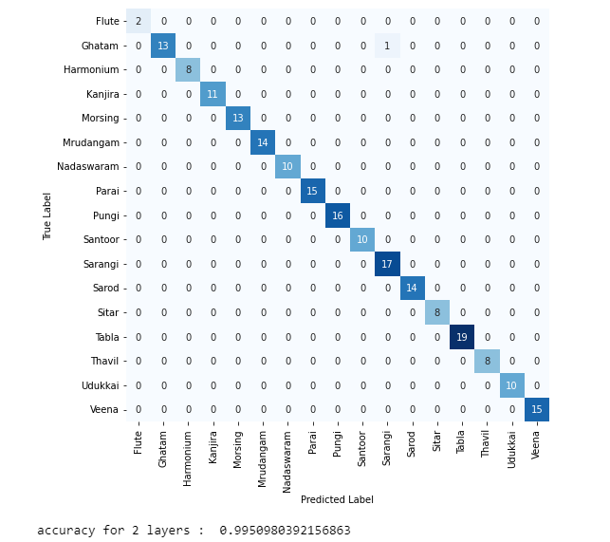

**2)**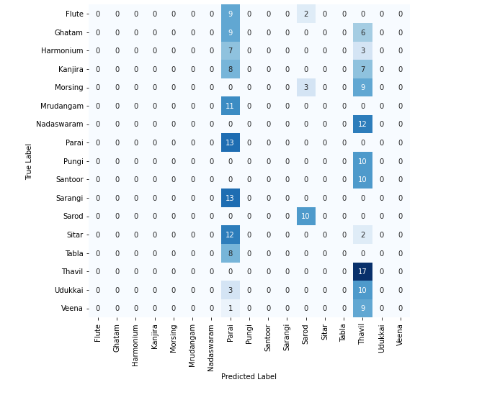

**3)**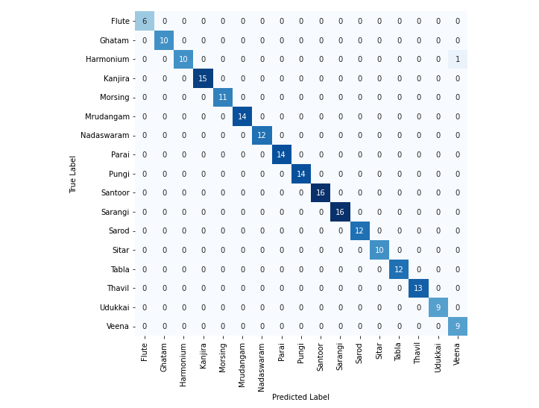

**4)**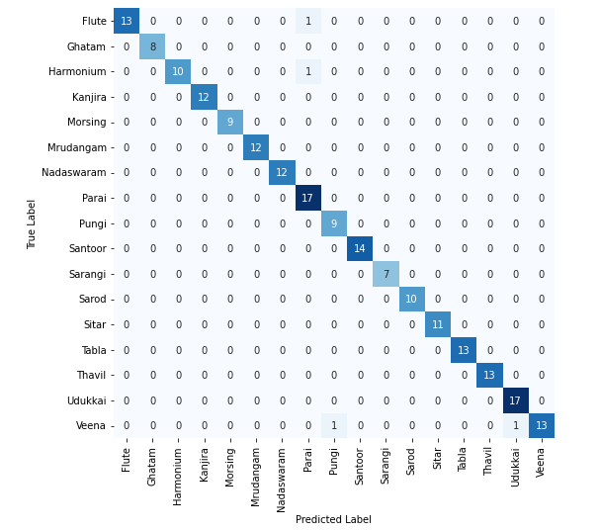

**5)**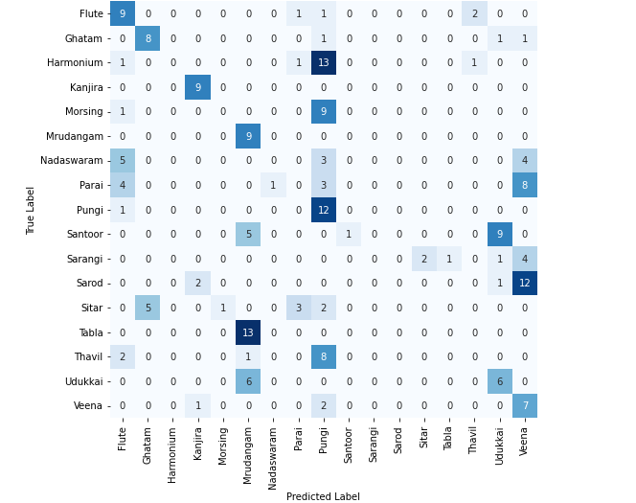

**6)**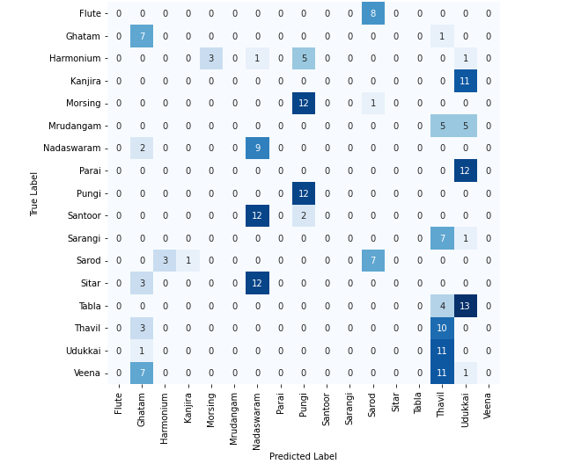

**7)**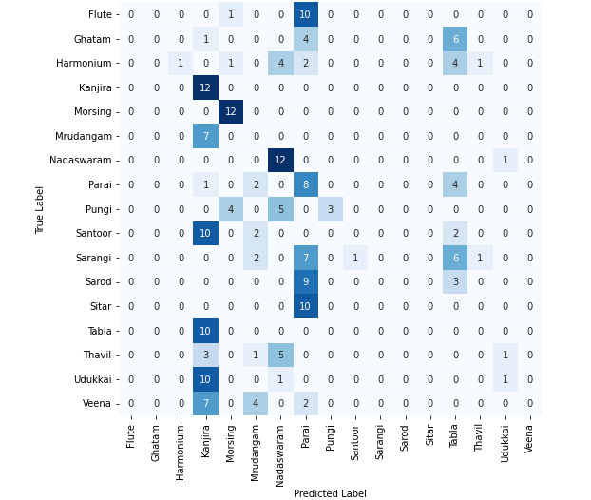

**8)**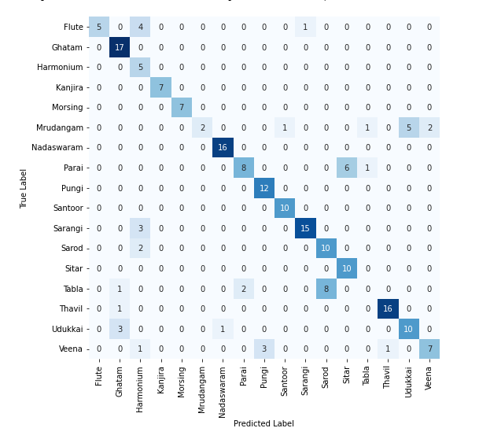

**9)**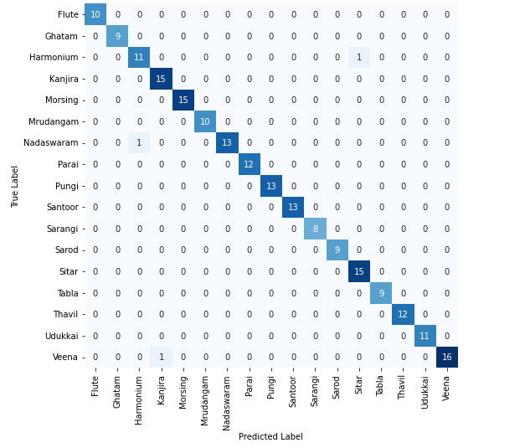

**10)**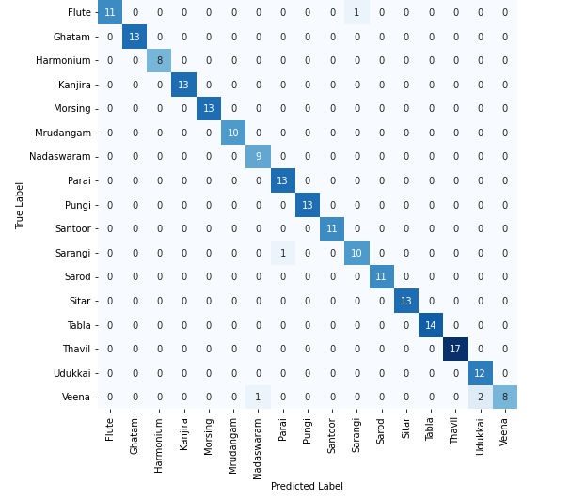

**11)**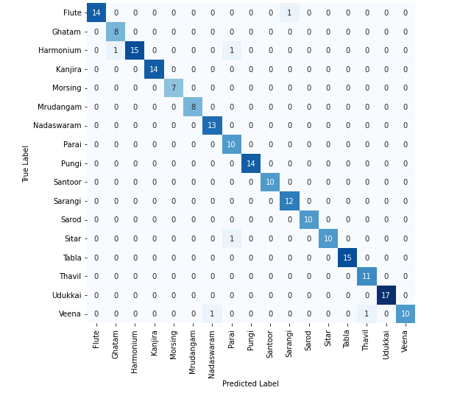

**12)**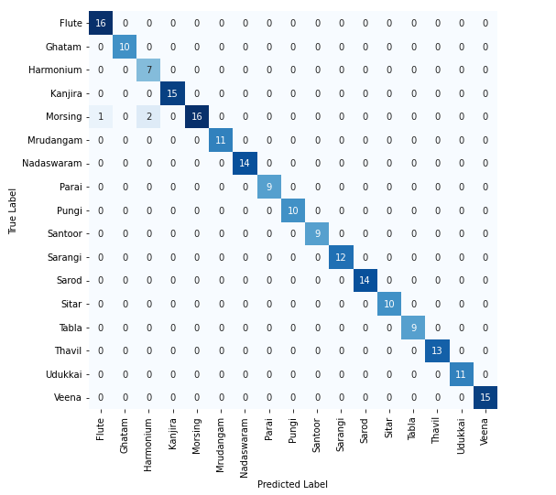

**13)**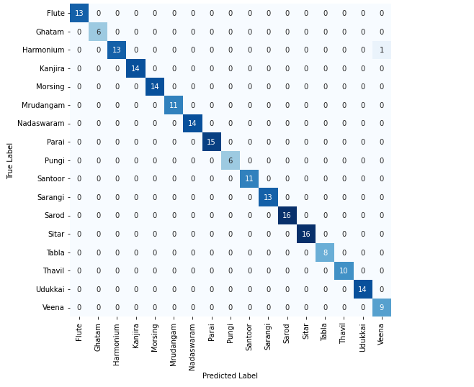

**14)**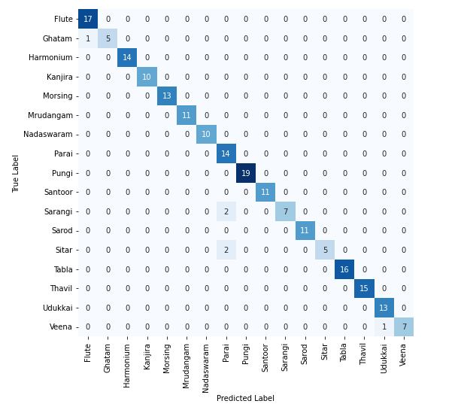

**15)**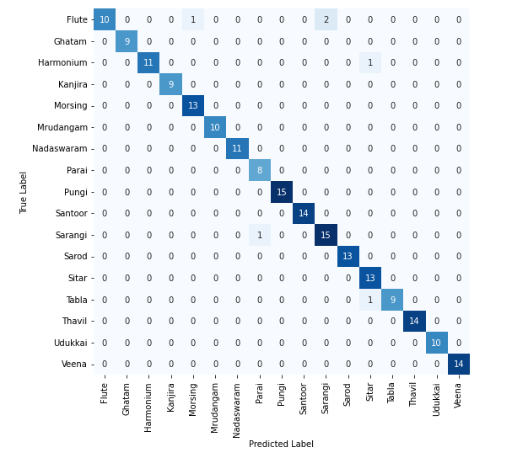

**16)**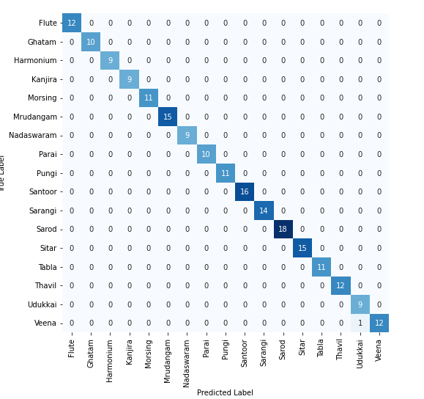

**17)**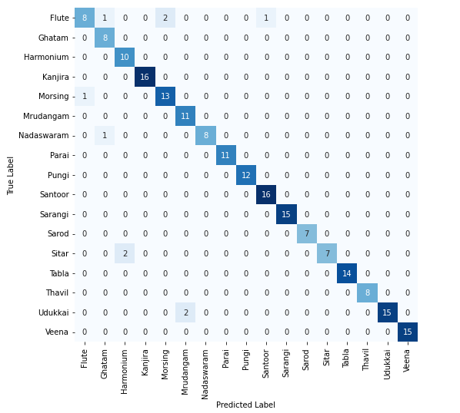

**18)**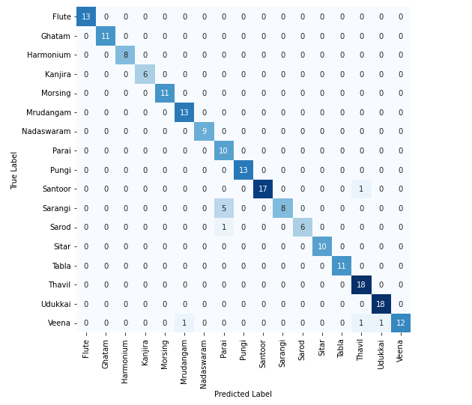

**INFERENCES FOR CONVOLUTIONAL NEURAL NETWORK**

The following inferences can be made from the above obtained results:

* Dropout in the network is inversely proportional to the accuracy. In most CNN models, accuracy increases when dropout value is decreased.
* Number of Nodes in the output layer in the network is directly proportional to the accuracy.

1. **RNN-LSTM:**

**FEATURE EXTRACTION METHOD:**

PROGRAM:

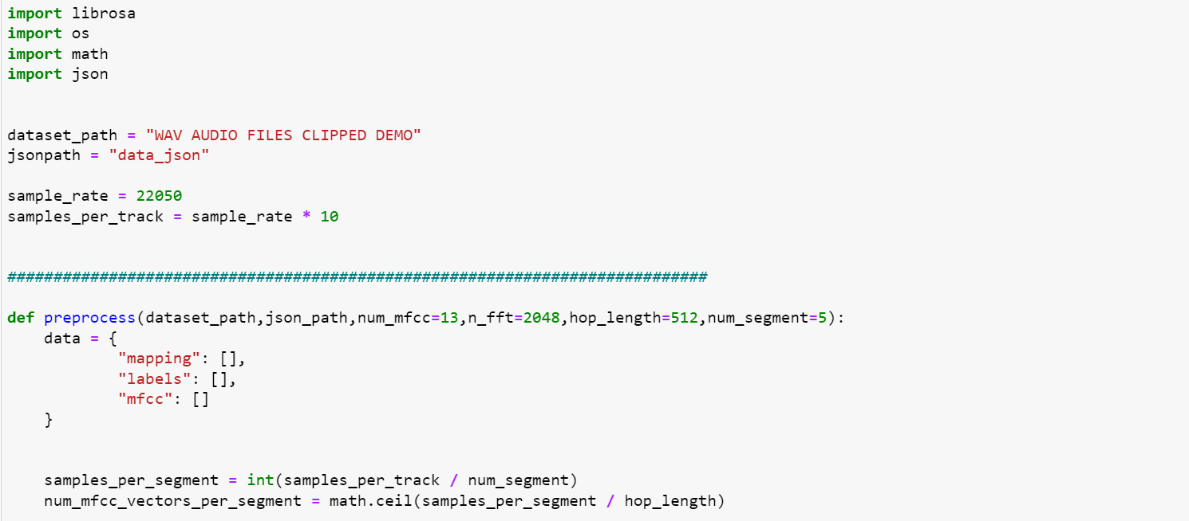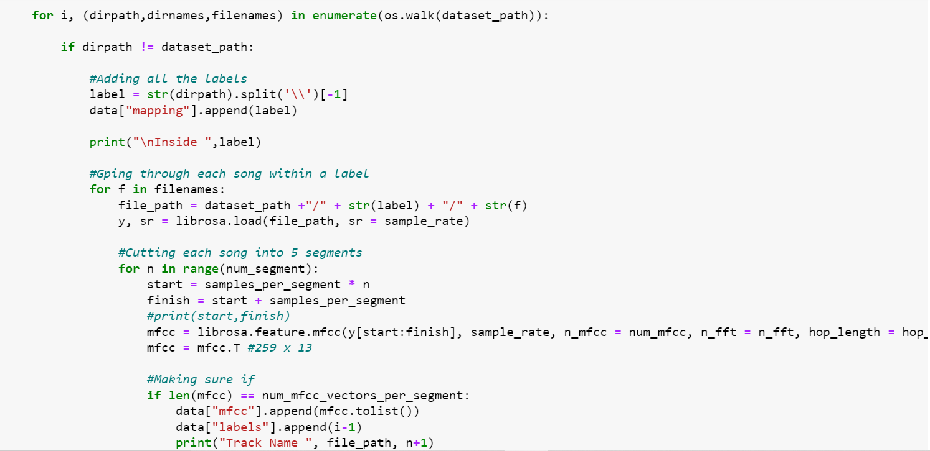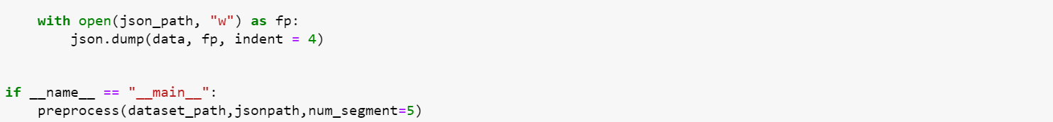

Output:

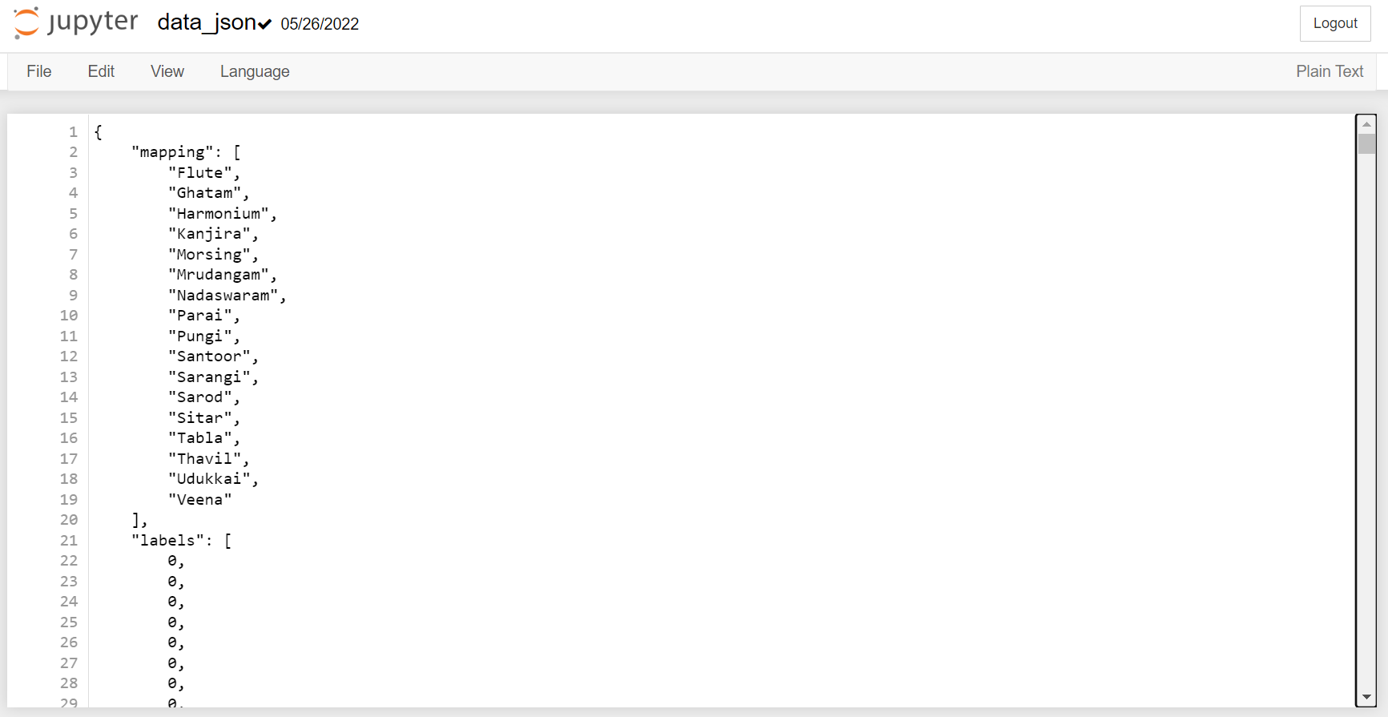

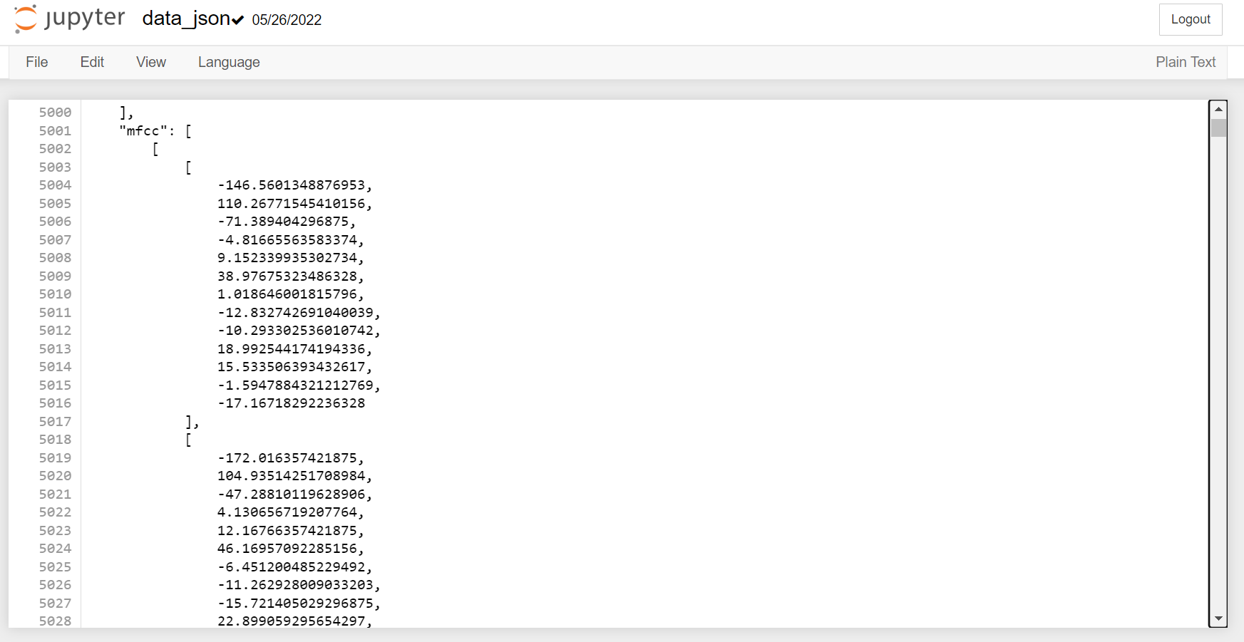

**METHODOLOGY**

The LSTM (Long Short-Term Memory) network is a variety of recurrent neural networks (RNNs) that are capable of learning long-term dependencies, especially in sequence prediction problems. LSTM has feedback connections, i.e., it is capable of processing the entire sequence of data such as in audio files, apart from single data points such as images. Thus, its applications include musical information retrieval. Though LSTM networks are primarily used for prediction, they provide high accuracy for classification problems also.

In the LSTM model proposed here, each audio file in the dataset described is divided into 5 segments each. For each segment the 13 MFCC features are extracted and written into a JavaScript Object Notation (json) file with the labels and mappings.

The MFCC vector is then read from the json file and the train-test split is done. An LSTM Network with 1 LSTM layer and 1 Dense layer (Base Model) is constructed and the model is compiled and trained with the train dataset. The model is tested with the test dataset and the output class probabilities for each segment are one hot encoded manually. The accuracy and confusion matrix is printed

**BLOCK DIAGRAM**

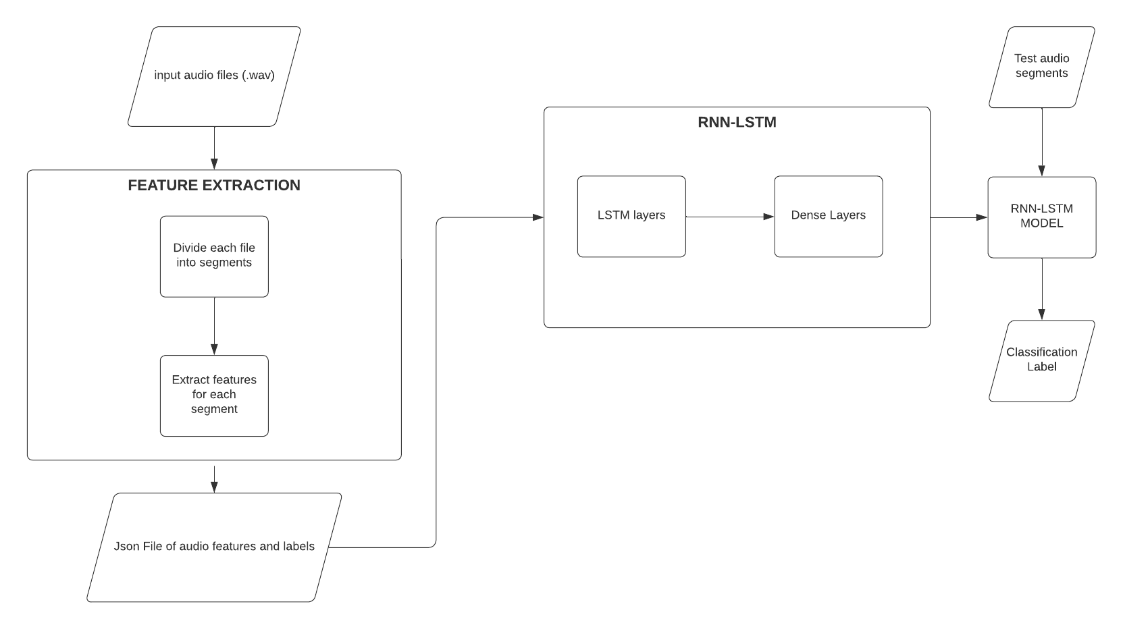

**IMPLEMENTATION**

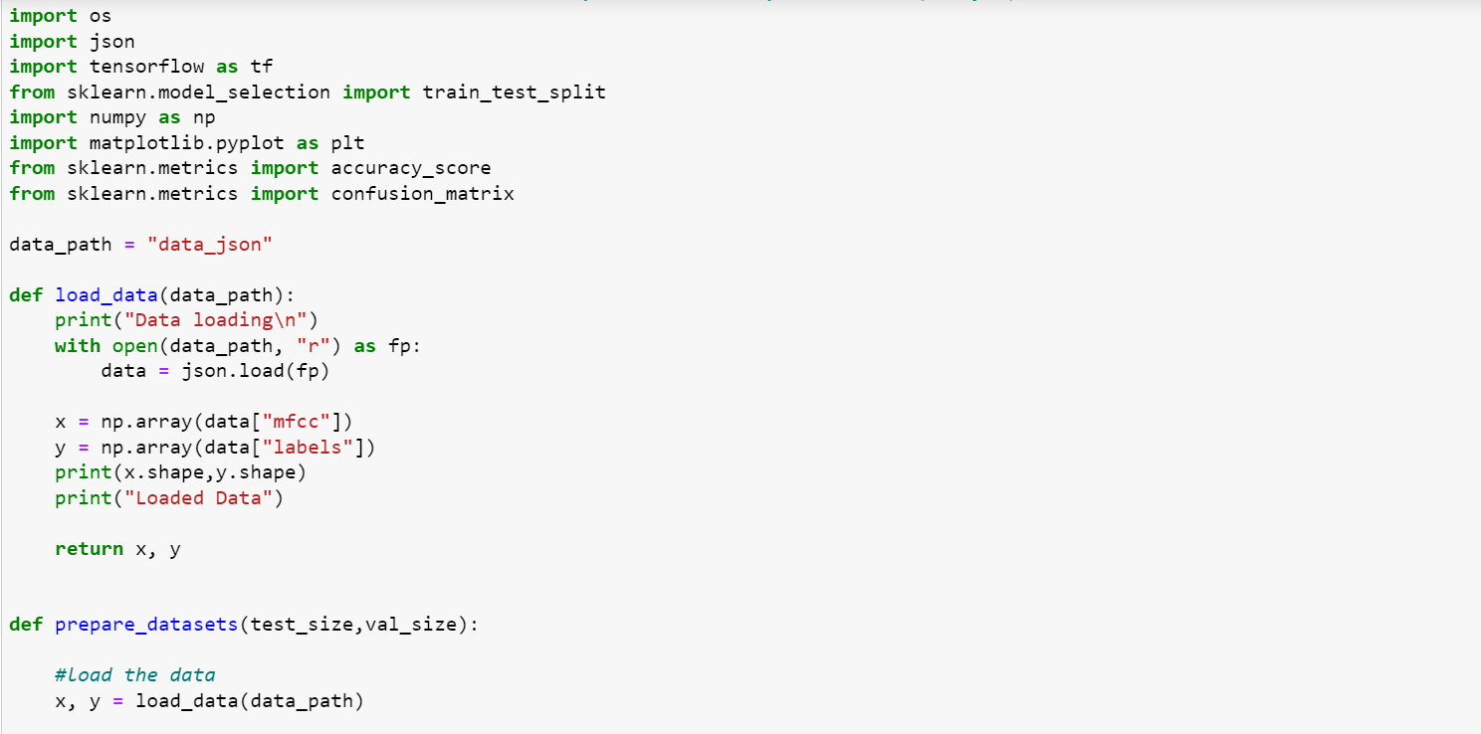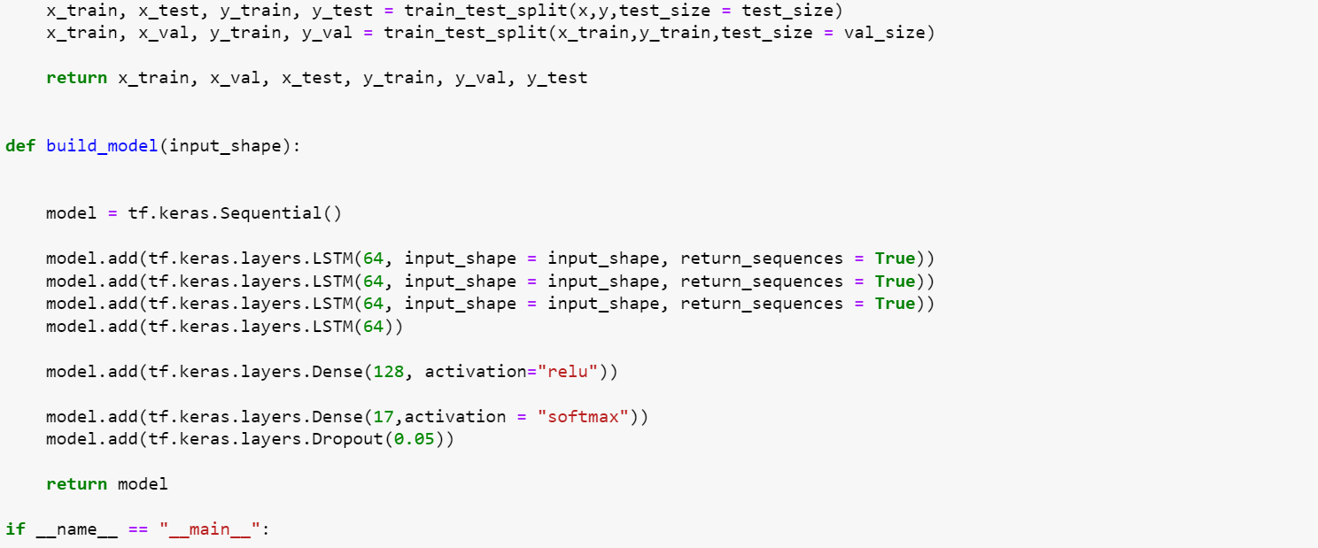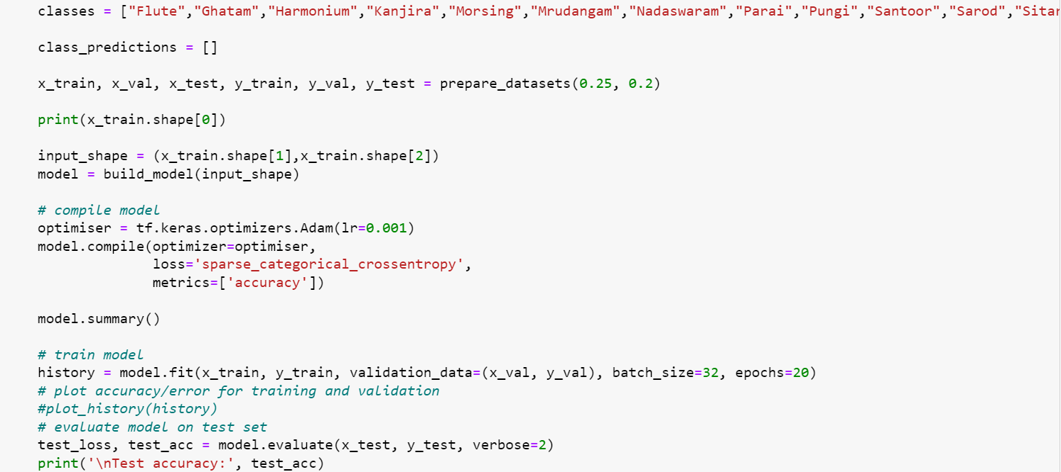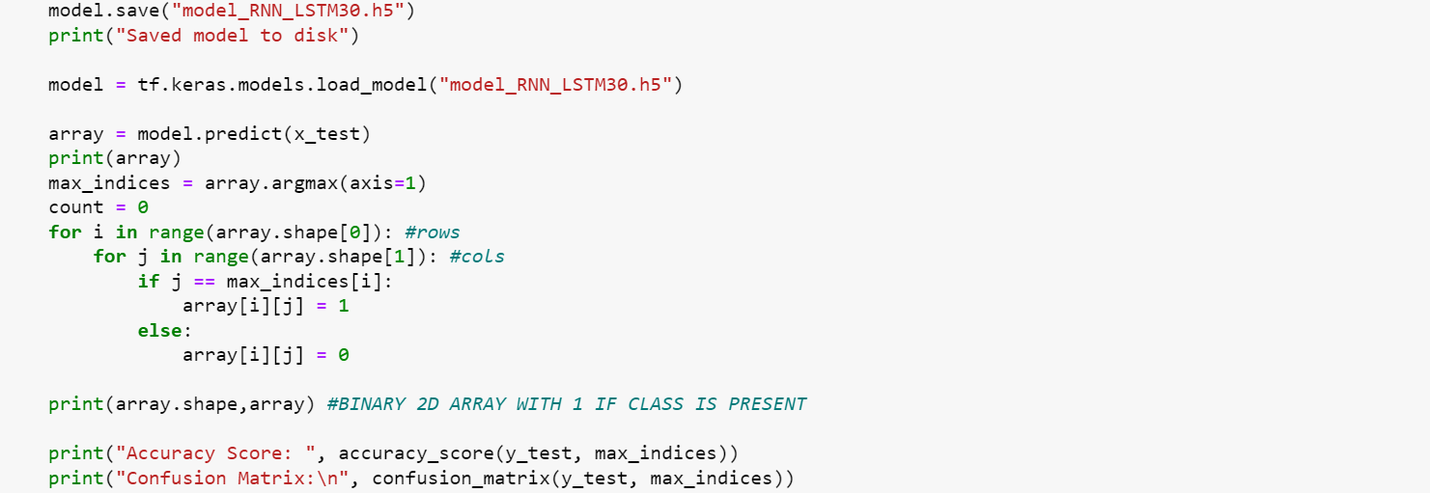

The above implementation is of a 6 layer LSTM model with 128 nodes in the 1st dense layer with a dropout value of 0.05 added after the last layer

**RESULTS**

The hyperparameters that were varied in RNN-LSTM:

* Number of layers
* Number of nodes in Dense layer
* Dropout value

The hyperparameters that were set constant in RNN-LSTM:

* Activation Function: relu, softmax
* Optimizer: Adam
* Number of Epochs: 20

*Dropout layer is added only after the last layer for all model variations

| Case | Number of LSTM Layers | No. of nodes in 1st Dense Layer | Dropout | Accuracy |
| --- | --- | --- | --- | --- |
| 1 | 2 | 17 | - | 0.99759 |
| 2 | 2 | 17 | 0.05 | 0.98955 |
| 3 | 2 | 17 | 0.1 | 0.98955 |
| 4 | 2 | 17 | 0.2 | 0.97349 |
| 5 | 4 | 128 | - | 0.99598 |
| 6 | 4 | 128 | 0.05 | 0.98634 |
| 7 | 4 | 128 | 0.1 | 0.98152 |
| 8 | 4 | 128 | 0.2 | 0.96706 |
| 9 | 4 | 256 | 0.05 | 0.96626 |
| 10 | 4 | 256 | 0.1 | 0.97429 |
| 11 | 4 | 256 | 0.2 | 0.97349 |
| 12 | 6 | 128 | - | 0.97028 |
| 13 | 6 | 128 | 0.05 | 0.97911 |
| 14 | 6 | 128 | 0.1 | 0.92771 |
| 15 | 6 | 128 | 0.2 | 0.93975 |
| 16 | 6 | 256 | 0.05 | 0.92289 |
| 17 | 6 | 256 | 0.1 | 0.95742 |
| 18 | 6 | 256 | 0.2 | 0.85783 |

**RESULT SNAPSHOTS FOR RNN-LSTM**

**Case 1:**

Epoch 1/20

94/94 [==============================] - 10s 68ms/step - loss: 2.3825 - accuracy: 0.3369 - val_loss: 1.8296 - val_accuracy: 0.6037

Epoch 2/20

94/94 [==============================] - 5s 52ms/step - loss: 1.4077 - accuracy: 0.7676 - val_loss: 1.0310 - val_accuracy: 0.8728

Epoch 3/20

94/94 [==============================] - 5s 50ms/step - loss: 0.8291 - accuracy: 0.8989 - val_loss: 0.6323 - val_accuracy: 0.9317

Epoch 4/20

94/94 [==============================] - 5s 52ms/step - loss: 0.5115 - accuracy: 0.9360 - val_loss: 0.4107 - val_accuracy: 0.9612

Epoch 5/20

94/94 [==============================] - 4s 41ms/step - loss: 0.3296 - accuracy: 0.9618 - val_loss: 0.2731 - val_accuracy: 0.9705

Epoch 6/20

94/94 [==============================] - 4s 44ms/step - loss: 0.2277 - accuracy: 0.9722 - val_loss: 0.2129 - val_accuracy: 0.9759

Epoch 7/20

94/94 [==============================] - 4s 43ms/step - loss: 0.1769 - accuracy: 0.9799 - val_loss: 0.1642 - val_accuracy: 0.9786

Epoch 8/20

94/94 [==============================] - 4s 42ms/step - loss: 0.1243 - accuracy: 0.9876 - val_loss: 0.1236 - val_accuracy: 0.9826

Epoch 9/20

94/94 [==============================] - 4s 43ms/step - loss: 0.0968 - accuracy: 0.9920 - val_loss: 0.1087 - val_accuracy: 0.9813

Epoch 10/20

94/94 [==============================] - 4s 42ms/step - loss: 0.0819 - accuracy: 0.9920 - val_loss: 0.0941 - val_accuracy: 0.9893

Epoch 11/20

94/94 [==============================] - 4s 42ms/step - loss: 0.0729 - accuracy: 0.9956 - val_loss: 0.0897 - val_accuracy: 0.9853

Epoch 12/20

94/94 [==============================] - 4s 41ms/step - loss: 0.0619 - accuracy: 0.9953 - val_loss: 0.0738 - val_accuracy: 0.9893

Epoch 13/20

94/94 [==============================] - 4s 41ms/step - loss: 0.0485 - accuracy: 0.9977 - val_loss: 0.0633 - val_accuracy: 0.9906

Epoch 14/20

94/94 [==============================] - 4s 39ms/step - loss: 0.0421 - accuracy: 0.9977 - val_loss: 0.0581 - val_accuracy: 0.9906

Epoch 15/20

94/94 [==============================] - 4s 43ms/step - loss: 0.0374 - accuracy: 0.9983 - val_loss: 0.0507 - val_accuracy: 0.9946

Epoch 16/20

94/94 [==============================] - 4s 43ms/step - loss: 0.0286 - accuracy: 0.9993 - val_loss: 0.0451 - val_accuracy: 0.9946

Epoch 17/20

94/94 [==============================] - 4s 44ms/step - loss: 0.0240 - accuracy: 0.9993 - val_loss: 0.0384 - val_accuracy: 0.9933

Epoch 18/20

94/94 [==============================] - 4s 45ms/step - loss: 0.0198 - accuracy: 0.9997 - val_loss: 0.0361 - val_accuracy: 0.9946

Epoch 19/20

94/94 [==============================] - 4s 44ms/step - loss: 0.0192 - accuracy: 0.9993 - val_loss: 0.0356 - val_accuracy: 0.9946

Epoch 20/20

94/94 [==============================] - 4s 42ms/step - loss: 0.0165 - accuracy: 0.9997 - val_loss: 0.0353 - val_accuracy: 0.9933

39/39 - 0s - loss: 0.0279 - accuracy: 0.9976 - 445ms/epoch - 11ms/step

Test accuracy: 0.9975903630256653

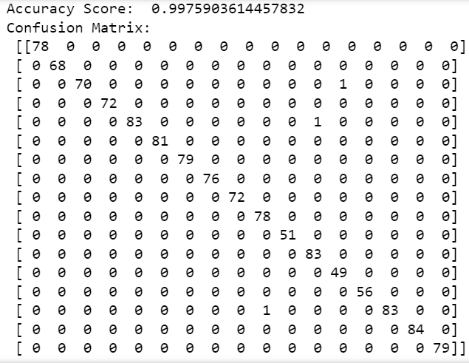

**Case 2:**

Epoch 1/20

94/94 [==============================] - 10s 68ms/step - loss: 2.9579 - accuracy: 0.2796 - val_loss: 1.8919 - val_accuracy: 0.5408

Epoch 2/20

94/94 [==============================] - 5s 56ms/step - loss: 2.2582 - accuracy: 0.6199 - val_loss: 1.3227 - val_accuracy: 0.7041

Epoch 3/20

94/94 [==============================] - 5s 58ms/step - loss: 1.8091 - accuracy: 0.7776 - val_loss: 0.8886 - val_accuracy: 0.8648

Epoch 4/20

94/94 [==============================] - 4s 41ms/step - loss: 1.3537 - accuracy: 0.8640 - val_loss: 0.5428 - val_accuracy: 0.9076

Epoch 5/20

94/94 [==============================] - 4s 41ms/step - loss: 1.2092 - accuracy: 0.8881 - val_loss: 0.3668 - val_accuracy: 0.9478

Epoch 6/20

94/94 [==============================] - 4s 42ms/step - loss: 0.8907 - accuracy: 0.9196 - val_loss: 0.2794 - val_accuracy: 0.9545

Epoch 7/20

94/94 [==============================] - 4s 43ms/step - loss: 0.9453 - accuracy: 0.9133 - val_loss: 0.2039 - val_accuracy: 0.9692

Epoch 8/20

94/94 [==============================] - 5s 50ms/step - loss: 0.7368 - accuracy: 0.9364 - val_loss: 0.1766 - val_accuracy: 0.9679

Epoch 9/20

94/94 [==============================] - 4s 48ms/step - loss: 0.7046 - accuracy: 0.9350 - val_loss: 0.1461 - val_accuracy: 0.9719

Epoch 10/20

94/94 [==============================] - 4s 42ms/step - loss: 0.5670 - accuracy: 0.9474 - val_loss: 0.1159 - val_accuracy: 0.9786

Epoch 11/20

94/94 [==============================] - 4s 41ms/step - loss: 0.7339 - accuracy: 0.9354 - val_loss: 0.1200 - val_accuracy: 0.9746

Epoch 12/20

94/94 [==============================] - 4s 46ms/step - loss: 0.6144 - accuracy: 0.9441 - val_loss: 0.1028 - val_accuracy: 0.9813

Epoch 13/20

94/94 [==============================] - 4s 45ms/step - loss: 0.6608 - accuracy: 0.9414 - val_loss: 0.0968 - val_accuracy: 0.9813

Epoch 14/20

94/94 [==============================] - 4s 42ms/step - loss: 0.6253 - accuracy: 0.9441 - val_loss: 0.0721 - val_accuracy: 0.9880

Epoch 15/20

94/94 [==============================] - 4s 44ms/step - loss: 0.6123 - accuracy: 0.9434 - val_loss: 0.0820 - val_accuracy: 0.9826

Epoch 16/20

94/94 [==============================] - 4s 42ms/step - loss: 0.6210 - accuracy: 0.9387 - val_loss: 0.0734 - val_accuracy: 0.9826

Epoch 17/20

94/94 [==============================] - 4s 45ms/step - loss: 0.5233 - accuracy: 0.9481 - val_loss: 0.0712 - val_accuracy: 0.9839

Epoch 18/20

94/94 [==============================] - 4s 41ms/step - loss: 0.5029 - accuracy: 0.9491 - val_loss: 0.0554 - val_accuracy: 0.9839

Epoch 19/20

94/94 [==============================] - 4s 41ms/step - loss: 0.4675 - accuracy: 0.9488 - val_loss: 0.0614 - val_accuracy: 0.9866

Epoch 20/20

94/94 [==============================] - 4s 45ms/step - loss: 0.5041 - accuracy: 0.9457 - val_loss: 0.0577 - val_accuracy: 0.9853

39/39 - 1s - loss: 0.0530 - accuracy: 0.9896 - 619ms/epoch - 16ms/step

Test accuracy: 0.989558219909668

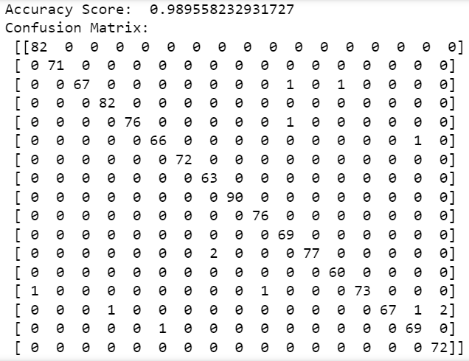

**Case 3:**

Epoch 1/20

94/94 [==============================] - 9s 61ms/step - loss: 3.5338 - accuracy: 0.3697 - val_loss: 1.7806 - val_accuracy: 0.6024

Epoch 2/20

94/94 [==============================] - 5s 52ms/step - loss: 2.7809 - accuracy: 0.6772 - val_loss: 1.0658 - val_accuracy: 0.8313

Epoch 3/20

94/94 [==============================] - 5s 53ms/step - loss: 2.1738 - accuracy: 0.8081 - val_loss: 0.6704 - val_accuracy: 0.9063

Epoch 4/20

94/94 [==============================] - 5s 52ms/step - loss: 1.8311 - accuracy: 0.8473 - val_loss: 0.4324 - val_accuracy: 0.9451

Epoch 5/20

94/94 [==============================] - 5s 51ms/step - loss: 1.6803 - accuracy: 0.8647 - val_loss: 0.2976 - val_accuracy: 0.9572

Epoch 6/20

94/94 [==============================] - 5s 51ms/step - loss: 1.6115 - accuracy: 0.8707 - val_loss: 0.2171 - val_accuracy: 0.9719

Epoch 7/20

94/94 [==============================] - 4s 39ms/step - loss: 1.3315 - accuracy: 0.8871 - val_loss: 0.1650 - val_accuracy: 0.9732

Epoch 8/20

94/94 [==============================] - 4s 46ms/step - loss: 1.3784 - accuracy: 0.8791 - val_loss: 0.1430 - val_accuracy: 0.9772

Epoch 9/20

94/94 [==============================] - 4s 44ms/step - loss: 1.2902 - accuracy: 0.8838 - val_loss: 0.1395 - val_accuracy: 0.9652

Epoch 10/20

94/94 [==============================] - 4s 47ms/step - loss: 1.2771 - accuracy: 0.8818 - val_loss: 0.1133 - val_accuracy: 0.9759

Epoch 11/20

94/94 [==============================] - 4s 43ms/step - loss: 1.1559 - accuracy: 0.8835 - val_loss: 0.0966 - val_accuracy: 0.9786

Epoch 12/20

94/94 [==============================] - 4s 45ms/step - loss: 1.1370 - accuracy: 0.8865 - val_loss: 0.0877 - val_accuracy: 0.9759

Epoch 13/20

94/94 [==============================] - 4s 43ms/step - loss: 1.0322 - accuracy: 0.8922 - val_loss: 0.0721 - val_accuracy: 0.9799

Epoch 14/20

94/94 [==============================] - 4s 43ms/step - loss: 0.9356 - accuracy: 0.8952 - val_loss: 0.0792 - val_accuracy: 0.9746

Epoch 15/20

94/94 [==============================] - 4s 44ms/step - loss: 0.9549 - accuracy: 0.8855 - val_loss: 0.0891 - val_accuracy: 0.9759

Epoch 16/20

94/94 [==============================] - 5s 56ms/step - loss: 0.8512 - accuracy: 0.8945 - val_loss: 0.0563 - val_accuracy: 0.9826

Epoch 17/20

94/94 [==============================] - 5s 55ms/step - loss: 0.7434 - accuracy: 0.8989 - val_loss: 0.0663 - val_accuracy: 0.9839

Epoch 18/20

94/94 [==============================] - 4s 45ms/step - loss: 0.8313 - accuracy: 0.8912 - val_loss: 0.0528 - val_accuracy: 0.9893

Epoch 19/20

94/94 [==============================] - 4s 43ms/step - loss: 0.7871 - accuracy: 0.8975 - val_loss: 0.0518 - val_accuracy: 0.9813

Epoch 20/20

94/94 [==============================] - 4s 40ms/step - loss: 0.7795 - accuracy: 0.8878 - val_loss: 0.0471 - val_accuracy: 0.9906

39/39 - 1s - loss: 0.0427 - accuracy: 0.9896 - 593ms/epoch - 15ms/step

Test accuracy: 0.989558219909668

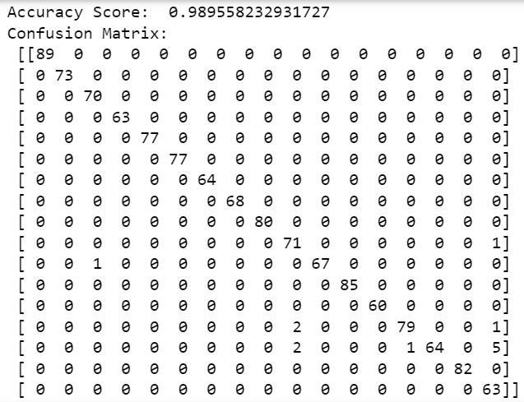

**Case 4:**

Epoch 1/20

94/94 [==============================] - 10s 62ms/step - loss: 5.0849 - accuracy: 0.2934 - val_loss: 1.9145 - val_accuracy: 0.5649

Epoch 2/20

94/94 [==============================] - 5s 51ms/step - loss: 4.1888 - accuracy: 0.5837 - val_loss: 1.2241 - val_accuracy: 0.7617

Epoch 3/20

94/94 [==============================] - 5s 54ms/step - loss: 3.9192 - accuracy: 0.6748 - val_loss: 0.8299 - val_accuracy: 0.8594

Epoch 4/20

94/94 [==============================] - 4s 45ms/step - loss: 3.3630 - accuracy: 0.7274 - val_loss: 0.5403 - val_accuracy: 0.9183

Epoch 5/20

94/94 [==============================] - 4s 42ms/step - loss: 3.1916 - accuracy: 0.7448 - val_loss: 0.3906 - val_accuracy: 0.9237

Epoch 6/20

94/94 [==============================] - 4s 37ms/step - loss: 2.9885 - accuracy: 0.7472 - val_loss: 0.3006 - val_accuracy: 0.9451

Epoch 7/20

94/94 [==============================] - 4s 41ms/step - loss: 2.6943 - accuracy: 0.7656 - val_loss: 0.2398 - val_accuracy: 0.9518

Epoch 8/20

94/94 [==============================] - 4s 46ms/step - loss: 2.4980 - accuracy: 0.7733 - val_loss: 0.2126 - val_accuracy: 0.9585

Epoch 9/20

94/94 [==============================] - 4s 39ms/step - loss: 2.4263 - accuracy: 0.7686 - val_loss: 0.2414 - val_accuracy: 0.9438

Epoch 10/20

94/94 [==============================] - 4s 41ms/step - loss: 2.3386 - accuracy: 0.7746 - val_loss: 0.1589 - val_accuracy: 0.9585

Epoch 11/20

94/94 [==============================] - 4s 40ms/step - loss: 2.2114 - accuracy: 0.7786 - val_loss: 0.1512 - val_accuracy: 0.9625

Epoch 12/20

94/94 [==============================] - 4s 44ms/step - loss: 2.0872 - accuracy: 0.7830 - val_loss: 0.1604 - val_accuracy: 0.9612

Epoch 13/20

94/94 [==============================] - 5s 54ms/step - loss: 2.0185 - accuracy: 0.7733 - val_loss: 0.1192 - val_accuracy: 0.9585

Epoch 14/20

94/94 [==============================] - 6s 66ms/step - loss: 1.8289 - accuracy: 0.7743 - val_loss: 0.0974 - val_accuracy: 0.9692

Epoch 15/20

94/94 [==============================] - 6s 63ms/step - loss: 1.7960 - accuracy: 0.7753 - val_loss: 0.1220 - val_accuracy: 0.9612

Epoch 16/20

94/94 [==============================] - 6s 64ms/step - loss: 1.6611 - accuracy: 0.7904 - val_loss: 0.1184 - val_accuracy: 0.9692

Epoch 17/20

94/94 [==============================] - 6s 62ms/step - loss: 1.6368 - accuracy: 0.7877 - val_loss: 0.1088 - val_accuracy: 0.9719

Epoch 18/20

94/94 [==============================] - 3s 37ms/step - loss: 1.4551 - accuracy: 0.7857 - val_loss: 0.0804 - val_accuracy: 0.9719

Epoch 19/20

94/94 [==============================] - 4s 41ms/step - loss: 1.4692 - accuracy: 0.7870 - val_loss: 0.0842 - val_accuracy: 0.9705

Epoch 20/20

94/94 [==============================] - 5s 48ms/step - loss: 1.4063 - accuracy: 0.7803 - val_loss: 0.0919 - val_accuracy: 0.9719

39/39 - 1s - loss: 0.0921 - accuracy: 0.9735 - 558ms/epoch - 14ms/step

Test accuracy: 0.9734939932823181

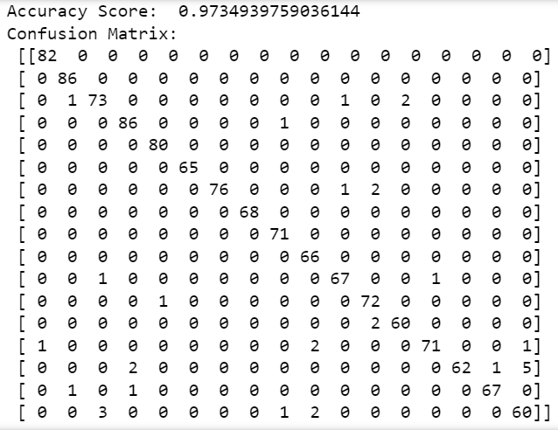

**Case 5:**

Epoch 1/20

94/94 [==============================] - 18s 130ms/step - loss: 1.4212 - accuracy: 0.6407 - val_loss: 0.5529 - val_accuracy: 0.8581

Epoch 2/20

94/94 [==============================] - 9s 100ms/step - loss: 0.3391 - accuracy: 0.9106 - val_loss: 0.2854 - val_accuracy: 0.9224

Epoch 3/20

94/94 [==============================] - 7s 79ms/step - loss: 0.1983 - accuracy: 0.9447 - val_loss: 0.2878 - val_accuracy: 0.9116

Epoch 4/20

94/94 [==============================] - 7s 74ms/step - loss: 0.1456 - accuracy: 0.9555 - val_loss: 0.1386 - val_accuracy: 0.9545

Epoch 5/20

94/94 [==============================] - 7s 75ms/step - loss: 0.0924 - accuracy: 0.9729 - val_loss: 0.1662 - val_accuracy: 0.9545

Epoch 6/20

94/94 [==============================] - 8s 81ms/step - loss: 0.0845 - accuracy: 0.9766 - val_loss: 0.1336 - val_accuracy: 0.9625

Epoch 7/20

94/94 [==============================] - 8s 84ms/step - loss: 0.1084 - accuracy: 0.9668 - val_loss: 0.0749 - val_accuracy: 0.9759

Epoch 8/20

94/94 [==============================] - 8s 84ms/step - loss: 0.0403 - accuracy: 0.9893 - val_loss: 0.0692 - val_accuracy: 0.9786

Epoch 9/20

94/94 [==============================] - 8s 88ms/step - loss: 0.0707 - accuracy: 0.9786 - val_loss: 0.0973 - val_accuracy: 0.9679

Epoch 10/20

94/94 [==============================] - 8s 85ms/step - loss: 0.0467 - accuracy: 0.9856 - val_loss: 0.0647 - val_accuracy: 0.9786

Epoch 11/20

94/94 [==============================] - 8s 87ms/step - loss: 0.0475 - accuracy: 0.9856 - val_loss: 0.0732 - val_accuracy: 0.9786

Epoch 12/20

94/94 [==============================] - 8s 85ms/step - loss: 0.0350 - accuracy: 0.9906 - val_loss: 0.0622 - val_accuracy: 0.9746

Epoch 13/20

94/94 [==============================] - 8s 82ms/step - loss: 0.0760 - accuracy: 0.9776 - val_loss: 0.0712 - val_accuracy: 0.9799

Epoch 14/20

94/94 [==============================] - 9s 91ms/step - loss: 0.1454 - accuracy: 0.9565 - val_loss: 0.1683 - val_accuracy: 0.9465

Epoch 15/20

94/94 [==============================] - 7s 78ms/step - loss: 0.0475 - accuracy: 0.9869 - val_loss: 0.0437 - val_accuracy: 0.9920

Epoch 16/20

94/94 [==============================] - 7s 76ms/step - loss: 0.0297 - accuracy: 0.9920 - val_loss: 0.0365 - val_accuracy: 0.9920

Epoch 17/20

94/94 [==============================] - 7s 75ms/step - loss: 0.0077 - accuracy: 0.9987 - val_loss: 0.0374 - val_accuracy: 0.9906

Epoch 18/20

94/94 [==============================] - 9s 91ms/step - loss: 0.0065 - accuracy: 0.9990 - val_loss: 0.0369 - val_accuracy: 0.9866

Epoch 19/20

94/94 [==============================] - 9s 93ms/step - loss: 0.0164 - accuracy: 0.9960 - val_loss: 0.0207 - val_accuracy: 0.9906

Epoch 20/20

94/94 [==============================] - 9s 95ms/step - loss: 0.0028 - accuracy: 1.0000 - val_loss: 0.0189 - val_accuracy: 0.9946

39/39 - 1s - loss: 0.0152 - accuracy: 0.9960 - 1s/epoch - 33ms/step

Test accuracy: 0.9959839582443237

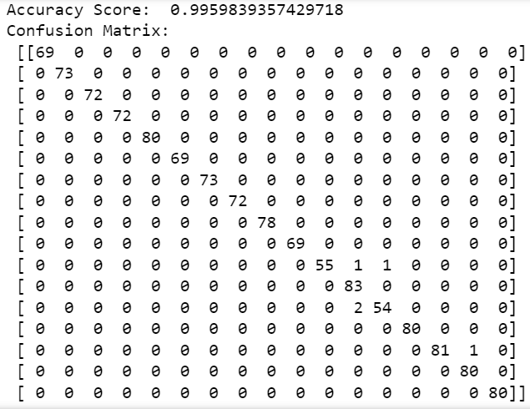

**Case 6:**

Epoch 1/20

94/94 [==============================] - 17s 124ms/step - loss: 2.2464 - accuracy: 0.5429 - val_loss: 0.7164 - val_accuracy: 0.7711

Epoch 2/20

94/94 [==============================] - 9s 97ms/step - loss: 1.2648 - accuracy: 0.7984 - val_loss: 0.2384 - val_accuracy: 0.9277

Epoch 3/20

94/94 [==============================] - 7s 75ms/step - loss: 0.8421 - accuracy: 0.8768 - val_loss: 0.7216 - val_accuracy: 0.8447

Epoch 4/20

94/94 [==============================] - 8s 83ms/step - loss: 0.8615 - accuracy: 0.8731 - val_loss: 0.1646 - val_accuracy: 0.9558

Epoch 5/20

94/94 [==============================] - 8s 82ms/step - loss: 0.6599 - accuracy: 0.8935 - val_loss: 0.1406 - val_accuracy: 0.9585

Epoch 6/20

94/94 [==============================] - 7s 78ms/step - loss: 0.5960 - accuracy: 0.9099 - val_loss: 0.3037 - val_accuracy: 0.9250

Epoch 7/20

94/94 [==============================] - 8s 86ms/step - loss: 0.5047 - accuracy: 0.9143 - val_loss: 0.1517 - val_accuracy: 0.9451

Epoch 8/20

94/94 [==============================] - 8s 84ms/step - loss: 0.4779 - accuracy: 0.9133 - val_loss: 0.2536 - val_accuracy: 0.9384

Epoch 9/20

94/94 [==============================] - 8s 80ms/step - loss: 0.5597 - accuracy: 0.8895 - val_loss: 0.3629 - val_accuracy: 0.8929

Epoch 10/20

94/94 [==============================] - 8s 85ms/step - loss: 0.5582 - accuracy: 0.9042 - val_loss: 0.0981 - val_accuracy: 0.9692

Epoch 11/20

94/94 [==============================] - 8s 83ms/step - loss: 0.4246 - accuracy: 0.9200 - val_loss: 0.1159 - val_accuracy: 0.9665

Epoch 12/20

94/94 [==============================] - 8s 85ms/step - loss: 0.3977 - accuracy: 0.9236 - val_loss: 0.1307 - val_accuracy: 0.9639

Epoch 13/20

94/94 [==============================] - 8s 84ms/step - loss: 0.2890 - accuracy: 0.9313 - val_loss: 0.0659 - val_accuracy: 0.9813

Epoch 14/20

94/94 [==============================] - 8s 85ms/step - loss: 0.3115 - accuracy: 0.9236 - val_loss: 0.1195 - val_accuracy: 0.9759

Epoch 15/20

94/94 [==============================] - 8s 88ms/step - loss: 0.2789 - accuracy: 0.9364 - val_loss: 0.1442 - val_accuracy: 0.9799

Epoch 16/20

94/94 [==============================] - 8s 86ms/step - loss: 0.4075 - accuracy: 0.9173 - val_loss: 0.3559 - val_accuracy: 0.9317

Epoch 17/20

94/94 [==============================] - 8s 86ms/step - loss: 0.3220 - accuracy: 0.9267 - val_loss: 0.0751 - val_accuracy: 0.9866

Epoch 18/20

94/94 [==============================] - 8s 86ms/step - loss: 0.2957 - accuracy: 0.9257 - val_loss: 0.1348 - val_accuracy: 0.9772

Epoch 19/20

94/94 [==============================] - 8s 87ms/step - loss: 0.2924 - accuracy: 0.9357 - val_loss: 0.0638 - val_accuracy: 0.9893

Epoch 20/20

94/94 [==============================] - 8s 89ms/step - loss: 0.2119 - accuracy: 0.9441 - val_loss: 0.0868 - val_accuracy: 0.9853

39/39 - 1s - loss: 0.0719 - accuracy: 0.9863 - 1s/epoch - 36ms/step

Test accuracy: 0.9863454103469849

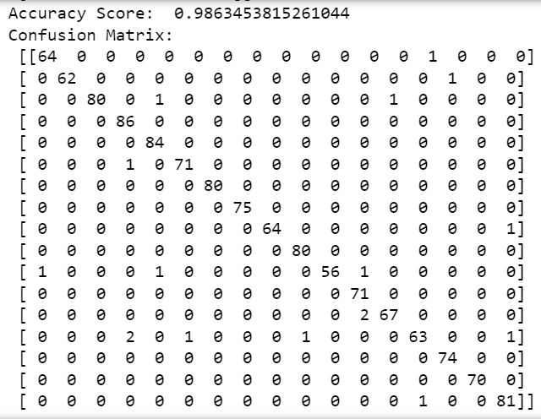

**Case 7:**

Epoch 1/20

94/94 [==============================] - 15s 111ms/step - loss: 2.8657 - accuracy: 0.5489 - val_loss: 0.6104 - val_accuracy: 0.8487

Epoch 2/20

94/94 [==============================] - 10s 101ms/step - loss: 1.6570 - accuracy: 0.7991 - val_loss: 0.3395 - val_accuracy: 0.9050

Epoch 3/20

94/94 [==============================] - 8s 89ms/step - loss: 1.4037 - accuracy: 0.8332 - val_loss: 0.3594 - val_accuracy: 0.9050

Epoch 4/20

94/94 [==============================] - 8s 82ms/step - loss: 1.1055 - accuracy: 0.8436 - val_loss: 0.2530 - val_accuracy: 0.9317

Epoch 5/20

94/94 [==============================] - 8s 86ms/step - loss: 0.8950 - accuracy: 0.8513 - val_loss: 0.2682 - val_accuracy: 0.9210

Epoch 6/20

94/94 [==============================] - 8s 88ms/step - loss: 0.8245 - accuracy: 0.8617 - val_loss: 0.1642 - val_accuracy: 0.9612

Epoch 7/20

94/94 [==============================] - 9s 96ms/step - loss: 0.6533 - accuracy: 0.8794 - val_loss: 0.2266 - val_accuracy: 0.9545

Epoch 8/20

94/94 [==============================] - 8s 90ms/step - loss: 0.5685 - accuracy: 0.8758 - val_loss: 0.1798 - val_accuracy: 0.9639

Epoch 9/20

94/94 [==============================] - 9s 92ms/step - loss: 0.5652 - accuracy: 0.8801 - val_loss: 0.3575 - val_accuracy: 0.9264

Epoch 10/20

94/94 [==============================] - 9s 94ms/step - loss: 0.5967 - accuracy: 0.8798 - val_loss: 0.1330 - val_accuracy: 0.9679

Epoch 11/20

94/94 [==============================] - 9s 92ms/step - loss: 0.6350 - accuracy: 0.8734 - val_loss: 0.2646 - val_accuracy: 0.9505

Epoch 12/20

94/94 [==============================] - 10s 101ms/step - loss: 0.4660 - accuracy: 0.8878 - val_loss: 0.1050 - val_accuracy: 0.9799

Epoch 13/20

94/94 [==============================] - 9s 92ms/step - loss: 0.4591 - accuracy: 0.8885 - val_loss: 0.1488 - val_accuracy: 0.9759

Epoch 14/20

94/94 [==============================] - 9s 91ms/step - loss: 0.5117 - accuracy: 0.8808 - val_loss: 0.1144 - val_accuracy: 0.9732

Epoch 15/20

94/94 [==============================] - 9s 90ms/step - loss: 0.5497 - accuracy: 0.8791 - val_loss: 0.1182 - val_accuracy: 0.9732

Epoch 16/20

94/94 [==============================] - 9s 93ms/step - loss: 0.4662 - accuracy: 0.8972 - val_loss: 0.3126 - val_accuracy: 0.9491

Epoch 17/20

94/94 [==============================] - 9s 94ms/step - loss: 0.4458 - accuracy: 0.8851 - val_loss: 0.1463 - val_accuracy: 0.9772

Epoch 18/20

94/94 [==============================] - 9s 93ms/step - loss: 0.3844 - accuracy: 0.8895 - val_loss: 0.0764 - val_accuracy: 0.9866

Epoch 19/20

94/94 [==============================] - 8s 88ms/step - loss: 0.3270 - accuracy: 0.8995 - val_loss: 0.0627 - val_accuracy: 0.9893

Epoch 20/20

94/94 [==============================] - 8s 88ms/step - loss: 0.3618 - accuracy: 0.8928 - val_loss: 0.0774 - val_accuracy: 0.9799

39/39 - 1s - loss: 0.0842 - accuracy: 0.9815 - 1s/epoch - 30ms/step

Test accuracy: 0.9815260767936707

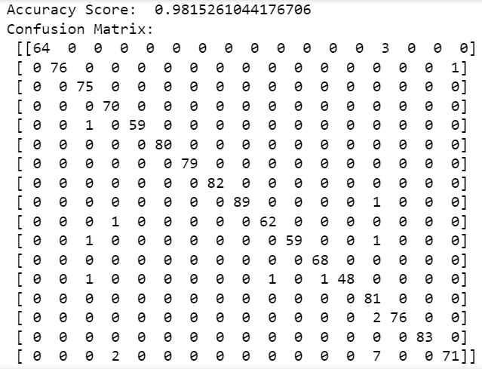

**Case 8:**

Epoch 1/20

94/94 [==============================] - 19s 132ms/step - loss: 3.9785 - accuracy: 0.5204 - val_loss: 0.6361 - val_accuracy: 0.8126

Epoch 2/20

94/94 [==============================] - 10s 103ms/step - loss: 2.6303 - accuracy: 0.7070 - val_loss: 0.5215 - val_accuracy: 0.8768

Epoch 3/20

94/94 [==============================] - 9s 92ms/step - loss: 1.9826 - accuracy: 0.7425 - val_loss: 0.2861 - val_accuracy: 0.9411

Epoch 4/20

94/94 [==============================] - 9s 95ms/step - loss: 2.1105 - accuracy: 0.6983 - val_loss: 0.3177 - val_accuracy: 0.9210

Epoch 5/20

94/94 [==============================] - 9s 96ms/step - loss: 1.5554 - accuracy: 0.7371 - val_loss: 0.4732 - val_accuracy: 0.9317

Epoch 6/20

94/94 [==============================] - 9s 97ms/step - loss: 1.3769 - accuracy: 0.7525 - val_loss: 0.4730 - val_accuracy: 0.9290

Epoch 7/20

94/94 [==============================] - 9s 97ms/step - loss: 1.1814 - accuracy: 0.7585 - val_loss: 0.3438 - val_accuracy: 0.9424

Epoch 8/20

94/94 [==============================] - 9s 100ms/step - loss: 1.2595 - accuracy: 0.7482 - val_loss: 0.3549 - val_accuracy: 0.9545

Epoch 9/20

94/94 [==============================] - 9s 96ms/step - loss: 1.4271 - accuracy: 0.7301 - val_loss: 0.4632 - val_accuracy: 0.9424

Epoch 10/20

94/94 [==============================] - 9s 97ms/step - loss: 1.2656 - accuracy: 0.7478 - val_loss: 0.2020 - val_accuracy: 0.9505

Epoch 11/20

94/94 [==============================] - 9s 93ms/step - loss: 1.1193 - accuracy: 0.7569 - val_loss: 0.5440 - val_accuracy: 0.9116

Epoch 12/20

94/94 [==============================] - 9s 97ms/step - loss: 1.0376 - accuracy: 0.7599 - val_loss: 0.3777 - val_accuracy: 0.9545

Epoch 13/20

94/94 [==============================] - 10s 102ms/step - loss: 1.0312 - accuracy: 0.7746 - val_loss: 0.2717 - val_accuracy: 0.9679

Epoch 14/20

94/94 [==============================] - 11s 113ms/step - loss: 0.8452 - accuracy: 0.7739 - val_loss: 0.1619 - val_accuracy: 0.9786

Epoch 15/20

94/94 [==============================] - 10s 102ms/step - loss: 0.7930 - accuracy: 0.7843 - val_loss: 0.1616 - val_accuracy: 0.9759

Epoch 16/20

94/94 [==============================] - 9s 100ms/step - loss: 0.8622 - accuracy: 0.7833 - val_loss: 0.1729 - val_accuracy: 0.9772

Epoch 17/20

94/94 [==============================] - 9s 98ms/step - loss: 0.9174 - accuracy: 0.7790 - val_loss: 0.2661 - val_accuracy: 0.9585

Epoch 18/20

94/94 [==============================] - 9s 101ms/step - loss: 0.9820 - accuracy: 0.7706 - val_loss: 0.3867 - val_accuracy: 0.9438

Epoch 19/20

94/94 [==============================] - 9s 101ms/step - loss: 1.6682 - accuracy: 0.7230 - val_loss: 0.4042 - val_accuracy: 0.9264

Epoch 20/20

94/94 [==============================] - 10s 103ms/step - loss: 0.9950 - accuracy: 0.7706 - val_loss: 0.3741 - val_accuracy: 0.9545

39/39 - 2s - loss: 0.2249 - accuracy: 0.9671 - 2s/epoch - 42ms/step

Test accuracy: 0.9670682549476624

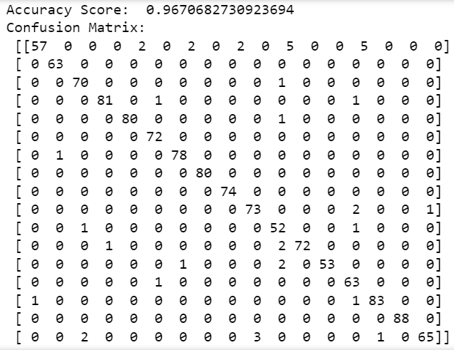

**Case 9:**

Epoch 1/20

94/94 [==============================] - 19s 139ms/step - loss: 2.2272 - accuracy: 0.5345 - val_loss: 0.6465 - val_accuracy: 0.7778

Epoch 2/20

94/94 [==============================] - 9s 96ms/step - loss: 1.0567 - accuracy: 0.8222 - val_loss: 0.4340 - val_accuracy: 0.8594

Epoch 3/20

94/94 [==============================] - 10s 106ms/step - loss: 0.8240 - accuracy: 0.8774 - val_loss: 0.1972 - val_accuracy: 0.9531

Epoch 4/20

94/94 [==============================] - 9s 97ms/step - loss: 0.6747 - accuracy: 0.8918 - val_loss: 0.3000 - val_accuracy: 0.9304

Epoch 5/20

94/94 [==============================] - 10s 105ms/step - loss: 0.5863 - accuracy: 0.8999 - val_loss: 0.2546 - val_accuracy: 0.9398

Epoch 6/20

94/94 [==============================] - 8s 89ms/step - loss: 0.5285 - accuracy: 0.9096 - val_loss: 0.1322 - val_accuracy: 0.9679

Epoch 7/20

94/94 [==============================] - 11s 116ms/step - loss: 0.5693 - accuracy: 0.8912 - val_loss: 0.1901 - val_accuracy: 0.9398

Epoch 8/20

94/94 [==============================] - 10s 110ms/step - loss: 0.5000 - accuracy: 0.9099 - val_loss: 0.1081 - val_accuracy: 0.9625

Epoch 9/20

94/94 [==============================] - 9s 97ms/step - loss: 0.3881 - accuracy: 0.9246 - val_loss: 0.1843 - val_accuracy: 0.9545

Epoch 10/20

94/94 [==============================] - 9s 101ms/step - loss: 0.4865 - accuracy: 0.9046 - val_loss: 0.1165 - val_accuracy: 0.9692

Epoch 11/20

94/94 [==============================] - 8s 87ms/step - loss: 0.2881 - accuracy: 0.9330 - val_loss: 0.0727 - val_accuracy: 0.9826

Epoch 12/20

94/94 [==============================] - 9s 91ms/step - loss: 0.3143 - accuracy: 0.9337 - val_loss: 0.1494 - val_accuracy: 0.9705

Epoch 13/20

94/94 [==============================] - 8s 89ms/step - loss: 0.3508 - accuracy: 0.9270 - val_loss: 0.1577 - val_accuracy: 0.9625

Epoch 14/20

94/94 [==============================] - 8s 90ms/step - loss: 0.3611 - accuracy: 0.9280 - val_loss: 0.1243 - val_accuracy: 0.9732

Epoch 15/20

94/94 [==============================] - 8s 89ms/step - loss: 0.3313 - accuracy: 0.9293 - val_loss: 0.1850 - val_accuracy: 0.9746

Epoch 16/20

94/94 [==============================] - 8s 88ms/step - loss: 0.2526 - accuracy: 0.9344 - val_loss: 0.0894 - val_accuracy: 0.9799

Epoch 17/20

94/94 [==============================] - 8s 89ms/step - loss: 0.3477 - accuracy: 0.9233 - val_loss: 0.1452 - val_accuracy: 0.9746

Epoch 18/20

94/94 [==============================] - 8s 89ms/step - loss: 0.2339 - accuracy: 0.9360 - val_loss: 0.0395 - val_accuracy: 0.9893

Epoch 19/20

94/94 [==============================] - 8s 90ms/step - loss: 0.1846 - accuracy: 0.9461 - val_loss: 0.0286 - val_accuracy: 0.9906

Epoch 20/20

94/94 [==============================] - 8s 89ms/step - loss: 0.2573 - accuracy: 0.9340 - val_loss: 0.2080 - val_accuracy: 0.9639

39/39 - 1s - loss: 0.2153 - accuracy: 0.9663 - 1s/epoch - 37ms/step

Test accuracy: 0.966265082359314

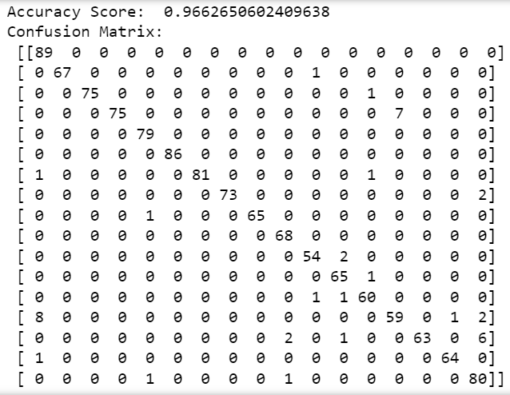

**Case 10:**

Epoch 1/20

94/94 [==============================] - 15s 105ms/step - loss: 2.5150 - accuracy: 0.6309 - val_loss: 0.4790 - val_accuracy: 0.8474

Epoch 2/20

94/94 [==============================] - 10s 103ms/step - loss: 1.6748 - accuracy: 0.7914 - val_loss: 0.3392 - val_accuracy: 0.9157

Epoch 3/20

94/94 [==============================] - 9s 94ms/step - loss: 1.2498 - accuracy: 0.8295 - val_loss: 0.2589 - val_accuracy: 0.9371

Epoch 4/20

94/94 [==============================] - 11s 114ms/step - loss: 1.1339 - accuracy: 0.8272 - val_loss: 0.2916 - val_accuracy: 0.9197

Epoch 5/20

94/94 [==============================] - 9s 98ms/step - loss: 1.0527 - accuracy: 0.8285 - val_loss: 0.2076 - val_accuracy: 0.9465

Epoch 6/20

94/94 [==============================] - 9s 100ms/step - loss: 0.8366 - accuracy: 0.8583 - val_loss: 0.1926 - val_accuracy: 0.9585

Epoch 7/20

94/94 [==============================] - 10s 108ms/step - loss: 0.7578 - accuracy: 0.8617 - val_loss: 0.2247 - val_accuracy: 0.9545

Epoch 8/20

94/94 [==============================] - 9s 93ms/step - loss: 0.7216 - accuracy: 0.8587 - val_loss: 0.1514 - val_accuracy: 0.9679

Epoch 9/20

94/94 [==============================] - 9s 98ms/step - loss: 0.5230 - accuracy: 0.8845 - val_loss: 0.1523 - val_accuracy: 0.9772

Epoch 10/20

94/94 [==============================] - 9s 96ms/step - loss: 0.5327 - accuracy: 0.8781 - val_loss: 0.2405 - val_accuracy: 0.9572

Epoch 11/20

94/94 [==============================] - 11s 113ms/step - loss: 0.6293 - accuracy: 0.8610 - val_loss: 0.1561 - val_accuracy: 0.9746

Epoch 12/20

94/94 [==============================] - 10s 103ms/step - loss: 0.4141 - accuracy: 0.8908 - val_loss: 0.1454 - val_accuracy: 0.9759

Epoch 13/20

94/94 [==============================] - 10s 107ms/step - loss: 0.4602 - accuracy: 0.8875 - val_loss: 0.3264 - val_accuracy: 0.9545

Epoch 14/20

94/94 [==============================] - 10s 104ms/step - loss: 0.4796 - accuracy: 0.8804 - val_loss: 0.0875 - val_accuracy: 0.9853

Epoch 15/20

94/94 [==============================] - 11s 112ms/step - loss: 0.4526 - accuracy: 0.8808 - val_loss: 0.1120 - val_accuracy: 0.9866

Epoch 16/20

94/94 [==============================] - 9s 94ms/step - loss: 0.4127 - accuracy: 0.8918 - val_loss: 0.2309 - val_accuracy: 0.9665

Epoch 17/20

94/94 [==============================] - 10s 110ms/step - loss: 0.4366 - accuracy: 0.8835 - val_loss: 0.2061 - val_accuracy: 0.9759

Epoch 18/20

94/94 [==============================] - 9s 98ms/step - loss: 0.4007 - accuracy: 0.8952 - val_loss: 0.1349 - val_accuracy: 0.9746

Epoch 19/20

94/94 [==============================] - 9s 94ms/step - loss: 0.4589 - accuracy: 0.8758 - val_loss: 0.3538 - val_accuracy: 0.9572

Epoch 20/20

94/94 [==============================] - 9s 97ms/step - loss: 0.5812 - accuracy: 0.8691 - val_loss: 0.1297 - val_accuracy: 0.9759

39/39 - 2s - loss: 0.1513 - accuracy: 0.9743 - 2s/epoch - 44ms/step

Test accuracy: 0.9742971658706665

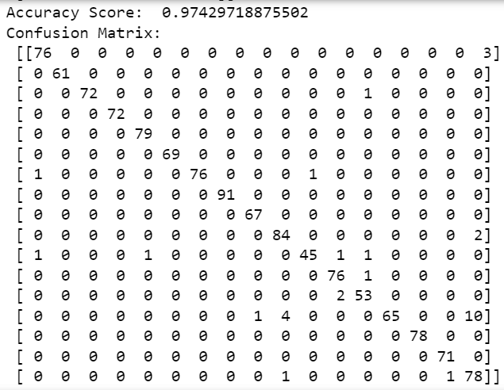

**Case 11:**

Epoch 1/20

94/94 [==============================] - 13s 102ms/step - loss: 3.9236 - accuracy: 0.4876 - val_loss: 0.5602 - val_accuracy: 0.8273

Epoch 2/20

94/94 [==============================] - 10s 108ms/step - loss: 2.5140 - accuracy: 0.7050 - val_loss: 0.4470 - val_accuracy: 0.8715

Epoch 3/20

94/94 [==============================] - 9s 96ms/step - loss: 2.1201 - accuracy: 0.6966 - val_loss: 0.4332 - val_accuracy: 0.9036

Epoch 4/20

94/94 [==============================] - 9s 90ms/step - loss: 1.6504 - accuracy: 0.7321 - val_loss: 0.3099 - val_accuracy: 0.9304

Epoch 5/20

94/94 [==============================] - 10s 107ms/step - loss: 1.2640 - accuracy: 0.7545 - val_loss: 0.5925 - val_accuracy: 0.8862

Epoch 6/20

94/94 [==============================] - 10s 107ms/step - loss: 1.6382 - accuracy: 0.7251 - val_loss: 0.3575 - val_accuracy: 0.9478

Epoch 7/20

94/94 [==============================] - 10s 110ms/step - loss: 1.1080 - accuracy: 0.7659 - val_loss: 0.2892 - val_accuracy: 0.9625

Epoch 8/20

94/94 [==============================] - 9s 100ms/step - loss: 0.9180 - accuracy: 0.7800 - val_loss: 0.6050 - val_accuracy: 0.9170

Epoch 9/20

94/94 [==============================] - 9s 100ms/step - loss: 1.1891 - accuracy: 0.7522 - val_loss: 1.1144 - val_accuracy: 0.8969

Epoch 10/20

94/94 [==============================] - 10s 106ms/step - loss: 1.3152 - accuracy: 0.7478 - val_loss: 1.3051 - val_accuracy: 0.8581

Epoch 11/20

94/94 [==============================] - 10s 107ms/step - loss: 1.4352 - accuracy: 0.7465 - val_loss: 0.3111 - val_accuracy: 0.9411

Epoch 12/20

94/94 [==============================] - 9s 95ms/step - loss: 1.4043 - accuracy: 0.7344 - val_loss: 0.8020 - val_accuracy: 0.8728

Epoch 13/20

94/94 [==============================] - 9s 94ms/step - loss: 1.2315 - accuracy: 0.7589 - val_loss: 0.3552 - val_accuracy: 0.9451

Epoch 14/20

94/94 [==============================] - 9s 95ms/step - loss: 1.0539 - accuracy: 0.7622 - val_loss: 0.3207 - val_accuracy: 0.9518

Epoch 15/20

94/94 [==============================] - 9s 94ms/step - loss: 0.8985 - accuracy: 0.7820 - val_loss: 0.2978 - val_accuracy: 0.9585

Epoch 16/20

94/94 [==============================] - 9s 96ms/step - loss: 0.8414 - accuracy: 0.7763 - val_loss: 0.2409 - val_accuracy: 0.9679

Epoch 17/20

94/94 [==============================] - 9s 95ms/step - loss: 0.7589 - accuracy: 0.7907 - val_loss: 0.3140 - val_accuracy: 0.9625

Epoch 18/20

94/94 [==============================] - 9s 96ms/step - loss: 0.7309 - accuracy: 0.7914 - val_loss: 0.3320 - val_accuracy: 0.9652

Epoch 19/20

94/94 [==============================] - 9s 95ms/step - loss: 0.7655 - accuracy: 0.7883 - val_loss: 0.3576 - val_accuracy: 0.9545

Epoch 20/20

94/94 [==============================] - 9s 94ms/step - loss: 0.7259 - accuracy: 0.7954 - val_loss: 0.2285 - val_accuracy: 0.9786

39/39 - 2s - loss: 0.2418 - accuracy: 0.9735 - 2s/epoch - 43ms/step

Test accuracy: 0.9734939932823181

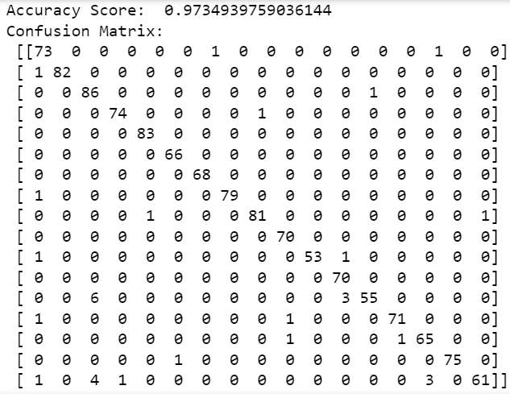

**Case 12:**

Epoch 1/20

94/94 [==============================] - 31s 212ms/step - loss: 1.5946 - accuracy: 0.4900 - val_loss: 0.9445 - val_accuracy: 0.6867

Epoch 2/20

94/94 [==============================] - 16s 165ms/step - loss: 0.6540 - accuracy: 0.7847 - val_loss: 0.6287 - val_accuracy: 0.8005

Epoch 3/20

94/94 [==============================] - 16s 174ms/step - loss: 0.4938 - accuracy: 0.8436 - val_loss: 0.4262 - val_accuracy: 0.8675

Epoch 4/20

94/94 [==============================] - 17s 185ms/step - loss: 0.4209 - accuracy: 0.8644 - val_loss: 0.5141 - val_accuracy: 0.8407

Epoch 5/20

94/94 [==============================] - 16s 169ms/step - loss: 0.2906 - accuracy: 0.9173 - val_loss: 0.2592 - val_accuracy: 0.9438

Epoch 6/20

94/94 [==============================] - 16s 171ms/step - loss: 0.1713 - accuracy: 0.9511 - val_loss: 0.2683 - val_accuracy: 0.9237

Epoch 7/20

94/94 [==============================] - 15s 155ms/step - loss: 0.1623 - accuracy: 0.9531 - val_loss: 0.2072 - val_accuracy: 0.9371

Epoch 8/20

94/94 [==============================] - 14s 152ms/step - loss: 0.1344 - accuracy: 0.9605 - val_loss: 0.3433 - val_accuracy: 0.8822

Epoch 9/20

94/94 [==============================] - 16s 167ms/step - loss: 0.1848 - accuracy: 0.9474 - val_loss: 0.2034 - val_accuracy: 0.9652

Epoch 10/20

94/94 [==============================] - 15s 162ms/step - loss: 0.0644 - accuracy: 0.9829 - val_loss: 0.1433 - val_accuracy: 0.9625

Epoch 11/20

94/94 [==============================] - 17s 185ms/step - loss: 0.0480 - accuracy: 0.9866 - val_loss: 0.1099 - val_accuracy: 0.9786

Epoch 12/20

94/94 [==============================] - 18s 190ms/step - loss: 0.0636 - accuracy: 0.9829 - val_loss: 0.1458 - val_accuracy: 0.9746

Epoch 13/20

94/94 [==============================] - 18s 195ms/step - loss: 0.0913 - accuracy: 0.9752 - val_loss: 0.1593 - val_accuracy: 0.9679

Epoch 14/20

94/94 [==============================] - 16s 171ms/step - loss: 0.1300 - accuracy: 0.9675 - val_loss: 0.1717 - val_accuracy: 0.9572

Epoch 15/20

94/94 [==============================] - 17s 183ms/step - loss: 0.0785 - accuracy: 0.9769 - val_loss: 0.1343 - val_accuracy: 0.9705

Epoch 16/20

94/94 [==============================] - 16s 169ms/step - loss: 0.0267 - accuracy: 0.9943 - val_loss: 0.1272 - val_accuracy: 0.9786

Epoch 17/20

94/94 [==============================] - 16s 170ms/step - loss: 0.1630 - accuracy: 0.9541 - val_loss: 0.2145 - val_accuracy: 0.9558

Epoch 18/20

94/94 [==============================] - 15s 164ms/step - loss: 0.1950 - accuracy: 0.9591 - val_loss: 0.1422 - val_accuracy: 0.9719

Epoch 19/20

94/94 [==============================] - 17s 178ms/step - loss: 0.1158 - accuracy: 0.9705 - val_loss: 0.1377 - val_accuracy: 0.9719

Epoch 20/20

94/94 [==============================] - 16s 173ms/step - loss: 0.0550 - accuracy: 0.9869 - val_loss: 0.2459 - val_accuracy: 0.9545

39/39 - 2s - loss: 0.1170 - accuracy: 0.9703 - 2s/epoch - 53ms/step

Test accuracy: 0.9702811241149902

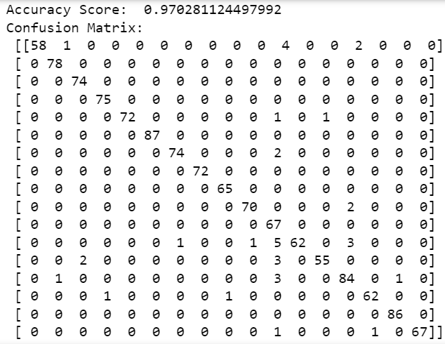

**Case 13:**

Epoch 1/20

94/94 [==============================] - 26s 192ms/step - loss: 2.1023 - accuracy: 0.5512 - val_loss: 0.6799 - val_accuracy: 0.8233

Epoch 2/20

94/94 [==============================] - 16s 172ms/step - loss: 1.1003 - accuracy: 0.8178 - val_loss: 0.3162 - val_accuracy: 0.9050

Epoch 3/20

94/94 [==============================] - 18s 187ms/step - loss: 1.0296 - accuracy: 0.8336 - val_loss: 0.5827 - val_accuracy: 0.8220

Epoch 4/20

94/94 [==============================] - 19s 202ms/step - loss: 1.3362 - accuracy: 0.7686 - val_loss: 0.4491 - val_accuracy: 0.8474

Epoch 5/20

94/94 [==============================] - 18s 194ms/step - loss: 0.7625 - accuracy: 0.8764 - val_loss: 0.2278 - val_accuracy: 0.9331

Epoch 6/20

94/94 [==============================] - 16s 171ms/step - loss: 0.6592 - accuracy: 0.8965 - val_loss: 0.1967 - val_accuracy: 0.9424

Epoch 7/20

94/94 [==============================] - 17s 185ms/step - loss: 0.6495 - accuracy: 0.9002 - val_loss: 0.2162 - val_accuracy: 0.9451

Epoch 8/20

94/94 [==============================] - 17s 182ms/step - loss: 0.5641 - accuracy: 0.9102 - val_loss: 0.1502 - val_accuracy: 0.9545

Epoch 9/20

94/94 [==============================] - 18s 192ms/step - loss: 0.6489 - accuracy: 0.8935 - val_loss: 0.3223 - val_accuracy: 0.9411

Epoch 10/20

94/94 [==============================] - 18s 193ms/step - loss: 0.6657 - accuracy: 0.8858 - val_loss: 0.5750 - val_accuracy: 0.8849

Epoch 11/20

94/94 [==============================] - 18s 189ms/step - loss: 0.7899 - accuracy: 0.8741 - val_loss: 0.3720 - val_accuracy: 0.9277

Epoch 12/20

94/94 [==============================] - 17s 184ms/step - loss: 0.5190 - accuracy: 0.9149 - val_loss: 0.1345 - val_accuracy: 0.9679

Epoch 13/20

94/94 [==============================] - 16s 175ms/step - loss: 0.3865 - accuracy: 0.9270 - val_loss: 0.1993 - val_accuracy: 0.9692

Epoch 14/20

94/94 [==============================] - 18s 187ms/step - loss: 0.6373 - accuracy: 0.8891 - val_loss: 0.3870 - val_accuracy: 0.8929

Epoch 15/20

94/94 [==============================] - 17s 185ms/step - loss: 0.4185 - accuracy: 0.9183 - val_loss: 0.2131 - val_accuracy: 0.9612

Epoch 16/20

94/94 [==============================] - 17s 180ms/step - loss: 0.3637 - accuracy: 0.9277 - val_loss: 0.2364 - val_accuracy: 0.9598

Epoch 17/20

94/94 [==============================] - 17s 179ms/step - loss: 0.3605 - accuracy: 0.9243 - val_loss: 0.1148 - val_accuracy: 0.9799

Epoch 18/20

94/94 [==============================] - 17s 180ms/step - loss: 0.2829 - accuracy: 0.9290 - val_loss: 0.1892 - val_accuracy: 0.9679

Epoch 19/20

94/94 [==============================] - 17s 180ms/step - loss: 0.4129 - accuracy: 0.9173 - val_loss: 0.1521 - val_accuracy: 0.9679

Epoch 20/20

94/94 [==============================] - 18s 194ms/step - loss: 0.4055 - accuracy: 0.9169 - val_loss: 0.1318 - val_accuracy: 0.9799

39/39 - 3s - loss: 0.1124 - accuracy: 0.9791 - 3s/epoch - 82ms/step

Test accuracy: 0.9791164398193359

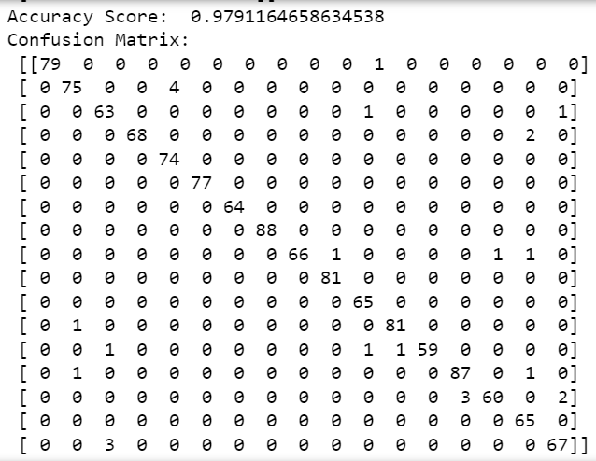

**Case 14:**

Epoch 1/20

94/94 [==============================] - 33s 247ms/step - loss: 2.9202 - accuracy: 0.4722 - val_loss: 1.1176 - val_accuracy: 0.6466

Epoch 2/20

94/94 [==============================] - 19s 206ms/step - loss: 1.8697 - accuracy: 0.7083 - val_loss: 0.5905 - val_accuracy: 0.8072

Epoch 3/20

94/94 [==============================] - 20s 209ms/step - loss: 1.5781 - accuracy: 0.7482 - val_loss: 0.5606 - val_accuracy: 0.8220

Epoch 4/20

94/94 [==============================] - 18s 189ms/step - loss: 1.4246 - accuracy: 0.7786 - val_loss: 0.6436 - val_accuracy: 0.8099

Epoch 5/20

94/94 [==============================] - 19s 200ms/step - loss: 1.2680 - accuracy: 0.8048 - val_loss: 0.3034 - val_accuracy: 0.9076

Epoch 6/20

94/94 [==============================] - 20s 209ms/step - loss: 1.3483 - accuracy: 0.7783 - val_loss: 0.4994 - val_accuracy: 0.8166

Epoch 7/20

94/94 [==============================] - 22s 229ms/step - loss: 1.3516 - accuracy: 0.7907 - val_loss: 0.4002 - val_accuracy: 0.8942

Epoch 8/20

94/94 [==============================] - 21s 223ms/step - loss: 1.0210 - accuracy: 0.8299 - val_loss: 0.4398 - val_accuracy: 0.8822

Epoch 9/20

94/94 [==============================] - 20s 214ms/step - loss: 0.7568 - accuracy: 0.8640 - val_loss: 0.1401 - val_accuracy: 0.9665

Epoch 10/20

94/94 [==============================] - 23s 245ms/step - loss: 0.8385 - accuracy: 0.8630 - val_loss: 0.7492 - val_accuracy: 0.8849

Epoch 11/20

94/94 [==============================] - 22s 236ms/step - loss: 0.9657 - accuracy: 0.8228 - val_loss: 0.2029 - val_accuracy: 0.9491

Epoch 12/20

94/94 [==============================] - 19s 200ms/step - loss: 0.7573 - accuracy: 0.8540 - val_loss: 0.7371 - val_accuracy: 0.9130

Epoch 13/20

94/94 [==============================] - 22s 230ms/step - loss: 0.8247 - accuracy: 0.8493 - val_loss: 0.2521 - val_accuracy: 0.9344

Epoch 14/20

94/94 [==============================] - 19s 202ms/step - loss: 0.7702 - accuracy: 0.8577 - val_loss: 0.2257 - val_accuracy: 0.9545

Epoch 15/20

94/94 [==============================] - 19s 201ms/step - loss: 0.6942 - accuracy: 0.8557 - val_loss: 0.1984 - val_accuracy: 0.9585

Epoch 16/20

94/94 [==============================] - 23s 239ms/step - loss: 0.6984 - accuracy: 0.8674 - val_loss: 0.1923 - val_accuracy: 0.9639

Epoch 17/20

94/94 [==============================] - 21s 224ms/step - loss: 1.1598 - accuracy: 0.7991 - val_loss: 0.4531 - val_accuracy: 0.9076

Epoch 18/20

94/94 [==============================] - 20s 208ms/step - loss: 0.8669 - accuracy: 0.8382 - val_loss: 0.3499 - val_accuracy: 0.9371

Epoch 19/20

94/94 [==============================] - 18s 189ms/step - loss: 0.7558 - accuracy: 0.8634 - val_loss: 0.3168 - val_accuracy: 0.9237

Epoch 20/20

94/94 [==============================] - 18s 192ms/step - loss: 0.8074 - accuracy: 0.8500 - val_loss: 0.3464 - val_accuracy: 0.9424

39/39 - 3s - loss: 0.5245 - accuracy: 0.9277 - 3s/epoch - 69ms/step

Test accuracy: 0.9277108311653137

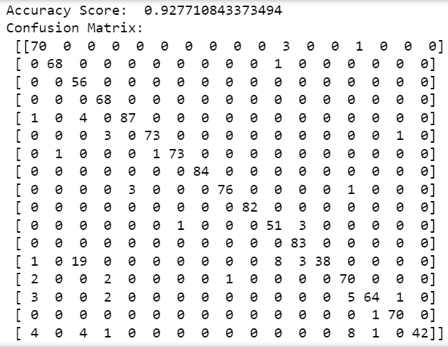

**Case 15:**

Epoch 1/20

94/94 [==============================] - 33s 234ms/step - loss: 4.2577 - accuracy: 0.4792 - val_loss: 0.9651 - val_accuracy: 0.6586

Epoch 2/20

94/94 [==============================] - 17s 183ms/step - loss: 3.0773 - accuracy: 0.6423 - val_loss: 0.7017 - val_accuracy: 0.8394

Epoch 3/20

94/94 [==============================] - 15s 163ms/step - loss: 2.7119 - accuracy: 0.6661 - val_loss: 0.4339 - val_accuracy: 0.9130

Epoch 4/20

94/94 [==============================] - 16s 169ms/step - loss: 2.1041 - accuracy: 0.6959 - val_loss: 2.3303 - val_accuracy: 0.7015

Epoch 5/20

94/94 [==============================] - 17s 184ms/step - loss: 2.8441 - accuracy: 0.6303 - val_loss: 0.6534 - val_accuracy: 0.8621

Epoch 6/20

94/94 [==============================] - 20s 209ms/step - loss: 1.8896 - accuracy: 0.7184 - val_loss: 0.6408 - val_accuracy: 0.8996

Epoch 7/20

94/94 [==============================] - 18s 194ms/step - loss: 2.1221 - accuracy: 0.6986 - val_loss: 0.5142 - val_accuracy: 0.9143

Epoch 8/20

94/94 [==============================] - 20s 210ms/step - loss: 1.8107 - accuracy: 0.7247 - val_loss: 0.6097 - val_accuracy: 0.9143

Epoch 9/20

94/94 [==============================] - 18s 192ms/step - loss: 1.3148 - accuracy: 0.7579 - val_loss: 0.7243 - val_accuracy: 0.9116

Epoch 10/20

94/94 [==============================] - 19s 198ms/step - loss: 1.3973 - accuracy: 0.7398 - val_loss: 0.4681 - val_accuracy: 0.9451

Epoch 11/20

94/94 [==============================] - 21s 229ms/step - loss: 1.0965 - accuracy: 0.7696 - val_loss: 0.4376 - val_accuracy: 0.9531

Epoch 12/20

94/94 [==============================] - 20s 217ms/step - loss: 1.1813 - accuracy: 0.7609 - val_loss: 1.0539 - val_accuracy: 0.9050

Epoch 13/20

94/94 [==============================] - 21s 229ms/step - loss: 1.1561 - accuracy: 0.7612 - val_loss: 0.3928 - val_accuracy: 0.9545

Epoch 14/20

94/94 [==============================] - 26s 275ms/step - loss: 1.0010 - accuracy: 0.7642 - val_loss: 0.4236 - val_accuracy: 0.9545

Epoch 15/20

94/94 [==============================] - 26s 282ms/step - loss: 0.9086 - accuracy: 0.7770 - val_loss: 0.8189 - val_accuracy: 0.9183

Epoch 16/20

94/94 [==============================] - 21s 222ms/step - loss: 1.0263 - accuracy: 0.7723 - val_loss: 0.4269 - val_accuracy: 0.9558

Epoch 17/20

94/94 [==============================] - 18s 195ms/step - loss: 2.1055 - accuracy: 0.6979 - val_loss: 0.6982 - val_accuracy: 0.8902

Epoch 18/20

94/94 [==============================] - 18s 190ms/step - loss: 1.6456 - accuracy: 0.7234 - val_loss: 1.3971 - val_accuracy: 0.8715

Epoch 19/20

94/94 [==============================] - 19s 202ms/step - loss: 1.5341 - accuracy: 0.7328 - val_loss: 0.9966 - val_accuracy: 0.8835

Epoch 20/20

94/94 [==============================] - 18s 195ms/step - loss: 1.2915 - accuracy: 0.7582 - val_loss: 0.4990 - val_accuracy: 0.9357

39/39 - 2s - loss: 0.5106 - accuracy: 0.9398 - 2s/epoch - 63ms/step

Test accuracy: 0.9397590160369873

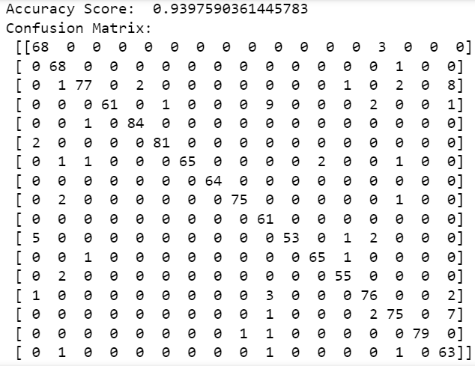

**Case 16:**

Epoch 1/20

94/94 [==============================] - 30s 224ms/step - loss: 2.2241 - accuracy: 0.4725 - val_loss: 0.7464 - val_accuracy: 0.7671

Epoch 2/20

94/94 [==============================] - 20s 213ms/step - loss: 1.3101 - accuracy: 0.7522 - val_loss: 0.4544 - val_accuracy: 0.8541

Epoch 3/20

94/94 [==============================] - 20s 211ms/step - loss: 1.1250 - accuracy: 0.8182 - val_loss: 0.2709 - val_accuracy: 0.9090

Epoch 4/20

94/94 [==============================] - 21s 221ms/step - loss: 0.8965 - accuracy: 0.8476 - val_loss: 0.3504 - val_accuracy: 0.8996

Epoch 5/20

94/94 [==============================] - 19s 205ms/step - loss: 0.6678 - accuracy: 0.8868 - val_loss: 0.1710 - val_accuracy: 0.9612

Epoch 6/20

94/94 [==============================] - 20s 209ms/step - loss: 0.6666 - accuracy: 0.8962 - val_loss: 0.2485 - val_accuracy: 0.9398

Epoch 7/20

94/94 [==============================] - 21s 221ms/step - loss: 0.5653 - accuracy: 0.9029 - val_loss: 0.3076 - val_accuracy: 0.9250

Epoch 8/20

94/94 [==============================] - 22s 238ms/step - loss: 0.6483 - accuracy: 0.8972 - val_loss: 0.1797 - val_accuracy: 0.9612

Epoch 9/20

94/94 [==============================] - 22s 239ms/step - loss: 0.5123 - accuracy: 0.9143 - val_loss: 0.4697 - val_accuracy: 0.9197

Epoch 10/20

94/94 [==============================] - 20s 218ms/step - loss: 0.5937 - accuracy: 0.8922 - val_loss: 0.3845 - val_accuracy: 0.8782

Epoch 11/20

94/94 [==============================] - 20s 215ms/step - loss: 0.6095 - accuracy: 0.8955 - val_loss: 0.2871 - val_accuracy: 0.9505

Epoch 12/20

94/94 [==============================] - 21s 218ms/step - loss: 0.3527 - accuracy: 0.9273 - val_loss: 0.1891 - val_accuracy: 0.9679

Epoch 13/20

94/94 [==============================] - 24s 250ms/step - loss: 0.3711 - accuracy: 0.9283 - val_loss: 0.1226 - val_accuracy: 0.9719

Epoch 14/20

94/94 [==============================] - 24s 261ms/step - loss: 0.3405 - accuracy: 0.9270 - val_loss: 0.1128 - val_accuracy: 0.9732

Epoch 15/20

94/94 [==============================] - 22s 232ms/step - loss: 0.6204 - accuracy: 0.9086 - val_loss: 0.2609 - val_accuracy: 0.9491

Epoch 16/20

94/94 [==============================] - 19s 205ms/step - loss: 0.3927 - accuracy: 0.9203 - val_loss: 0.2296 - val_accuracy: 0.9639

Epoch 17/20

94/94 [==============================] - 18s 193ms/step - loss: 0.4068 - accuracy: 0.9220 - val_loss: 0.3381 - val_accuracy: 0.9558

Epoch 18/20

94/94 [==============================] - 22s 233ms/step - loss: 0.3571 - accuracy: 0.9226 - val_loss: 0.1201 - val_accuracy: 0.9772

Epoch 19/20

94/94 [==============================] - 21s 225ms/step - loss: 0.2522 - accuracy: 0.9397 - val_loss: 0.2197 - val_accuracy: 0.9813

Epoch 20/20

94/94 [==============================] - 20s 210ms/step - loss: 0.4131 - accuracy: 0.9226 - val_loss: 0.7323 - val_accuracy: 0.9050

39/39 - 3s - loss: 0.6118 - accuracy: 0.9229 - 3s/epoch - 65ms/step

Test accuracy: 0.9228915572166443

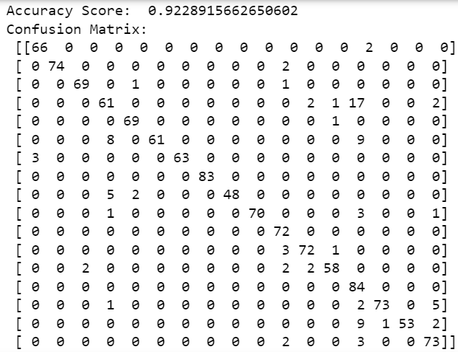

**Case 17:**

Epoch 1/20

94/94 [==============================] - 30s 228ms/step - loss: 2.8748 - accuracy: 0.4933 - val_loss: 0.7264 - val_accuracy: 0.7497

Epoch 2/20

94/94 [==============================] - 19s 202ms/step - loss: 1.9316 - accuracy: 0.7197 - val_loss: 0.5554 - val_accuracy: 0.8367

Epoch 3/20

94/94 [==============================] - 18s 188ms/step - loss: 1.6052 - accuracy: 0.7686 - val_loss: 0.9924 - val_accuracy: 0.7537

Epoch 4/20

94/94 [==============================] - 19s 197ms/step - loss: 1.4448 - accuracy: 0.7960 - val_loss: 0.4751 - val_accuracy: 0.8849

Epoch 5/20

94/94 [==============================] - 22s 239ms/step - loss: 1.1329 - accuracy: 0.8319 - val_loss: 0.3000 - val_accuracy: 0.9384

Epoch 6/20

94/94 [==============================] - 23s 245ms/step - loss: 1.1559 - accuracy: 0.8302 - val_loss: 0.2649 - val_accuracy: 0.9478

Epoch 7/20

94/94 [==============================] - 24s 251ms/step - loss: 1.0799 - accuracy: 0.8255 - val_loss: 0.4989 - val_accuracy: 0.8956

Epoch 8/20

94/94 [==============================] - 21s 228ms/step - loss: 1.0397 - accuracy: 0.8449 - val_loss: 0.2491 - val_accuracy: 0.9518

Epoch 9/20

94/94 [==============================] - 21s 229ms/step - loss: 0.8461 - accuracy: 0.8634 - val_loss: 0.5747 - val_accuracy: 0.9331

Epoch 10/20

94/94 [==============================] - 21s 225ms/step - loss: 0.6395 - accuracy: 0.8674 - val_loss: 0.0897 - val_accuracy: 0.9826

Epoch 11/20

94/94 [==============================] - 23s 240ms/step - loss: 0.4779 - accuracy: 0.8875 - val_loss: 0.4431 - val_accuracy: 0.9478

Epoch 12/20

94/94 [==============================] - 18s 190ms/step - loss: 0.7862 - accuracy: 0.8510 - val_loss: 0.2400 - val_accuracy: 0.9705

Epoch 13/20

94/94 [==============================] - 17s 182ms/step - loss: 0.6411 - accuracy: 0.8758 - val_loss: 0.4795 - val_accuracy: 0.9197

Epoch 14/20

94/94 [==============================] - 17s 184ms/step - loss: 0.7139 - accuracy: 0.8664 - val_loss: 0.1619 - val_accuracy: 0.9759

Epoch 15/20

94/94 [==============================] - 18s 187ms/step - loss: 0.7339 - accuracy: 0.8543 - val_loss: 0.5561 - val_accuracy: 0.9224

Epoch 16/20

94/94 [==============================] - 17s 180ms/step - loss: 0.7935 - accuracy: 0.8439 - val_loss: 0.2515 - val_accuracy: 0.9679

Epoch 17/20

94/94 [==============================] - 17s 185ms/step - loss: 0.6167 - accuracy: 0.8731 - val_loss: 0.1577 - val_accuracy: 0.9759

Epoch 18/20

94/94 [==============================] - 21s 225ms/step - loss: 0.4860 - accuracy: 0.8912 - val_loss: 0.4649 - val_accuracy: 0.9518

Epoch 19/20

94/94 [==============================] - 20s 213ms/step - loss: 0.5715 - accuracy: 0.8741 - val_loss: 0.3420 - val_accuracy: 0.9572

Epoch 20/20

94/94 [==============================] - 19s 197ms/step - loss: 0.5305 - accuracy: 0.8838 - val_loss: 0.5570 - val_accuracy: 0.9451

39/39 - 3s - loss: 0.4586 - accuracy: 0.9574 - 3s/epoch - 66ms/step

Test accuracy: 0.9574297070503235

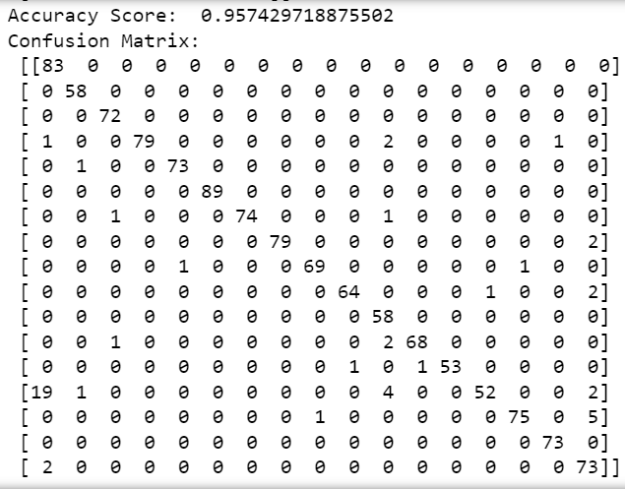

**Case 18:**

Epoch 1/20

94/94 [==============================] - 31s 229ms/step - loss: 3.9505 - accuracy: 0.4699 - val_loss: 1.0950 - val_accuracy: 0.6252

Epoch 2/20

94/94 [==============================] - 20s 207ms/step - loss: 3.0074 - accuracy: 0.5968 - val_loss: 0.7375 - val_accuracy: 0.7537

Epoch 3/20

94/94 [==============================] - 17s 181ms/step - loss: 2.5845 - accuracy: 0.6460 - val_loss: 1.0579 - val_accuracy: 0.7483

Epoch 4/20

94/94 [==============================] - 19s 197ms/step - loss: 2.2592 - accuracy: 0.6621 - val_loss: 1.0352 - val_accuracy: 0.7510

Epoch 5/20

94/94 [==============================] - 18s 192ms/step - loss: 2.0225 - accuracy: 0.6842 - val_loss: 0.7042 - val_accuracy: 0.8501

Epoch 6/20

94/94 [==============================] - 18s 188ms/step - loss: 1.9707 - accuracy: 0.6919 - val_loss: 0.7237 - val_accuracy: 0.8461

Epoch 7/20

94/94 [==============================] - 17s 185ms/step - loss: 1.8804 - accuracy: 0.7063 - val_loss: 0.8869 - val_accuracy: 0.8246

Epoch 8/20

94/94 [==============================] - 18s 186ms/step - loss: 1.8136 - accuracy: 0.7083 - val_loss: 0.5086 - val_accuracy: 0.8876

Epoch 9/20

94/94 [==============================] - 18s 196ms/step - loss: 1.7534 - accuracy: 0.7157 - val_loss: 1.0551 - val_accuracy: 0.8179

Epoch 10/20

94/94 [==============================] - 19s 197ms/step - loss: 1.9293 - accuracy: 0.7093 - val_loss: 0.6338 - val_accuracy: 0.8942

Epoch 11/20

94/94 [==============================] - 18s 197ms/step - loss: 1.5694 - accuracy: 0.7415 - val_loss: 0.5929 - val_accuracy: 0.9116

Epoch 12/20

94/94 [==============================] - 18s 194ms/step - loss: 1.7513 - accuracy: 0.7204 - val_loss: 0.7671 - val_accuracy: 0.9063

Epoch 13/20

94/94 [==============================] - 17s 183ms/step - loss: 1.7898 - accuracy: 0.7103 - val_loss: 0.6848 - val_accuracy: 0.8487

Epoch 14/20

94/94 [==============================] - 17s 182ms/step - loss: 1.4745 - accuracy: 0.7328 - val_loss: 0.4634 - val_accuracy: 0.9009

Epoch 15/20

94/94 [==============================] - 17s 181ms/step - loss: 1.2622 - accuracy: 0.7599 - val_loss: 0.3702 - val_accuracy: 0.9585

Epoch 16/20

94/94 [==============================] - 18s 188ms/step - loss: 1.3019 - accuracy: 0.7522 - val_loss: 0.3770 - val_accuracy: 0.9585

Epoch 17/20

94/94 [==============================] - 17s 182ms/step - loss: 1.2194 - accuracy: 0.7495 - val_loss: 0.4495 - val_accuracy: 0.9465

Epoch 18/20

94/94 [==============================] - 18s 190ms/step - loss: 1.0718 - accuracy: 0.7713 - val_loss: 0.7666 - val_accuracy: 0.9197

Epoch 19/20

94/94 [==============================] - 18s 194ms/step - loss: 1.1599 - accuracy: 0.7646 - val_loss: 1.6133 - val_accuracy: 0.8621

Epoch 20/20

94/94 [==============================] - 18s 190ms/step - loss: 1.2139 - accuracy: 0.7612 - val_loss: 1.7371 - val_accuracy: 0.8541

39/39 - 2s - loss: 1.8306 - accuracy: 0.8578 - 2s/epoch - 62ms/step

Test accuracy: 0.8578312993049622

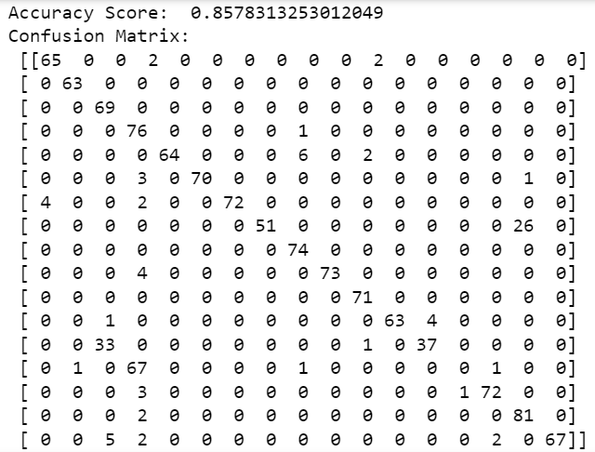

**INFERENCES FOR RNN-LSTM:**

The following inferences can be made from the above obtained results:

* Number of layers in the network is inversely proportional to the accuracy.
* The accuracy for the most model variations is highest when there is no dropout value

1. **DEEP BELIEF NETWORK**

**FEATURE EXTRACTION METHOD**

**CODE:**

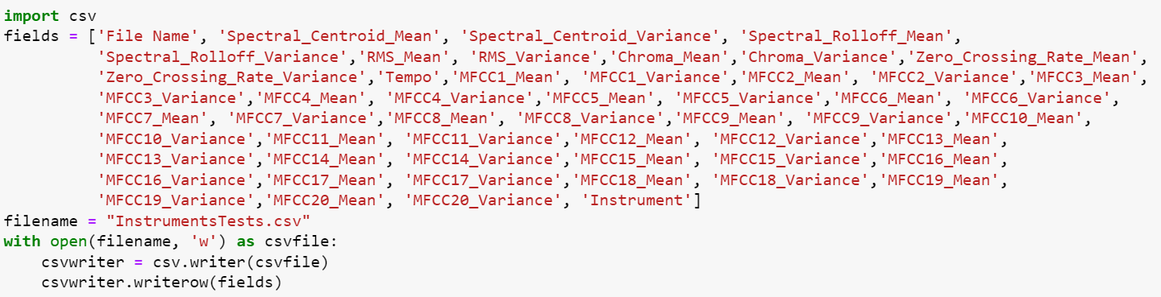

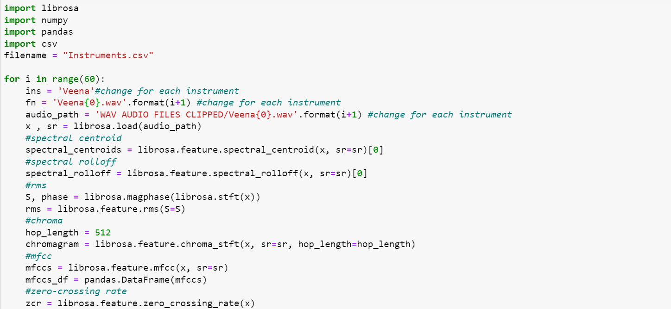

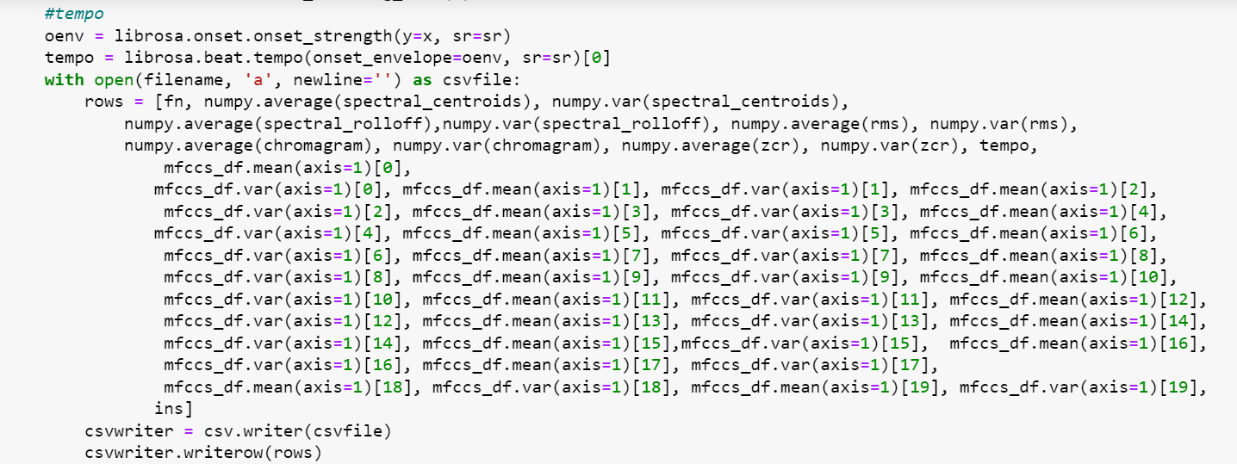

**OUTPUT:** [CSV file](https://drive.google.com/file/d/1uqvTcXq3tCAfHBZcjn1yLGEh2RNpX7XY/view?usp=sharing) is generated with 51 features, target label and audio sample filename**.**

**METHODOLOGY**

Deep Belief Network (DBN), a powerful generative model that uses a deep architecture of multiple stacks of Restricted Boltzmann machines(RBM) is used for musical instrument classification.51 features such as Mel Frequency Cepstral Coefficients (MFCC), Tempo, Zero Crossing Rate, Spectral Centroid, Spectral Roll-off, RMS, Chroma and their corresponding means and variances are extracted from the audio samples and stored in a CSV file along with the file name of the audio sample. The target i.e the instrument name is annotated for each audio sample.

The obtained features are then scaled and the target, which is the name of the instrument, is integer coded. The dataset is split into train and test sets. Several Deep Belief Networks are built by tuning the hyperparameters such as number of layers, number of Restricted Boltzmann Machines (RBMs) and dropouts. The network is trained and tested over the dataset and accuracy and confusion matrix is obtained.

**BLOCK DIAGRAM**

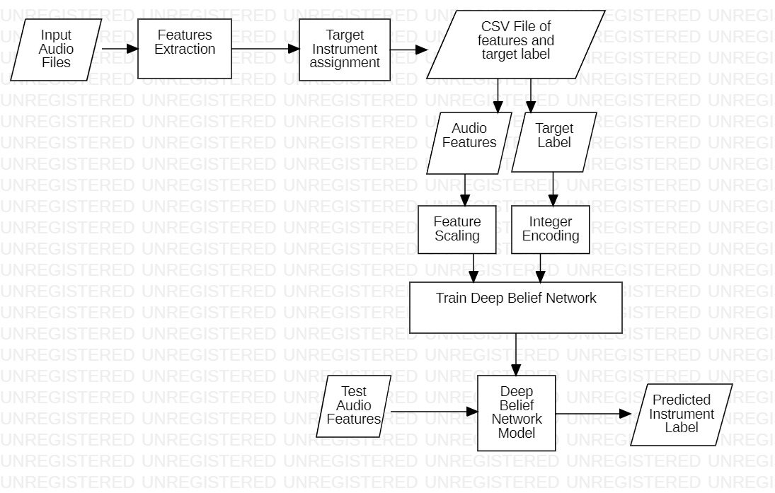

**IMPLEMENTATION CODE**

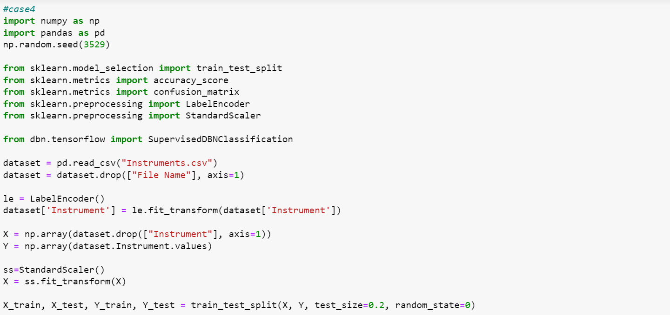

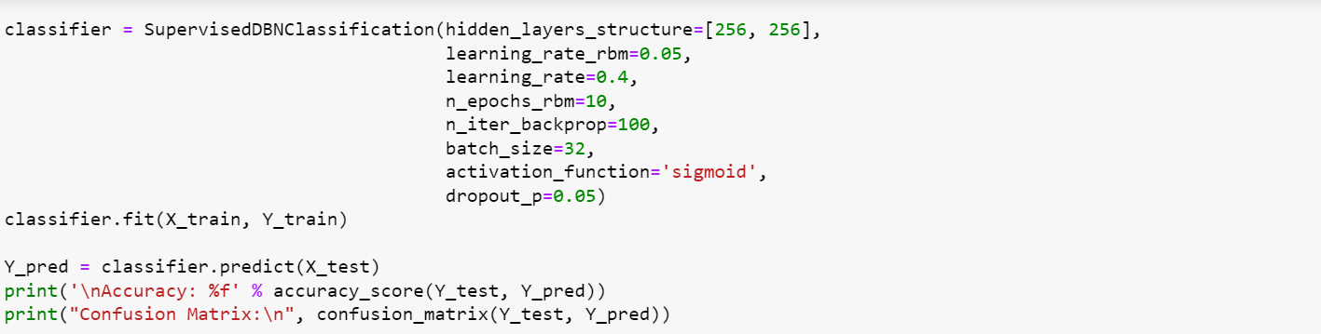

**RESULTS**

The hyperparameters that were varied in DBN:

* Number of layers (2, 4, 6)
* Number of Restricted Boltzmann Machines (RBM) in layers (128, 256)
* Dropout (0.05, 0.1, 0.2)

The hyperparameters that were set constant in DBN:

* Activation Function: Sigmoid
* Learning Rate: 0.4
* Learning Rate of RBM: 0.05
* Number of Epochs of RBM: 10
* Number of Iterations of Back Propagation: 100

| Case | Number of Layers | Number of RBMs in Each Layer | Dropout | Accuracy |
| --- | --- | --- | --- | --- |
| 1 | 2 | 128 | 0.05 | 92.6471 |
| 2 | 2 | 128 | 0.1 | 85.2941 |
| 3 | 2 | 128 | 0.2 | 81.3725 |
| 4 | 2 | 256 | 0.05 | 93.1373 |
| 5 | 2 | 256 | 0.1 | 92.6471 |
| 6 | 2 | 256 | 0.2 | 87.2549 |
| 7 | 4 | 128 | 0.05 | 85.2941 |
| 8 | 4 | 128 | 0.1 | 71.0784 |
| 9 | 4 | 128 | 0.2 | 75.4902 |
| 10 | 4 | 256 | 0.05 | 85.7843 |
| 11 | 4 | 256 | 0.1 | 89.7059 |
| 12 | 4 | 256 | 0.2 | 78.9216 |
| 13 | 6 | 128 | 0.05 | 61.7647 |
| 14 | 6 | 128 | 0.1 | 56.3725 |
| 15 | 6 | 128 | 0.2 | 49.5098 |
| 16 | 6 | 256 | 0.05 | 90.1961 |
| 17 | 6 | 256 | 0.1 | 85.7843 |
| 18 | 6 | 256 | 0.2 | 84.3137 |

**RESULT SNAPSHOTS FOR DEEP BELIEF NETWORK**

**Case 1:**

[START] Pre-training step:

>> Epoch 1 finished RBM Reconstruction error 43.599544

>> Epoch 2 finished RBM Reconstruction error 42.976945

>> Epoch 3 finished RBM Reconstruction error 42.911898

>> Epoch 4 finished RBM Reconstruction error 42.992147

>> Epoch 5 finished RBM Reconstruction error 43.180143

>> Epoch 6 finished RBM Reconstruction error 43.271735

>> Epoch 7 finished RBM Reconstruction error 43.482608

>> Epoch 8 finished RBM Reconstruction error 43.651730

>> Epoch 9 finished RBM Reconstruction error 44.033955

>> Epoch 10 finished RBM Reconstruction error 43.820545

>> Epoch 1 finished RBM Reconstruction error 9.997884

>> Epoch 2 finished RBM Reconstruction error 6.580758

>> Epoch 3 finished RBM Reconstruction error 5.279427

>> Epoch 4 finished RBM Reconstruction error 4.759158

>> Epoch 5 finished RBM Reconstruction error 4.508030

>> Epoch 6 finished RBM Reconstruction error 4.248742

>> Epoch 7 finished RBM Reconstruction error 4.053245

>> Epoch 8 finished RBM Reconstruction error 3.889613

>> Epoch 9 finished RBM Reconstruction error 3.757097

>> Epoch 10 finished RBM Reconstruction error 3.596914

[END] Pre-training step

[START] Fine tuning step:

>> Epoch 0 finished ANN training loss 2.037231

>> Epoch 1 finished ANN training loss 2.530553

>> Epoch 2 finished ANN training loss 1.891335

>> Epoch 3 finished ANN training loss 1.708371

>> Epoch 4 finished ANN training loss 1.705091

>> Epoch 5 finished ANN training loss 1.508305

>> Epoch 6 finished ANN training loss 1.467426

>> Epoch 7 finished ANN training loss 1.478177

>> Epoch 8 finished ANN training loss 1.308451

>> Epoch 9 finished ANN training loss 1.238117

>> Epoch 10 finished ANN training loss 1.209970

>> Epoch 11 finished ANN training loss 1.123635

>> Epoch 12 finished ANN training loss 1.187243

>> Epoch 13 finished ANN training loss 1.089304

>> Epoch 14 finished ANN training loss 1.323144

>> Epoch 15 finished ANN training loss 1.095376

>> Epoch 16 finished ANN training loss 1.378574

>> Epoch 17 finished ANN training loss 1.214751

>> Epoch 18 finished ANN training loss 1.263677

>> Epoch 19 finished ANN training loss 0.960594

>> Epoch 20 finished ANN training loss 0.875466

>> Epoch 21 finished ANN training loss 0.955809

>> Epoch 22 finished ANN training loss 0.862924

>> Epoch 23 finished ANN training loss 0.911252

>> Epoch 24 finished ANN training loss 0.805782

>> Epoch 25 finished ANN training loss 0.961703

>> Epoch 26 finished ANN training loss 0.942794

>> Epoch 27 finished ANN training loss 0.728192

>> Epoch 28 finished ANN training loss 0.667025

>> Epoch 29 finished ANN training loss 0.763087

>> Epoch 30 finished ANN training loss 0.751965

>> Epoch 31 finished ANN training loss 0.928952

>> Epoch 32 finished ANN training loss 0.774827

>> Epoch 33 finished ANN training loss 0.587178

>> Epoch 34 finished ANN training loss 0.665162

>> Epoch 35 finished ANN training loss 0.776877

>> Epoch 36 finished ANN training loss 0.565274

>> Epoch 37 finished ANN training loss 0.569235

>> Epoch 38 finished ANN training loss 0.596031

>> Epoch 39 finished ANN training loss 0.577027

>> Epoch 40 finished ANN training loss 0.553418

>> Epoch 41 finished ANN training loss 0.620908

>> Epoch 42 finished ANN training loss 0.571162

>> Epoch 43 finished ANN training loss 0.526746

>> Epoch 44 finished ANN training loss 0.530537

>> Epoch 45 finished ANN training loss 0.608071

>> Epoch 46 finished ANN training loss 0.593929

>> Epoch 47 finished ANN training loss 0.494764

>> Epoch 48 finished ANN training loss 0.487681

>> Epoch 49 finished ANN training loss 0.564391

>> Epoch 50 finished ANN training loss 0.523037

>> Epoch 51 finished ANN training loss 0.474280

>> Epoch 52 finished ANN training loss 0.510944

>> Epoch 53 finished ANN training loss 0.475152

>> Epoch 54 finished ANN training loss 0.486462

>> Epoch 55 finished ANN training loss 0.456293

>> Epoch 56 finished ANN training loss 0.475490

>> Epoch 57 finished ANN training loss 0.393183

>> Epoch 58 finished ANN training loss 0.413918

>> Epoch 59 finished ANN training loss 0.437031

>> Epoch 60 finished ANN training loss 0.432454

>> Epoch 61 finished ANN training loss 0.679555

>> Epoch 62 finished ANN training loss 0.398085

>> Epoch 63 finished ANN training loss 0.353334

>> Epoch 64 finished ANN training loss 0.425641

>> Epoch 65 finished ANN training loss 0.476713

>> Epoch 66 finished ANN training loss 0.380425

>> Epoch 67 finished ANN training loss 0.410107

>> Epoch 68 finished ANN training loss 0.411578

>> Epoch 69 finished ANN training loss 0.321684

>> Epoch 70 finished ANN training loss 0.305066

>> Epoch 71 finished ANN training loss 0.314879

>> Epoch 72 finished ANN training loss 0.280945

>> Epoch 73 finished ANN training loss 0.254134

>> Epoch 74 finished ANN training loss 0.246903

>> Epoch 75 finished ANN training loss 0.234316

>> Epoch 76 finished ANN training loss 0.282456

>> Epoch 77 finished ANN training loss 0.230592

>> Epoch 78 finished ANN training loss 0.209004

>> Epoch 79 finished ANN training loss 0.334618

>> Epoch 80 finished ANN training loss 0.222582

>> Epoch 81 finished ANN training loss 0.204601

>> Epoch 82 finished ANN training loss 0.203881

>> Epoch 83 finished ANN training loss 0.235314

>> Epoch 84 finished ANN training loss 0.269530

>> Epoch 85 finished ANN training loss 0.205300

>> Epoch 86 finished ANN training loss 0.197776

>> Epoch 87 finished ANN training loss 0.294495

>> Epoch 88 finished ANN training loss 0.181181

>> Epoch 89 finished ANN training loss 0.174272

>> Epoch 90 finished ANN training loss 0.204566

>> Epoch 91 finished ANN training loss 0.211796

>> Epoch 92 finished ANN training loss 0.196329

>> Epoch 93 finished ANN training loss 0.162750

>> Epoch 94 finished ANN training loss 0.172406

>> Epoch 95 finished ANN training loss 0.191705

>> Epoch 96 finished ANN training loss 0.195645

>> Epoch 97 finished ANN training loss 0.226054

>> Epoch 98 finished ANN training loss 0.160112

>> Epoch 99 finished ANN training loss 0.182126

[END] Fine tuning step

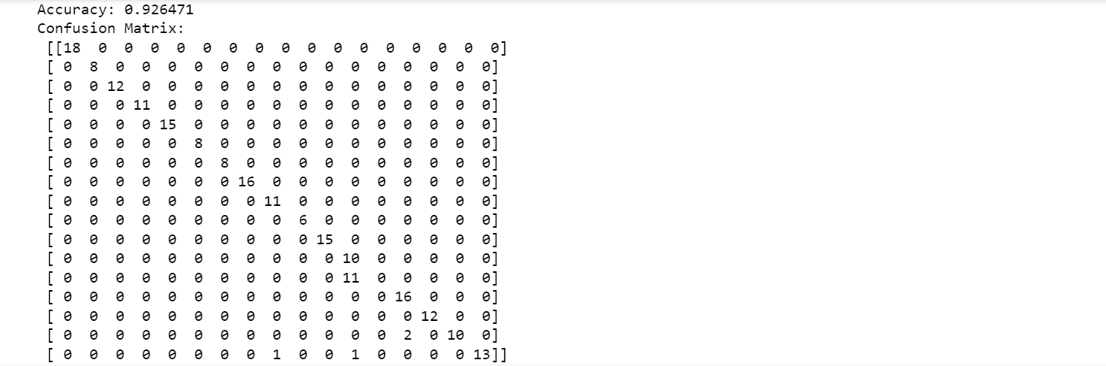

**Case 2:**

[START] Pre-training step:

>> Epoch 1 finished RBM Reconstruction error 43.782150

>> Epoch 2 finished RBM Reconstruction error 42.928241

>> Epoch 3 finished RBM Reconstruction error 42.655945

>> Epoch 4 finished RBM Reconstruction error 42.693698

>> Epoch 5 finished RBM Reconstruction error 42.927321

>> Epoch 6 finished RBM Reconstruction error 43.209267

>> Epoch 7 finished RBM Reconstruction error 43.481772

>> Epoch 8 finished RBM Reconstruction error 43.672546

>> Epoch 9 finished RBM Reconstruction error 44.062125

>> Epoch 10 finished RBM Reconstruction error 43.818609

>> Epoch 1 finished RBM Reconstruction error 10.392400

>> Epoch 2 finished RBM Reconstruction error 6.700058

>> Epoch 3 finished RBM Reconstruction error 5.298466

>> Epoch 4 finished RBM Reconstruction error 4.796281

>> Epoch 5 finished RBM Reconstruction error 4.568461

>> Epoch 6 finished RBM Reconstruction error 4.397188

>> Epoch 7 finished RBM Reconstruction error 4.223192

>> Epoch 8 finished RBM Reconstruction error 4.061265

>> Epoch 9 finished RBM Reconstruction error 4.007226

>> Epoch 10 finished RBM Reconstruction error 3.796173

[END] Pre-training step

[START] Fine tuning step:

>> Epoch 0 finished ANN training loss 2.048473

>> Epoch 1 finished ANN training loss 2.555068

>> Epoch 2 finished ANN training loss 1.943166

>> Epoch 3 finished ANN training loss 1.845320

>> Epoch 4 finished ANN training loss 1.839659

>> Epoch 5 finished ANN training loss 1.595223

>> Epoch 6 finished ANN training loss 1.597985

>> Epoch 7 finished ANN training loss 1.599554

>> Epoch 8 finished ANN training loss 1.423829

>> Epoch 9 finished ANN training loss 1.343475

>> Epoch 10 finished ANN training loss 1.404213

>> Epoch 11 finished ANN training loss 1.280437

>> Epoch 12 finished ANN training loss 1.263719

>> Epoch 13 finished ANN training loss 1.295932

>> Epoch 14 finished ANN training loss 1.376567

>> Epoch 15 finished ANN training loss 1.238679

>> Epoch 16 finished ANN training loss 1.426598

>> Epoch 17 finished ANN training loss 1.251217

>> Epoch 18 finished ANN training loss 1.269683

>> Epoch 19 finished ANN training loss 1.157708

>> Epoch 20 finished ANN training loss 1.030899

>> Epoch 21 finished ANN training loss 1.006503

>> Epoch 22 finished ANN training loss 1.036715

>> Epoch 23 finished ANN training loss 1.050383

>> Epoch 24 finished ANN training loss 0.966062

>> Epoch 25 finished ANN training loss 1.019315

>> Epoch 26 finished ANN training loss 0.969783

>> Epoch 27 finished ANN training loss 0.830298

>> Epoch 28 finished ANN training loss 0.992098

>> Epoch 29 finished ANN training loss 0.902074

>> Epoch 30 finished ANN training loss 0.933671

>> Epoch 31 finished ANN training loss 1.063265

>> Epoch 32 finished ANN training loss 0.949229

>> Epoch 33 finished ANN training loss 0.699161

>> Epoch 34 finished ANN training loss 0.749050

>> Epoch 35 finished ANN training loss 0.831956

>> Epoch 36 finished ANN training loss 0.697498

>> Epoch 37 finished ANN training loss 0.649158

>> Epoch 38 finished ANN training loss 0.676074

>> Epoch 39 finished ANN training loss 0.642122

>> Epoch 40 finished ANN training loss 0.669421

>> Epoch 41 finished ANN training loss 0.657683

>> Epoch 42 finished ANN training loss 0.625996

>> Epoch 43 finished ANN training loss 0.676108

>> Epoch 44 finished ANN training loss 0.635477

>> Epoch 45 finished ANN training loss 0.625749

>> Epoch 46 finished ANN training loss 0.692621

>> Epoch 47 finished ANN training loss 0.539687

>> Epoch 48 finished ANN training loss 0.588893

>> Epoch 49 finished ANN training loss 0.591711

>> Epoch 50 finished ANN training loss 0.604669

>> Epoch 51 finished ANN training loss 0.519620

>> Epoch 52 finished ANN training loss 0.542684

>> Epoch 53 finished ANN training loss 0.644590

>> Epoch 54 finished ANN training loss 0.529678

>> Epoch 55 finished ANN training loss 0.498389

>> Epoch 56 finished ANN training loss 0.540913

>> Epoch 57 finished ANN training loss 0.478119

>> Epoch 58 finished ANN training loss 0.516382

>> Epoch 59 finished ANN training loss 0.503232

>> Epoch 60 finished ANN training loss 0.565553

>> Epoch 61 finished ANN training loss 0.475282

>> Epoch 62 finished ANN training loss 0.508320

>> Epoch 63 finished ANN training loss 0.459403

>> Epoch 64 finished ANN training loss 0.476170

>> Epoch 65 finished ANN training loss 0.493728

>> Epoch 66 finished ANN training loss 0.453150

>> Epoch 67 finished ANN training loss 0.437306

>> Epoch 68 finished ANN training loss 0.524561

>> Epoch 69 finished ANN training loss 0.456132

>> Epoch 70 finished ANN training loss 0.408970

>> Epoch 71 finished ANN training loss 0.424216

>> Epoch 72 finished ANN training loss 0.470458

>> Epoch 73 finished ANN training loss 0.384628

>> Epoch 74 finished ANN training loss 0.405904

>> Epoch 75 finished ANN training loss 0.378710

>> Epoch 76 finished ANN training loss 0.527515

>> Epoch 77 finished ANN training loss 0.385493

>> Epoch 78 finished ANN training loss 0.355130

>> Epoch 79 finished ANN training loss 0.371594

>> Epoch 80 finished ANN training loss 0.397235

>> Epoch 81 finished ANN training loss 0.391941

>> Epoch 82 finished ANN training loss 0.361381

>> Epoch 83 finished ANN training loss 0.392323

>> Epoch 84 finished ANN training loss 0.374375

>> Epoch 85 finished ANN training loss 0.363242

>> Epoch 86 finished ANN training loss 0.374447

>> Epoch 87 finished ANN training loss 0.403555

>> Epoch 88 finished ANN training loss 0.329691

>> Epoch 89 finished ANN training loss 0.334911

>> Epoch 90 finished ANN training loss 0.342292

>> Epoch 91 finished ANN training loss 0.330106

>> Epoch 92 finished ANN training loss 0.310393

>> Epoch 93 finished ANN training loss 0.314418

>> Epoch 94 finished ANN training loss 0.358456

>> Epoch 95 finished ANN training loss 0.327619

>> Epoch 96 finished ANN training loss 0.293542

>> Epoch 97 finished ANN training loss 0.355162

>> Epoch 98 finished ANN training loss 0.440505

>> Epoch 99 finished ANN training loss 0.372699

[END] Fine tuning step

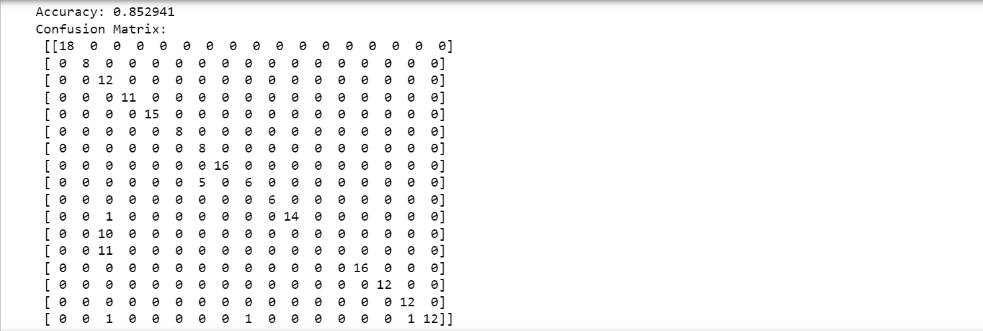

**Case 3:**

[START] Pre-training step:

>> Epoch 1 finished RBM Reconstruction error 43.579861

>> Epoch 2 finished RBM Reconstruction error 42.648378

>> Epoch 3 finished RBM Reconstruction error 42.461308

>> Epoch 4 finished RBM Reconstruction error 42.441174

>> Epoch 5 finished RBM Reconstruction error 42.601003

>> Epoch 6 finished RBM Reconstruction error 42.680919

>> Epoch 7 finished RBM Reconstruction error 42.801097

>> Epoch 8 finished RBM Reconstruction error 42.832580

>> Epoch 9 finished RBM Reconstruction error 43.133236

>> Epoch 10 finished RBM Reconstruction error 42.917262

>> Epoch 1 finished RBM Reconstruction error 10.114342

>> Epoch 2 finished RBM Reconstruction error 6.303115

>> Epoch 3 finished RBM Reconstruction error 5.110419

>> Epoch 4 finished RBM Reconstruction error 4.639163

>> Epoch 5 finished RBM Reconstruction error 4.457079

>> Epoch 6 finished RBM Reconstruction error 4.256772

>> Epoch 7 finished RBM Reconstruction error 4.115946

>> Epoch 8 finished RBM Reconstruction error 3.963893

>> Epoch 9 finished RBM Reconstruction error 3.893830

>> Epoch 10 finished RBM Reconstruction error 3.757128

[END] Pre-training step

[START] Fine tuning step:

>> Epoch 0 finished ANN training loss 2.084739

>> Epoch 1 finished ANN training loss 2.693096

>> Epoch 2 finished ANN training loss 2.023645

>> Epoch 3 finished ANN training loss 1.936663

>> Epoch 4 finished ANN training loss 1.938408

>> Epoch 5 finished ANN training loss 1.711225

>> Epoch 6 finished ANN training loss 1.646958

>> Epoch 7 finished ANN training loss 1.562639

>> Epoch 8 finished ANN training loss 1.439193

>> Epoch 9 finished ANN training loss 1.368606

>> Epoch 10 finished ANN training loss 1.421918

>> Epoch 11 finished ANN training loss 1.213603

>> Epoch 12 finished ANN training loss 1.258609

>> Epoch 13 finished ANN training loss 1.207161

>> Epoch 14 finished ANN training loss 1.266410

>> Epoch 15 finished ANN training loss 1.160871

>> Epoch 16 finished ANN training loss 1.171288

>> Epoch 17 finished ANN training loss 1.218048

>> Epoch 18 finished ANN training loss 1.098999

>> Epoch 19 finished ANN training loss 1.062969

>> Epoch 20 finished ANN training loss 0.980961

>> Epoch 21 finished ANN training loss 1.051329

>> Epoch 22 finished ANN training loss 0.966101

>> Epoch 23 finished ANN training loss 0.999138

>> Epoch 24 finished ANN training loss 0.893240

>> Epoch 25 finished ANN training loss 0.988844

>> Epoch 26 finished ANN training loss 0.925951

>> Epoch 27 finished ANN training loss 0.834280

>> Epoch 28 finished ANN training loss 0.842872

>> Epoch 29 finished ANN training loss 0.883498

>> Epoch 30 finished ANN training loss 0.845186

>> Epoch 31 finished ANN training loss 0.978131

>> Epoch 32 finished ANN training loss 0.832040

>> Epoch 33 finished ANN training loss 0.768827

>> Epoch 34 finished ANN training loss 0.794108

>> Epoch 35 finished ANN training loss 0.798608

>> Epoch 36 finished ANN training loss 0.782939

>> Epoch 37 finished ANN training loss 0.712071

>> Epoch 38 finished ANN training loss 0.737106

>> Epoch 39 finished ANN training loss 0.726010

>> Epoch 40 finished ANN training loss 0.737025

>> Epoch 41 finished ANN training loss 0.692586

>> Epoch 42 finished ANN training loss 0.695108

>> Epoch 43 finished ANN training loss 0.693935

>> Epoch 44 finished ANN training loss 0.676004

>> Epoch 45 finished ANN training loss 0.715704

>> Epoch 46 finished ANN training loss 0.777306

>> Epoch 47 finished ANN training loss 0.686728

>> Epoch 48 finished ANN training loss 0.622795

>> Epoch 49 finished ANN training loss 0.752038

>> Epoch 50 finished ANN training loss 0.640022

>> Epoch 51 finished ANN training loss 0.600058

>> Epoch 52 finished ANN training loss 0.623110

>> Epoch 53 finished ANN training loss 0.620080

>> Epoch 54 finished ANN training loss 0.608240

>> Epoch 55 finished ANN training loss 0.569297

>> Epoch 56 finished ANN training loss 0.614504

>> Epoch 57 finished ANN training loss 0.563499

>> Epoch 58 finished ANN training loss 0.564582

>> Epoch 59 finished ANN training loss 0.547316

>> Epoch 60 finished ANN training loss 0.652366

>> Epoch 61 finished ANN training loss 0.645404

>> Epoch 62 finished ANN training loss 0.556507

>> Epoch 63 finished ANN training loss 0.508432

>> Epoch 64 finished ANN training loss 0.480117

>> Epoch 65 finished ANN training loss 0.549756

>> Epoch 66 finished ANN training loss 0.559426

>> Epoch 67 finished ANN training loss 0.482389

>> Epoch 68 finished ANN training loss 0.614246

>> Epoch 69 finished ANN training loss 0.505947

>> Epoch 70 finished ANN training loss 0.450987

>> Epoch 71 finished ANN training loss 0.441960

>> Epoch 72 finished ANN training loss 0.459380

>> Epoch 73 finished ANN training loss 0.435842

>> Epoch 74 finished ANN training loss 0.411909

>> Epoch 75 finished ANN training loss 0.453610

>> Epoch 76 finished ANN training loss 0.553233

>> Epoch 77 finished ANN training loss 0.444737

>> Epoch 78 finished ANN training loss 0.420708

>> Epoch 79 finished ANN training loss 0.425887

>> Epoch 80 finished ANN training loss 0.473440

>> Epoch 81 finished ANN training loss 0.386143

>> Epoch 82 finished ANN training loss 0.395802

>> Epoch 83 finished ANN training loss 0.395745

>> Epoch 84 finished ANN training loss 0.383671

>> Epoch 85 finished ANN training loss 0.395391

>> Epoch 86 finished ANN training loss 0.452694

>> Epoch 87 finished ANN training loss 0.375133

>> Epoch 88 finished ANN training loss 0.394350

>> Epoch 89 finished ANN training loss 0.354372

>> Epoch 90 finished ANN training loss 0.359927

>> Epoch 91 finished ANN training loss 0.397791

>> Epoch 92 finished ANN training loss 0.375923

>> Epoch 93 finished ANN training loss 0.343724

>> Epoch 94 finished ANN training loss 0.371028

>> Epoch 95 finished ANN training loss 0.330187

>> Epoch 96 finished ANN training loss 0.350419

>> Epoch 97 finished ANN training loss 0.356131

>> Epoch 98 finished ANN training loss 0.326913

>> Epoch 99 finished ANN training loss 0.425495

[END] Fine tuning step

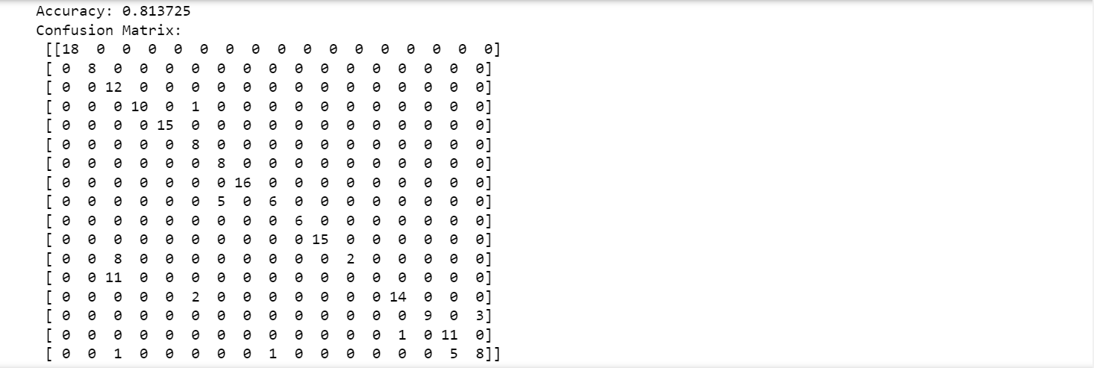

**Case 4:**

[START] Pre-training step:

>> Epoch 1 finished RBM Reconstruction error 41.815052

>> Epoch 2 finished RBM Reconstruction error 40.867323

>> Epoch 3 finished RBM Reconstruction error 40.931374

>> Epoch 4 finished RBM Reconstruction error 41.054906

>> Epoch 5 finished RBM Reconstruction error 41.300267

>> Epoch 6 finished RBM Reconstruction error 41.585167

>> Epoch 7 finished RBM Reconstruction error 41.854288

>> Epoch 8 finished RBM Reconstruction error 42.041261

>> Epoch 9 finished RBM Reconstruction error 42.439653

>> Epoch 10 finished RBM Reconstruction error 42.228696

>> Epoch 1 finished RBM Reconstruction error 14.240275

>> Epoch 2 finished RBM Reconstruction error 11.222238

>> Epoch 3 finished RBM Reconstruction error 10.207335

>> Epoch 4 finished RBM Reconstruction error 9.561489

>> Epoch 5 finished RBM Reconstruction error 8.943264

>> Epoch 6 finished RBM Reconstruction error 8.386539

>> Epoch 7 finished RBM Reconstruction error 8.092778

>> Epoch 8 finished RBM Reconstruction error 7.484471

>> Epoch 9 finished RBM Reconstruction error 7.351327

>> Epoch 10 finished RBM Reconstruction error 6.951092

[END] Pre-training step

[START] Fine tuning step:

>> Epoch 0 finished ANN training loss 3.202194

>> Epoch 1 finished ANN training loss 2.924797

>> Epoch 2 finished ANN training loss 1.900054

>> Epoch 3 finished ANN training loss 1.650820

>> Epoch 4 finished ANN training loss 1.939302

>> Epoch 5 finished ANN training loss 1.507740

>> Epoch 6 finished ANN training loss 1.211567

>> Epoch 7 finished ANN training loss 1.176030

>> Epoch 8 finished ANN training loss 1.068863

>> Epoch 9 finished ANN training loss 1.129925

>> Epoch 10 finished ANN training loss 0.909382

>> Epoch 11 finished ANN training loss 0.868795

>> Epoch 12 finished ANN training loss 0.739042

>> Epoch 13 finished ANN training loss 0.740777

>> Epoch 14 finished ANN training loss 0.865510

>> Epoch 15 finished ANN training loss 0.884911

>> Epoch 16 finished ANN training loss 0.799987

>> Epoch 17 finished ANN training loss 0.885908

>> Epoch 18 finished ANN training loss 0.910038

>> Epoch 19 finished ANN training loss 0.683045

>> Epoch 20 finished ANN training loss 0.647366

>> Epoch 21 finished ANN training loss 0.774005

>> Epoch 22 finished ANN training loss 0.817662

>> Epoch 23 finished ANN training loss 1.131454

>> Epoch 24 finished ANN training loss 0.628250

>> Epoch 25 finished ANN training loss 0.929307

>> Epoch 26 finished ANN training loss 0.680526

>> Epoch 27 finished ANN training loss 0.494073

>> Epoch 28 finished ANN training loss 0.480094

>> Epoch 29 finished ANN training loss 0.503564

>> Epoch 30 finished ANN training loss 0.712954

>> Epoch 31 finished ANN training loss 1.083019

>> Epoch 32 finished ANN training loss 1.127132

>> Epoch 33 finished ANN training loss 0.403434

>> Epoch 34 finished ANN training loss 0.413601

>> Epoch 35 finished ANN training loss 0.906533

>> Epoch 36 finished ANN training loss 0.415442

>> Epoch 37 finished ANN training loss 0.370264

>> Epoch 38 finished ANN training loss 0.485404

>> Epoch 39 finished ANN training loss 0.346662

>> Epoch 40 finished ANN training loss 0.347488

>> Epoch 41 finished ANN training loss 0.437101

>> Epoch 42 finished ANN training loss 0.361671

>> Epoch 43 finished ANN training loss 0.405144

>> Epoch 44 finished ANN training loss 0.286435

>> Epoch 45 finished ANN training loss 0.376581

>> Epoch 46 finished ANN training loss 0.357732

>> Epoch 47 finished ANN training loss 0.263748

>> Epoch 48 finished ANN training loss 0.259885

>> Epoch 49 finished ANN training loss 0.597352

>> Epoch 50 finished ANN training loss 0.336615

>> Epoch 51 finished ANN training loss 0.414701

>> Epoch 52 finished ANN training loss 0.357649

>> Epoch 53 finished ANN training loss 0.328534

>> Epoch 54 finished ANN training loss 0.307624

>> Epoch 55 finished ANN training loss 0.565138

>> Epoch 56 finished ANN training loss 0.333186

>> Epoch 57 finished ANN training loss 0.229221

>> Epoch 58 finished ANN training loss 0.283868

>> Epoch 59 finished ANN training loss 0.274469

>> Epoch 60 finished ANN training loss 0.193745

>> Epoch 61 finished ANN training loss 0.343308

>> Epoch 62 finished ANN training loss 0.250944

>> Epoch 63 finished ANN training loss 0.221485

>> Epoch 64 finished ANN training loss 0.287643

>> Epoch 65 finished ANN training loss 0.261605

>> Epoch 66 finished ANN training loss 0.232030

>> Epoch 67 finished ANN training loss 0.212772

>> Epoch 68 finished ANN training loss 0.341266

>> Epoch 69 finished ANN training loss 0.228987

>> Epoch 70 finished ANN training loss 0.247523

>> Epoch 71 finished ANN training loss 0.185374

>> Epoch 72 finished ANN training loss 0.239396

>> Epoch 73 finished ANN training loss 0.171875

>> Epoch 74 finished ANN training loss 0.168191

>> Epoch 75 finished ANN training loss 0.168862

>> Epoch 76 finished ANN training loss 0.319793

>> Epoch 77 finished ANN training loss 0.205173

>> Epoch 78 finished ANN training loss 0.174847

>> Epoch 79 finished ANN training loss 0.159940

>> Epoch 80 finished ANN training loss 0.169374

>> Epoch 81 finished ANN training loss 0.161327

>> Epoch 82 finished ANN training loss 0.162334

>> Epoch 83 finished ANN training loss 0.354639

>> Epoch 84 finished ANN training loss 0.189050

>> Epoch 85 finished ANN training loss 0.203366

>> Epoch 86 finished ANN training loss 0.143702

>> Epoch 87 finished ANN training loss 0.228449

>> Epoch 88 finished ANN training loss 0.123880

>> Epoch 89 finished ANN training loss 0.156070

>> Epoch 90 finished ANN training loss 0.139956

>> Epoch 91 finished ANN training loss 0.231481

>> Epoch 92 finished ANN training loss 0.118180

>> Epoch 93 finished ANN training loss 0.113211

>> Epoch 94 finished ANN training loss 0.141887

>> Epoch 95 finished ANN training loss 0.177936

>> Epoch 96 finished ANN training loss 0.131760

>> Epoch 97 finished ANN training loss 0.125809

>> Epoch 98 finished ANN training loss 0.121686

>> Epoch 99 finished ANN training loss 0.165044

[END] Fine tuning step

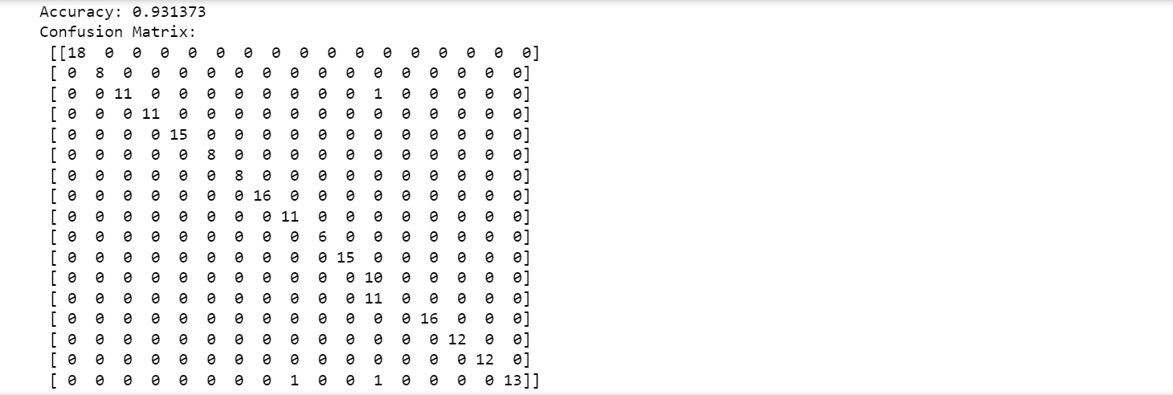

**Case 5:**

[START] Pre-training step:

>> Epoch 1 finished RBM Reconstruction error 41.452019

>> Epoch 2 finished RBM Reconstruction error 40.543458

>> Epoch 3 finished RBM Reconstruction error 40.711748

>> Epoch 4 finished RBM Reconstruction error 41.021558

>> Epoch 5 finished RBM Reconstruction error 41.274169

>> Epoch 6 finished RBM Reconstruction error 41.495661

>> Epoch 7 finished RBM Reconstruction error 41.789053

>> Epoch 8 finished RBM Reconstruction error 41.998737

>> Epoch 9 finished RBM Reconstruction error 42.236481

>> Epoch 10 finished RBM Reconstruction error 42.178893

>> Epoch 1 finished RBM Reconstruction error 14.061078

>> Epoch 2 finished RBM Reconstruction error 10.807890

>> Epoch 3 finished RBM Reconstruction error 9.859759

>> Epoch 4 finished RBM Reconstruction error 9.207584

>> Epoch 5 finished RBM Reconstruction error 8.653982

>> Epoch 6 finished RBM Reconstruction error 8.070736

>> Epoch 7 finished RBM Reconstruction error 7.613231

>> Epoch 8 finished RBM Reconstruction error 7.054420

>> Epoch 9 finished RBM Reconstruction error 6.930345

>> Epoch 10 finished RBM Reconstruction error 6.447775

[END] Pre-training step

[START] Fine tuning step:

>> Epoch 0 finished ANN training loss 3.099351

>> Epoch 1 finished ANN training loss 3.690585

>> Epoch 2 finished ANN training loss 1.846033

>> Epoch 3 finished ANN training loss 1.780526

>> Epoch 4 finished ANN training loss 1.993870

>> Epoch 5 finished ANN training loss 1.328447

>> Epoch 6 finished ANN training loss 1.570774

>> Epoch 7 finished ANN training loss 1.445312

>> Epoch 8 finished ANN training loss 1.099473

>> Epoch 9 finished ANN training loss 0.944150

>> Epoch 10 finished ANN training loss 1.163033

>> Epoch 11 finished ANN training loss 0.915219

>> Epoch 12 finished ANN training loss 1.020712

>> Epoch 13 finished ANN training loss 0.825129

>> Epoch 14 finished ANN training loss 1.211958

>> Epoch 15 finished ANN training loss 0.939748

>> Epoch 16 finished ANN training loss 0.948906

>> Epoch 17 finished ANN training loss 1.122801

>> Epoch 18 finished ANN training loss 1.027700

>> Epoch 19 finished ANN training loss 0.868018

>> Epoch 20 finished ANN training loss 0.639140

>> Epoch 21 finished ANN training loss 0.752026

>> Epoch 22 finished ANN training loss 0.920182

>> Epoch 23 finished ANN training loss 0.917732

>> Epoch 24 finished ANN training loss 0.755384

>> Epoch 25 finished ANN training loss 1.310156

>> Epoch 26 finished ANN training loss 0.614711

>> Epoch 27 finished ANN training loss 0.537003

>> Epoch 28 finished ANN training loss 0.515101

>> Epoch 29 finished ANN training loss 0.602237

>> Epoch 30 finished ANN training loss 0.611064

>> Epoch 31 finished ANN training loss 1.283455

>> Epoch 32 finished ANN training loss 1.082329

>> Epoch 33 finished ANN training loss 0.446334

>> Epoch 34 finished ANN training loss 0.477346

>> Epoch 35 finished ANN training loss 0.863169

>> Epoch 36 finished ANN training loss 0.427697

>> Epoch 37 finished ANN training loss 0.509130

>> Epoch 38 finished ANN training loss 0.493523

>> Epoch 39 finished ANN training loss 0.443775

>> Epoch 40 finished ANN training loss 0.432427

>> Epoch 41 finished ANN training loss 0.499896

>> Epoch 42 finished ANN training loss 0.456430

>> Epoch 43 finished ANN training loss 0.612598

>> Epoch 44 finished ANN training loss 0.378792

>> Epoch 45 finished ANN training loss 0.443362

>> Epoch 46 finished ANN training loss 0.432399

>> Epoch 47 finished ANN training loss 0.317934

>> Epoch 48 finished ANN training loss 0.302224

>> Epoch 49 finished ANN training loss 0.474888

>> Epoch 50 finished ANN training loss 0.457301

>> Epoch 51 finished ANN training loss 0.365441

>> Epoch 52 finished ANN training loss 0.490203

>> Epoch 53 finished ANN training loss 0.379194

>> Epoch 54 finished ANN training loss 0.282750

>> Epoch 55 finished ANN training loss 0.321877

>> Epoch 56 finished ANN training loss 0.385713

>> Epoch 57 finished ANN training loss 0.254959

>> Epoch 58 finished ANN training loss 0.310375

>> Epoch 59 finished ANN training loss 0.284413

>> Epoch 60 finished ANN training loss 0.293341

>> Epoch 61 finished ANN training loss 0.292962

>> Epoch 62 finished ANN training loss 0.238246

>> Epoch 63 finished ANN training loss 0.258658

>> Epoch 64 finished ANN training loss 0.283514

>> Epoch 65 finished ANN training loss 0.284998

>> Epoch 66 finished ANN training loss 0.289878

>> Epoch 67 finished ANN training loss 0.262780

>> Epoch 68 finished ANN training loss 0.232620

>> Epoch 69 finished ANN training loss 0.239553

>> Epoch 70 finished ANN training loss 0.270340

>> Epoch 71 finished ANN training loss 0.260992

>> Epoch 72 finished ANN training loss 0.194435

>> Epoch 73 finished ANN training loss 0.212557

>> Epoch 74 finished ANN training loss 0.242026

>> Epoch 75 finished ANN training loss 0.260550

>> Epoch 76 finished ANN training loss 0.334537

>> Epoch 77 finished ANN training loss 0.614288

>> Epoch 78 finished ANN training loss 0.166397

>> Epoch 79 finished ANN training loss 0.179294

>> Epoch 80 finished ANN training loss 0.202732

>> Epoch 81 finished ANN training loss 0.167124

>> Epoch 82 finished ANN training loss 0.145069

>> Epoch 83 finished ANN training loss 0.178274

>> Epoch 84 finished ANN training loss 0.219602

>> Epoch 85 finished ANN training loss 0.208531

>> Epoch 86 finished ANN training loss 0.143639

>> Epoch 87 finished ANN training loss 0.204151

>> Epoch 88 finished ANN training loss 0.152926

>> Epoch 89 finished ANN training loss 0.178770

>> Epoch 90 finished ANN training loss 0.191168

>> Epoch 91 finished ANN training loss 0.197651

>> Epoch 92 finished ANN training loss 0.146057

>> Epoch 93 finished ANN training loss 0.131446

>> Epoch 94 finished ANN training loss 0.146481

>> Epoch 95 finished ANN training loss 0.159577

>> Epoch 96 finished ANN training loss 0.127134

>> Epoch 97 finished ANN training loss 0.153763

>> Epoch 98 finished ANN training loss 0.131997

>> Epoch 99 finished ANN training loss 0.161735

[END] Fine tuning step

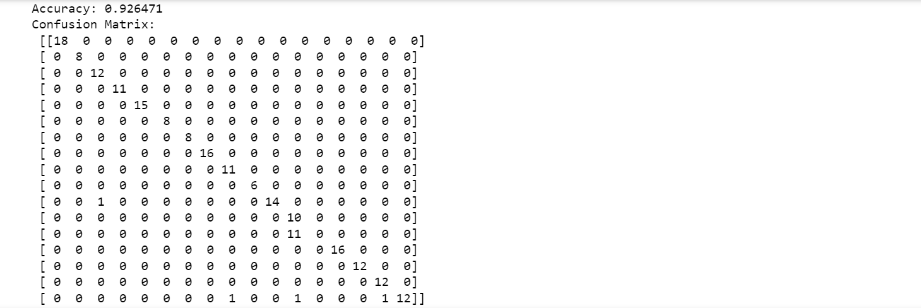

**Case 6:**

[START] Pre-training step:

>> Epoch 1 finished RBM Reconstruction error 41.850058

>> Epoch 2 finished RBM Reconstruction error 40.894614

>> Epoch 3 finished RBM Reconstruction error 40.964123

>> Epoch 4 finished RBM Reconstruction error 41.160024

>> Epoch 5 finished RBM Reconstruction error 41.381316

>> Epoch 6 finished RBM Reconstruction error 41.600540

>> Epoch 7 finished RBM Reconstruction error 41.795998

>> Epoch 8 finished RBM Reconstruction error 42.015733

>> Epoch 9 finished RBM Reconstruction error 42.387931

>> Epoch 10 finished RBM Reconstruction error 42.106841

>> Epoch 1 finished RBM Reconstruction error 14.815408

>> Epoch 2 finished RBM Reconstruction error 11.054120

>> Epoch 3 finished RBM Reconstruction error 10.096250

>> Epoch 4 finished RBM Reconstruction error 9.336926

>> Epoch 5 finished RBM Reconstruction error 8.701862

>> Epoch 6 finished RBM Reconstruction error 8.046473

>> Epoch 7 finished RBM Reconstruction error 7.714260

>> Epoch 8 finished RBM Reconstruction error 7.135638

>> Epoch 9 finished RBM Reconstruction error 6.876895

>> Epoch 10 finished RBM Reconstruction error 6.518500

[END] Pre-training step

[START] Fine tuning step:

>> Epoch 0 finished ANN training loss 2.718808

>> Epoch 1 finished ANN training loss 3.416688

>> Epoch 2 finished ANN training loss 1.814120

>> Epoch 3 finished ANN training loss 1.778116

>> Epoch 4 finished ANN training loss 1.885764

>> Epoch 5 finished ANN training loss 1.402628

>> Epoch 6 finished ANN training loss 1.176439

>> Epoch 7 finished ANN training loss 1.260576

>> Epoch 8 finished ANN training loss 1.306911

>> Epoch 9 finished ANN training loss 1.187582

>> Epoch 10 finished ANN training loss 0.969498

>> Epoch 11 finished ANN training loss 0.976272

>> Epoch 12 finished ANN training loss 1.066424

>> Epoch 13 finished ANN training loss 0.802644

>> Epoch 14 finished ANN training loss 1.021625

>> Epoch 15 finished ANN training loss 1.114406

>> Epoch 16 finished ANN training loss 1.012872

>> Epoch 17 finished ANN training loss 1.134081

>> Epoch 18 finished ANN training loss 0.989781

>> Epoch 19 finished ANN training loss 0.777639

>> Epoch 20 finished ANN training loss 0.725350

>> Epoch 21 finished ANN training loss 0.752409

>> Epoch 22 finished ANN training loss 0.768745

>> Epoch 23 finished ANN training loss 0.967344

>> Epoch 24 finished ANN training loss 0.754432

>> Epoch 25 finished ANN training loss 0.860515

>> Epoch 26 finished ANN training loss 0.645970

>> Epoch 27 finished ANN training loss 0.638390

>> Epoch 28 finished ANN training loss 0.506377

>> Epoch 29 finished ANN training loss 0.621008

>> Epoch 30 finished ANN training loss 0.624500

>> Epoch 31 finished ANN training loss 1.045910

>> Epoch 32 finished ANN training loss 0.916337

>> Epoch 33 finished ANN training loss 0.512938

>> Epoch 34 finished ANN training loss 0.589099

>> Epoch 35 finished ANN training loss 0.860165

>> Epoch 36 finished ANN training loss 0.592429

>> Epoch 37 finished ANN training loss 0.591650

>> Epoch 38 finished ANN training loss 0.455230

>> Epoch 39 finished ANN training loss 0.557336

>> Epoch 40 finished ANN training loss 0.518949

>> Epoch 41 finished ANN training loss 0.581727

>> Epoch 42 finished ANN training loss 0.480343

>> Epoch 43 finished ANN training loss 0.427032

>> Epoch 44 finished ANN training loss 0.471221

>> Epoch 45 finished ANN training loss 0.456733

>> Epoch 46 finished ANN training loss 0.506937

>> Epoch 47 finished ANN training loss 0.414737

>> Epoch 48 finished ANN training loss 0.383229

>> Epoch 49 finished ANN training loss 0.648670

>> Epoch 50 finished ANN training loss 0.515359

>> Epoch 51 finished ANN training loss 0.407835

>> Epoch 52 finished ANN training loss 0.483763

>> Epoch 53 finished ANN training loss 0.382627

>> Epoch 54 finished ANN training loss 0.390435

>> Epoch 55 finished ANN training loss 0.400153

>> Epoch 56 finished ANN training loss 0.504246

>> Epoch 57 finished ANN training loss 0.384212

>> Epoch 58 finished ANN training loss 0.375902

>> Epoch 59 finished ANN training loss 0.404311

>> Epoch 60 finished ANN training loss 0.445458

>> Epoch 61 finished ANN training loss 0.334489

>> Epoch 62 finished ANN training loss 0.361197

>> Epoch 63 finished ANN training loss 0.329897

>> Epoch 64 finished ANN training loss 0.290024

>> Epoch 65 finished ANN training loss 0.326399

>> Epoch 66 finished ANN training loss 0.326028

>> Epoch 67 finished ANN training loss 0.407774

>> Epoch 68 finished ANN training loss 0.346832

>> Epoch 69 finished ANN training loss 0.352717

>> Epoch 70 finished ANN training loss 0.273628

>> Epoch 71 finished ANN training loss 0.356377

>> Epoch 72 finished ANN training loss 0.315419

>> Epoch 73 finished ANN training loss 0.257262

>> Epoch 74 finished ANN training loss 0.297363

>> Epoch 75 finished ANN training loss 0.255015

>> Epoch 76 finished ANN training loss 0.373465

>> Epoch 77 finished ANN training loss 0.273223

>> Epoch 78 finished ANN training loss 0.242477

>> Epoch 79 finished ANN training loss 0.276181

>> Epoch 80 finished ANN training loss 0.260728

>> Epoch 81 finished ANN training loss 0.253995

>> Epoch 82 finished ANN training loss 0.215218

>> Epoch 83 finished ANN training loss 0.276128

>> Epoch 84 finished ANN training loss 0.287112

>> Epoch 85 finished ANN training loss 0.282366

>> Epoch 86 finished ANN training loss 0.260891

>> Epoch 87 finished ANN training loss 0.242337

>> Epoch 88 finished ANN training loss 0.211894

>> Epoch 89 finished ANN training loss 0.214325

>> Epoch 90 finished ANN training loss 0.234565

>> Epoch 91 finished ANN training loss 0.236237

>> Epoch 92 finished ANN training loss 0.205068

>> Epoch 93 finished ANN training loss 0.201132

>> Epoch 94 finished ANN training loss 0.186718

>> Epoch 95 finished ANN training loss 0.204233

>> Epoch 96 finished ANN training loss 0.221619

>> Epoch 97 finished ANN training loss 0.265261

>> Epoch 98 finished ANN training loss 0.188180

>> Epoch 99 finished ANN training loss 0.242758

[END] Fine tuning step

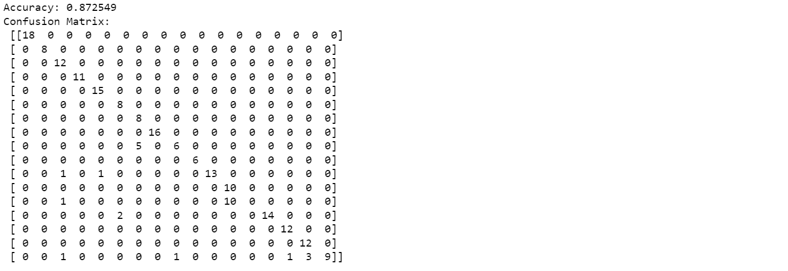

**Case 7:**

[START] Pre-training step:

>> Epoch 1 finished RBM Reconstruction error 43.611068

>> Epoch 2 finished RBM Reconstruction error 42.323009

>> Epoch 3 finished RBM Reconstruction error 42.124878

>> Epoch 4 finished RBM Reconstruction error 42.228901

>> Epoch 5 finished RBM Reconstruction error 42.515722

>> Epoch 6 finished RBM Reconstruction error 42.770853

>> Epoch 7 finished RBM Reconstruction error 42.997237

>> Epoch 8 finished RBM Reconstruction error 43.172563

>> Epoch 9 finished RBM Reconstruction error 43.458511

>> Epoch 10 finished RBM Reconstruction error 43.307241

>> Epoch 1 finished RBM Reconstruction error 9.489080

>> Epoch 2 finished RBM Reconstruction error 6.303519

>> Epoch 3 finished RBM Reconstruction error 5.026020

>> Epoch 4 finished RBM Reconstruction error 4.575114

>> Epoch 5 finished RBM Reconstruction error 4.419034

>> Epoch 6 finished RBM Reconstruction error 4.197204

>> Epoch 7 finished RBM Reconstruction error 4.079415

>> Epoch 8 finished RBM Reconstruction error 3.926174

>> Epoch 9 finished RBM Reconstruction error 3.837740

>> Epoch 10 finished RBM Reconstruction error 3.688907

>> Epoch 1 finished RBM Reconstruction error 3.424402

>> Epoch 2 finished RBM Reconstruction error 1.400390

>> Epoch 3 finished RBM Reconstruction error 0.868024

>> Epoch 4 finished RBM Reconstruction error 0.716623

>> Epoch 5 finished RBM Reconstruction error 0.662347

>> Epoch 6 finished RBM Reconstruction error 0.653877

>> Epoch 7 finished RBM Reconstruction error 0.631490

>> Epoch 8 finished RBM Reconstruction error 0.619303

>> Epoch 9 finished RBM Reconstruction error 0.589857

>> Epoch 10 finished RBM Reconstruction error 0.523940

>> Epoch 1 finished RBM Reconstruction error 3.008495

>> Epoch 2 finished RBM Reconstruction error 1.183653

>> Epoch 3 finished RBM Reconstruction error 0.472936

>> Epoch 4 finished RBM Reconstruction error 0.303096

>> Epoch 5 finished RBM Reconstruction error 0.269574

>> Epoch 6 finished RBM Reconstruction error 0.247869

>> Epoch 7 finished RBM Reconstruction error 0.223870

>> Epoch 8 finished RBM Reconstruction error 0.204703

>> Epoch 9 finished RBM Reconstruction error 0.206227

>> Epoch 10 finished RBM Reconstruction error 0.192435

[END] Pre-training step

[START] Fine tuning step:

>> Epoch 0 finished ANN training loss 2.153566

>> Epoch 1 finished ANN training loss 2.086350

>> Epoch 2 finished ANN training loss 2.101676

>> Epoch 3 finished ANN training loss 2.073774

>> Epoch 4 finished ANN training loss 1.979826

>> Epoch 5 finished ANN training loss 1.880534

>> Epoch 6 finished ANN training loss 2.024677

>> Epoch 7 finished ANN training loss 1.797245

>> Epoch 8 finished ANN training loss 1.709345

>> Epoch 9 finished ANN training loss 1.801885

>> Epoch 10 finished ANN training loss 1.719839

>> Epoch 11 finished ANN training loss 1.599324

>> Epoch 12 finished ANN training loss 1.614488

>> Epoch 13 finished ANN training loss 1.648429

>> Epoch 14 finished ANN training loss 1.585097

>> Epoch 15 finished ANN training loss 1.556749

>> Epoch 16 finished ANN training loss 1.547412

>> Epoch 17 finished ANN training loss 1.534549

>> Epoch 18 finished ANN training loss 1.480174

>> Epoch 19 finished ANN training loss 1.552689

>> Epoch 20 finished ANN training loss 1.505747

>> Epoch 21 finished ANN training loss 1.526027

>> Epoch 22 finished ANN training loss 1.435349

>> Epoch 23 finished ANN training loss 1.401416

>> Epoch 24 finished ANN training loss 1.403844

>> Epoch 25 finished ANN training loss 1.467097

>> Epoch 26 finished ANN training loss 1.397644

>> Epoch 27 finished ANN training loss 1.301118

>> Epoch 28 finished ANN training loss 1.372970

>> Epoch 29 finished ANN training loss 1.275185

>> Epoch 30 finished ANN training loss 1.292008

>> Epoch 31 finished ANN training loss 1.339373

>> Epoch 32 finished ANN training loss 1.231508

>> Epoch 33 finished ANN training loss 1.178891

>> Epoch 34 finished ANN training loss 1.151788

>> Epoch 35 finished ANN training loss 1.226502

>> Epoch 36 finished ANN training loss 1.139428

>> Epoch 37 finished ANN training loss 1.346881

>> Epoch 38 finished ANN training loss 1.055764

>> Epoch 39 finished ANN training loss 1.112608

>> Epoch 40 finished ANN training loss 1.116235

>> Epoch 41 finished ANN training loss 1.027043

>> Epoch 42 finished ANN training loss 1.031240

>> Epoch 43 finished ANN training loss 1.008655

>> Epoch 44 finished ANN training loss 1.042904

>> Epoch 45 finished ANN training loss 0.982141

>> Epoch 46 finished ANN training loss 0.954353

>> Epoch 47 finished ANN training loss 1.037781

>> Epoch 48 finished ANN training loss 0.953754

>> Epoch 49 finished ANN training loss 0.947172

>> Epoch 50 finished ANN training loss 0.929894

>> Epoch 51 finished ANN training loss 1.004077

>> Epoch 52 finished ANN training loss 0.848558

>> Epoch 53 finished ANN training loss 0.849199

>> Epoch 54 finished ANN training loss 0.855254

>> Epoch 55 finished ANN training loss 0.957421

>> Epoch 56 finished ANN training loss 0.786234

>> Epoch 57 finished ANN training loss 0.935120

>> Epoch 58 finished ANN training loss 0.969913

>> Epoch 59 finished ANN training loss 0.824870

>> Epoch 60 finished ANN training loss 0.860923

>> Epoch 61 finished ANN training loss 0.798085

>> Epoch 62 finished ANN training loss 0.722395

>> Epoch 63 finished ANN training loss 0.687953

>> Epoch 64 finished ANN training loss 0.759430

>> Epoch 65 finished ANN training loss 0.700532

>> Epoch 66 finished ANN training loss 0.688448

>> Epoch 67 finished ANN training loss 0.768305

>> Epoch 68 finished ANN training loss 0.655071

>> Epoch 69 finished ANN training loss 0.704207

>> Epoch 70 finished ANN training loss 0.663004

>> Epoch 71 finished ANN training loss 0.600730

>> Epoch 72 finished ANN training loss 0.656497

>> Epoch 73 finished ANN training loss 0.683468

>> Epoch 74 finished ANN training loss 0.586385

>> Epoch 75 finished ANN training loss 0.581089

>> Epoch 76 finished ANN training loss 0.685384

>> Epoch 77 finished ANN training loss 0.589066

>> Epoch 78 finished ANN training loss 0.619617

>> Epoch 79 finished ANN training loss 0.665656

>> Epoch 80 finished ANN training loss 0.551548

>> Epoch 81 finished ANN training loss 0.682065

>> Epoch 82 finished ANN training loss 0.564787

>> Epoch 83 finished ANN training loss 0.716488

>> Epoch 84 finished ANN training loss 0.550645

>> Epoch 85 finished ANN training loss 0.571785

>> Epoch 86 finished ANN training loss 0.583134

>> Epoch 87 finished ANN training loss 0.549609

>> Epoch 88 finished ANN training loss 0.629348

>> Epoch 89 finished ANN training loss 0.481051

>> Epoch 90 finished ANN training loss 0.507449

>> Epoch 91 finished ANN training loss 0.484555

>> Epoch 92 finished ANN training loss 0.526343

>> Epoch 93 finished ANN training loss 0.696431

>> Epoch 94 finished ANN training loss 0.688071

>> Epoch 95 finished ANN training loss 0.697145

>> Epoch 96 finished ANN training loss 0.672433

>> Epoch 97 finished ANN training loss 0.628760

>> Epoch 98 finished ANN training loss 0.511595

>> Epoch 99 finished ANN training loss 0.402390

[END] Fine tuning step

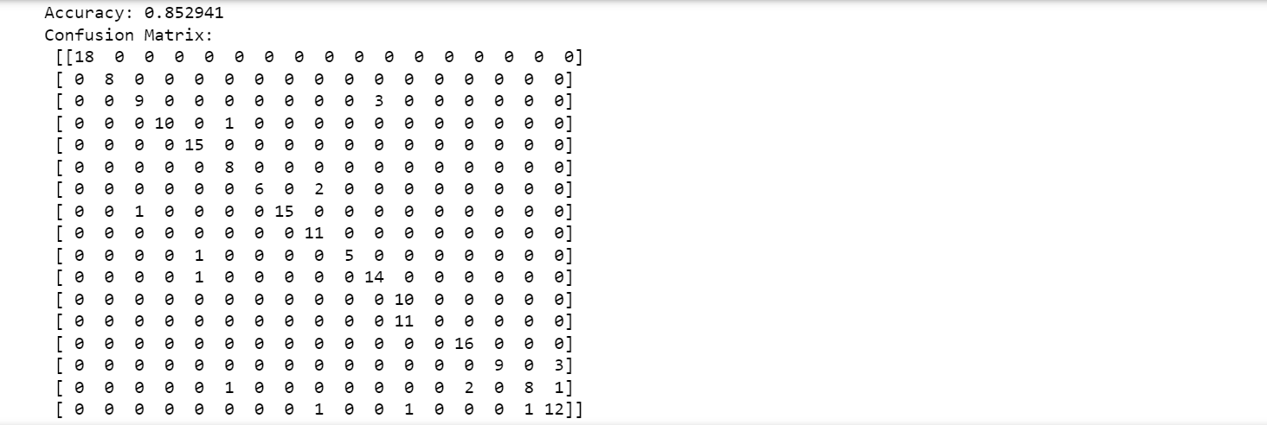

**Case 8:**

[START] Pre-training step:

>> Epoch 1 finished RBM Reconstruction error 43.862700

>> Epoch 2 finished RBM Reconstruction error 43.131203

>> Epoch 3 finished RBM Reconstruction error 43.034387

>> Epoch 4 finished RBM Reconstruction error 43.150786

>> Epoch 5 finished RBM Reconstruction error 43.268527

>> Epoch 6 finished RBM Reconstruction error 43.463622

>> Epoch 7 finished RBM Reconstruction error 43.633679

>> Epoch 8 finished RBM Reconstruction error 43.762163

>> Epoch 9 finished RBM Reconstruction error 44.120498

>> Epoch 10 finished RBM Reconstruction error 44.008004

>> Epoch 1 finished RBM Reconstruction error 11.074246

>> Epoch 2 finished RBM Reconstruction error 7.542301

>> Epoch 3 finished RBM Reconstruction error 5.969889

>> Epoch 4 finished RBM Reconstruction error 5.339882

>> Epoch 5 finished RBM Reconstruction error 5.073346

>> Epoch 6 finished RBM Reconstruction error 4.748718

>> Epoch 7 finished RBM Reconstruction error 4.537777

>> Epoch 8 finished RBM Reconstruction error 4.353485

>> Epoch 9 finished RBM Reconstruction error 4.203320

>> Epoch 10 finished RBM Reconstruction error 4.109626

>> Epoch 1 finished RBM Reconstruction error 4.082773

>> Epoch 2 finished RBM Reconstruction error 1.579649

>> Epoch 3 finished RBM Reconstruction error 1.004919

>> Epoch 4 finished RBM Reconstruction error 0.883139

>> Epoch 5 finished RBM Reconstruction error 0.805344

>> Epoch 6 finished RBM Reconstruction error 0.800753

>> Epoch 7 finished RBM Reconstruction error 0.743595

>> Epoch 8 finished RBM Reconstruction error 0.697562

>> Epoch 9 finished RBM Reconstruction error 0.660530

>> Epoch 10 finished RBM Reconstruction error 0.614470

>> Epoch 1 finished RBM Reconstruction error 3.436915

>> Epoch 2 finished RBM Reconstruction error 1.213127

>> Epoch 3 finished RBM Reconstruction error 0.517840

>> Epoch 4 finished RBM Reconstruction error 0.337148

>> Epoch 5 finished RBM Reconstruction error 0.280519

>> Epoch 6 finished RBM Reconstruction error 0.263852

>> Epoch 7 finished RBM Reconstruction error 0.230781

>> Epoch 8 finished RBM Reconstruction error 0.235931

>> Epoch 9 finished RBM Reconstruction error 0.197512

>> Epoch 10 finished RBM Reconstruction error 0.207421

[END] Pre-training step

[START] Fine tuning step:

>> Epoch 0 finished ANN training loss 2.236196

>> Epoch 1 finished ANN training loss 2.154101

>> Epoch 2 finished ANN training loss 2.241579

>> Epoch 3 finished ANN training loss 2.083358

>> Epoch 4 finished ANN training loss 2.016831

>> Epoch 5 finished ANN training loss 1.860466

>> Epoch 6 finished ANN training loss 2.092218

>> Epoch 7 finished ANN training loss 1.887535

>> Epoch 8 finished ANN training loss 1.762124

>> Epoch 9 finished ANN training loss 1.796763

>> Epoch 10 finished ANN training loss 1.735878

>> Epoch 11 finished ANN training loss 1.643505

>> Epoch 12 finished ANN training loss 1.634183

>> Epoch 13 finished ANN training loss 1.747173

>> Epoch 14 finished ANN training loss 1.578380

>> Epoch 15 finished ANN training loss 1.553794

>> Epoch 16 finished ANN training loss 1.546279

>> Epoch 17 finished ANN training loss 1.521776

>> Epoch 18 finished ANN training loss 1.517237

>> Epoch 19 finished ANN training loss 1.560154

>> Epoch 20 finished ANN training loss 1.457675

>> Epoch 21 finished ANN training loss 1.450898

>> Epoch 22 finished ANN training loss 1.426255

>> Epoch 23 finished ANN training loss 1.402175

>> Epoch 24 finished ANN training loss 1.402005

>> Epoch 25 finished ANN training loss 1.506710

>> Epoch 26 finished ANN training loss 1.372117

>> Epoch 27 finished ANN training loss 1.344714

>> Epoch 28 finished ANN training loss 1.420532

>> Epoch 29 finished ANN training loss 1.331015

>> Epoch 30 finished ANN training loss 1.245345

>> Epoch 31 finished ANN training loss 1.210212

>> Epoch 32 finished ANN training loss 1.238708

>> Epoch 33 finished ANN training loss 1.221147

>> Epoch 34 finished ANN training loss 1.174080

>> Epoch 35 finished ANN training loss 1.265576

>> Epoch 36 finished ANN training loss 1.119487

>> Epoch 37 finished ANN training loss 1.125924

>> Epoch 38 finished ANN training loss 1.067990

>> Epoch 39 finished ANN training loss 1.096529

>> Epoch 40 finished ANN training loss 1.093302

>> Epoch 41 finished ANN training loss 0.997662

>> Epoch 42 finished ANN training loss 0.983302

>> Epoch 43 finished ANN training loss 1.074824

>> Epoch 44 finished ANN training loss 1.075821

>> Epoch 45 finished ANN training loss 0.908324

>> Epoch 46 finished ANN training loss 0.883497

>> Epoch 47 finished ANN training loss 0.919771

>> Epoch 48 finished ANN training loss 1.043951

>> Epoch 49 finished ANN training loss 0.892177

>> Epoch 50 finished ANN training loss 0.837381

>> Epoch 51 finished ANN training loss 0.832067

>> Epoch 52 finished ANN training loss 0.830100

>> Epoch 53 finished ANN training loss 0.807840

>> Epoch 54 finished ANN training loss 0.802779

>> Epoch 55 finished ANN training loss 0.745554

>> Epoch 56 finished ANN training loss 0.906654

>> Epoch 57 finished ANN training loss 0.842373

>> Epoch 58 finished ANN training loss 0.805926

>> Epoch 59 finished ANN training loss 0.855421

>> Epoch 60 finished ANN training loss 0.779791

>> Epoch 61 finished ANN training loss 0.769894

>> Epoch 62 finished ANN training loss 0.826937

>> Epoch 63 finished ANN training loss 0.729880

>> Epoch 64 finished ANN training loss 0.687411

>> Epoch 65 finished ANN training loss 0.702664

>> Epoch 66 finished ANN training loss 0.717851

>> Epoch 67 finished ANN training loss 0.728867

>> Epoch 68 finished ANN training loss 0.713585

>> Epoch 69 finished ANN training loss 0.697073

>> Epoch 70 finished ANN training loss 0.717017

>> Epoch 71 finished ANN training loss 0.660610

>> Epoch 72 finished ANN training loss 0.662168

>> Epoch 73 finished ANN training loss 0.659880

>> Epoch 74 finished ANN training loss 0.642302

>> Epoch 75 finished ANN training loss 0.632477

>> Epoch 76 finished ANN training loss 0.637926

>> Epoch 77 finished ANN training loss 0.706719

>> Epoch 78 finished ANN training loss 0.643955

>> Epoch 79 finished ANN training loss 0.604086

>> Epoch 80 finished ANN training loss 0.698737

>> Epoch 81 finished ANN training loss 0.647504

>> Epoch 82 finished ANN training loss 0.617290

>> Epoch 83 finished ANN training loss 0.609476

>> Epoch 84 finished ANN training loss 0.602303

>> Epoch 85 finished ANN training loss 0.622460

>> Epoch 86 finished ANN training loss 0.611600

>> Epoch 87 finished ANN training loss 0.584281

>> Epoch 88 finished ANN training loss 0.607825

>> Epoch 89 finished ANN training loss 0.603049

>> Epoch 90 finished ANN training loss 0.639664

>> Epoch 91 finished ANN training loss 0.618348

>> Epoch 92 finished ANN training loss 0.580980

>> Epoch 93 finished ANN training loss 0.616672

>> Epoch 94 finished ANN training loss 0.580682

>> Epoch 95 finished ANN training loss 0.572026

>> Epoch 96 finished ANN training loss 0.559155

>> Epoch 97 finished ANN training loss 0.568003

>> Epoch 98 finished ANN training loss 0.541280

>> Epoch 99 finished ANN training loss 0.580273

[END] Fine tuning step

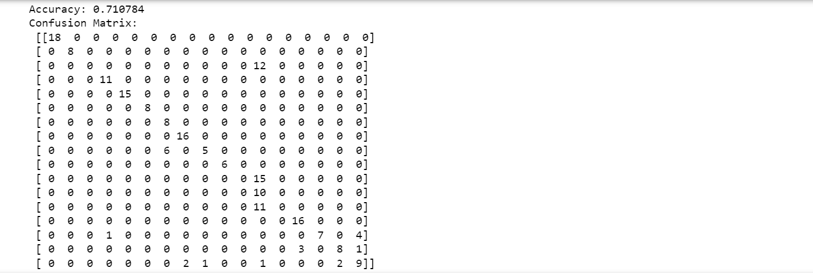

**Case 9:**

[START] Pre-training step:

>> Epoch 1 finished RBM Reconstruction error 43.231257

>> Epoch 2 finished RBM Reconstruction error 42.375992

>> Epoch 3 finished RBM Reconstruction error 42.243234

>> Epoch 4 finished RBM Reconstruction error 42.214945

>> Epoch 5 finished RBM Reconstruction error 42.350674

>> Epoch 6 finished RBM Reconstruction error 42.420852

>> Epoch 7 finished RBM Reconstruction error 42.563558

>> Epoch 8 finished RBM Reconstruction error 42.631410

>> Epoch 9 finished RBM Reconstruction error 42.861455

>> Epoch 10 finished RBM Reconstruction error 42.754961

>> Epoch 1 finished RBM Reconstruction error 9.733202

>> Epoch 2 finished RBM Reconstruction error 6.367573

>> Epoch 3 finished RBM Reconstruction error 5.268157

>> Epoch 4 finished RBM Reconstruction error 4.822360

>> Epoch 5 finished RBM Reconstruction error 4.627028

>> Epoch 6 finished RBM Reconstruction error 4.419239

>> Epoch 7 finished RBM Reconstruction error 4.263068

>> Epoch 8 finished RBM Reconstruction error 4.109338

>> Epoch 9 finished RBM Reconstruction error 3.995229

>> Epoch 10 finished RBM Reconstruction error 3.835503

>> Epoch 1 finished RBM Reconstruction error 3.560134

>> Epoch 2 finished RBM Reconstruction error 1.531209

>> Epoch 3 finished RBM Reconstruction error 0.942849

>> Epoch 4 finished RBM Reconstruction error 0.857359

>> Epoch 5 finished RBM Reconstruction error 0.817596

>> Epoch 6 finished RBM Reconstruction error 0.791272

>> Epoch 7 finished RBM Reconstruction error 0.732284

>> Epoch 8 finished RBM Reconstruction error 0.695379

>> Epoch 9 finished RBM Reconstruction error 0.723669

>> Epoch 10 finished RBM Reconstruction error 0.674755

>> Epoch 1 finished RBM Reconstruction error 2.774211

>> Epoch 2 finished RBM Reconstruction error 1.092773

>> Epoch 3 finished RBM Reconstruction error 0.459111

>> Epoch 4 finished RBM Reconstruction error 0.312057

>> Epoch 5 finished RBM Reconstruction error 0.263150

>> Epoch 6 finished RBM Reconstruction error 0.256782

>> Epoch 7 finished RBM Reconstruction error 0.229957

>> Epoch 8 finished RBM Reconstruction error 0.204971

>> Epoch 9 finished RBM Reconstruction error 0.212785

>> Epoch 10 finished RBM Reconstruction error 0.183680

[END] Pre-training step

[START] Fine tuning step:

>> Epoch 0 finished ANN training loss 2.161781

>> Epoch 1 finished ANN training loss 2.162324

>> Epoch 2 finished ANN training loss 2.231463

>> Epoch 3 finished ANN training loss 2.037632

>> Epoch 4 finished ANN training loss 2.005377

>> Epoch 5 finished ANN training loss 1.926284

>> Epoch 6 finished ANN training loss 2.027987

>> Epoch 7 finished ANN training loss 1.953428

>> Epoch 8 finished ANN training loss 1.832274

>> Epoch 9 finished ANN training loss 1.863648

>> Epoch 10 finished ANN training loss 1.835893

>> Epoch 11 finished ANN training loss 1.673477

>> Epoch 12 finished ANN training loss 1.691658

>> Epoch 13 finished ANN training loss 1.692844

>> Epoch 14 finished ANN training loss 1.663815

>> Epoch 15 finished ANN training loss 1.615688

>> Epoch 16 finished ANN training loss 1.618857

>> Epoch 17 finished ANN training loss 1.618945

>> Epoch 18 finished ANN training loss 1.594308

>> Epoch 19 finished ANN training loss 1.616004

>> Epoch 20 finished ANN training loss 1.566871

>> Epoch 21 finished ANN training loss 1.586625

>> Epoch 22 finished ANN training loss 1.526542

>> Epoch 23 finished ANN training loss 1.529343

>> Epoch 24 finished ANN training loss 1.497098

>> Epoch 25 finished ANN training loss 1.551028

>> Epoch 26 finished ANN training loss 1.448715

>> Epoch 27 finished ANN training loss 1.457039

>> Epoch 28 finished ANN training loss 1.531772

>> Epoch 29 finished ANN training loss 1.426155

>> Epoch 30 finished ANN training loss 1.395560

>> Epoch 31 finished ANN training loss 1.373403

>> Epoch 32 finished ANN training loss 1.393595

>> Epoch 33 finished ANN training loss 1.356537

>> Epoch 34 finished ANN training loss 1.338161

>> Epoch 35 finished ANN training loss 1.357755

>> Epoch 36 finished ANN training loss 1.334401

>> Epoch 37 finished ANN training loss 1.326859

>> Epoch 38 finished ANN training loss 1.294037

>> Epoch 39 finished ANN training loss 1.310475

>> Epoch 40 finished ANN training loss 1.285604

>> Epoch 41 finished ANN training loss 1.251143

>> Epoch 42 finished ANN training loss 1.238622

>> Epoch 43 finished ANN training loss 1.244420

>> Epoch 44 finished ANN training loss 1.227694

>> Epoch 45 finished ANN training loss 1.234250

>> Epoch 46 finished ANN training loss 1.192151

>> Epoch 47 finished ANN training loss 1.282872

>> Epoch 48 finished ANN training loss 1.202125

>> Epoch 49 finished ANN training loss 1.195783

>> Epoch 50 finished ANN training loss 1.173911

>> Epoch 51 finished ANN training loss 1.180761

>> Epoch 52 finished ANN training loss 1.126582

>> Epoch 53 finished ANN training loss 1.107668

>> Epoch 54 finished ANN training loss 1.080279

>> Epoch 55 finished ANN training loss 1.054442

>> Epoch 56 finished ANN training loss 1.064081

>> Epoch 57 finished ANN training loss 1.106891

>> Epoch 58 finished ANN training loss 1.017401

>> Epoch 59 finished ANN training loss 1.091074

>> Epoch 60 finished ANN training loss 1.101666

>> Epoch 61 finished ANN training loss 0.970878

>> Epoch 62 finished ANN training loss 0.990581

>> Epoch 63 finished ANN training loss 0.924880

>> Epoch 64 finished ANN training loss 0.933200

>> Epoch 65 finished ANN training loss 0.888013

>> Epoch 66 finished ANN training loss 0.914845

>> Epoch 67 finished ANN training loss 0.895561

>> Epoch 68 finished ANN training loss 0.862002

>> Epoch 69 finished ANN training loss 0.860283

>> Epoch 70 finished ANN training loss 0.926866

>> Epoch 71 finished ANN training loss 0.825624

>> Epoch 72 finished ANN training loss 0.955979

>> Epoch 73 finished ANN training loss 0.837455

>> Epoch 74 finished ANN training loss 0.838362

>> Epoch 75 finished ANN training loss 0.824579

>> Epoch 76 finished ANN training loss 0.837506

>> Epoch 77 finished ANN training loss 0.799540

>> Epoch 78 finished ANN training loss 0.782582

>> Epoch 79 finished ANN training loss 0.809945

>> Epoch 80 finished ANN training loss 0.776058

>> Epoch 81 finished ANN training loss 0.801965

>> Epoch 82 finished ANN training loss 0.743689

>> Epoch 83 finished ANN training loss 0.748219

>> Epoch 84 finished ANN training loss 0.725424

>> Epoch 85 finished ANN training loss 0.707048

>> Epoch 86 finished ANN training loss 0.760290

>> Epoch 87 finished ANN training loss 0.732380

>> Epoch 88 finished ANN training loss 0.725342

>> Epoch 89 finished ANN training loss 0.722347

>> Epoch 90 finished ANN training loss 0.747846

>> Epoch 91 finished ANN training loss 0.766685

>> Epoch 92 finished ANN training loss 0.678031

>> Epoch 93 finished ANN training loss 0.728679

>> Epoch 94 finished ANN training loss 0.665033

>> Epoch 95 finished ANN training loss 0.704792

>> Epoch 96 finished ANN training loss 0.666352

>> Epoch 97 finished ANN training loss 0.711128

>> Epoch 98 finished ANN training loss 0.653001

>> Epoch 99 finished ANN training loss 0.628350

[END] Fine tuning step

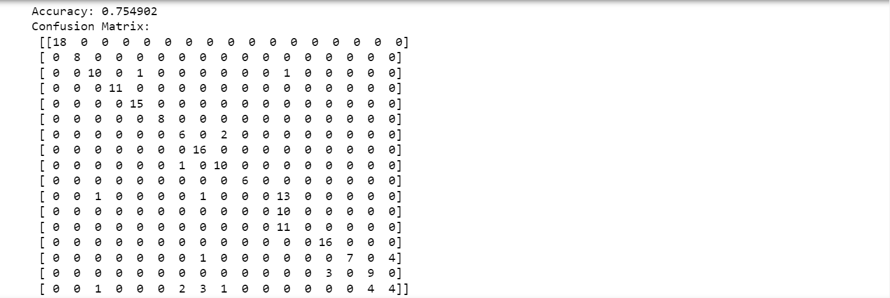

**Case 10:**

[START] Pre-training step:

>> Epoch 1 finished RBM Reconstruction error 41.780271

>> Epoch 2 finished RBM Reconstruction error 40.872977

>> Epoch 3 finished RBM Reconstruction error 41.017986

>> Epoch 4 finished RBM Reconstruction error 41.373823

>> Epoch 5 finished RBM Reconstruction error 41.698571

>> Epoch 6 finished RBM Reconstruction error 41.948013

>> Epoch 7 finished RBM Reconstruction error 42.196067

>> Epoch 8 finished RBM Reconstruction error 42.439778

>> Epoch 9 finished RBM Reconstruction error 42.863548

>> Epoch 10 finished RBM Reconstruction error 42.649242

>> Epoch 1 finished RBM Reconstruction error 14.179907

>> Epoch 2 finished RBM Reconstruction error 10.724631

>> Epoch 3 finished RBM Reconstruction error 9.625305

>> Epoch 4 finished RBM Reconstruction error 8.980324

>> Epoch 5 finished RBM Reconstruction error 8.484160

>> Epoch 6 finished RBM Reconstruction error 7.885944

>> Epoch 7 finished RBM Reconstruction error 7.560121

>> Epoch 8 finished RBM Reconstruction error 6.955149

>> Epoch 9 finished RBM Reconstruction error 6.810843

>> Epoch 10 finished RBM Reconstruction error 6.380751

>> Epoch 1 finished RBM Reconstruction error 5.757024

>> Epoch 2 finished RBM Reconstruction error 4.113161

>> Epoch 3 finished RBM Reconstruction error 3.063645

>> Epoch 4 finished RBM Reconstruction error 2.526045

>> Epoch 5 finished RBM Reconstruction error 2.097313

>> Epoch 6 finished RBM Reconstruction error 1.734041

>> Epoch 7 finished RBM Reconstruction error 1.423209

>> Epoch 8 finished RBM Reconstruction error 1.144207

>> Epoch 9 finished RBM Reconstruction error 1.041854

>> Epoch 10 finished RBM Reconstruction error 0.907573

>> Epoch 1 finished RBM Reconstruction error 4.189174

>> Epoch 2 finished RBM Reconstruction error 2.415335

>> Epoch 3 finished RBM Reconstruction error 1.955680

>> Epoch 4 finished RBM Reconstruction error 1.743029

>> Epoch 5 finished RBM Reconstruction error 1.464093

>> Epoch 6 finished RBM Reconstruction error 1.215696

>> Epoch 7 finished RBM Reconstruction error 1.052109

>> Epoch 8 finished RBM Reconstruction error 0.962401

>> Epoch 9 finished RBM Reconstruction error 0.828475

>> Epoch 10 finished RBM Reconstruction error 0.752980

[END] Pre-training step

[START] Fine tuning step:

>> Epoch 0 finished ANN training loss 2.355754

>> Epoch 1 finished ANN training loss 2.005809

>> Epoch 2 finished ANN training loss 1.949715

>> Epoch 3 finished ANN training loss 1.816342

>> Epoch 4 finished ANN training loss 1.468088

>> Epoch 5 finished ANN training loss 1.378142

>> Epoch 6 finished ANN training loss 1.732937

>> Epoch 7 finished ANN training loss 1.304914

>> Epoch 8 finished ANN training loss 1.208001

>> Epoch 9 finished ANN training loss 1.296047

>> Epoch 10 finished ANN training loss 1.338111

>> Epoch 11 finished ANN training loss 1.184829

>> Epoch 12 finished ANN training loss 1.196126

>> Epoch 13 finished ANN training loss 1.291828

>> Epoch 14 finished ANN training loss 0.966330

>> Epoch 15 finished ANN training loss 1.119303

>> Epoch 16 finished ANN training loss 1.046144

>> Epoch 17 finished ANN training loss 1.036193

>> Epoch 18 finished ANN training loss 0.796963

>> Epoch 19 finished ANN training loss 0.966526

>> Epoch 20 finished ANN training loss 0.884428

>> Epoch 21 finished ANN training loss 0.799144

>> Epoch 22 finished ANN training loss 1.092183

>> Epoch 23 finished ANN training loss 0.710476

>> Epoch 24 finished ANN training loss 0.769813

>> Epoch 25 finished ANN training loss 1.368138

>> Epoch 26 finished ANN training loss 0.828462

>> Epoch 27 finished ANN training loss 0.812755

>> Epoch 28 finished ANN training loss 0.726576

>> Epoch 29 finished ANN training loss 0.920830

>> Epoch 30 finished ANN training loss 0.821545

>> Epoch 31 finished ANN training loss 0.601399

>> Epoch 32 finished ANN training loss 0.741971

>> Epoch 33 finished ANN training loss 0.607226

>> Epoch 34 finished ANN training loss 0.659265

>> Epoch 35 finished ANN training loss 0.672722

>> Epoch 36 finished ANN training loss 1.319239

>> Epoch 37 finished ANN training loss 0.686871

>> Epoch 38 finished ANN training loss 0.555630

>> Epoch 39 finished ANN training loss 0.632449

>> Epoch 40 finished ANN training loss 0.636977

>> Epoch 41 finished ANN training loss 0.565965

>> Epoch 42 finished ANN training loss 0.552924

>> Epoch 43 finished ANN training loss 0.667722

>> Epoch 44 finished ANN training loss 0.747259

>> Epoch 45 finished ANN training loss 0.532093

>> Epoch 46 finished ANN training loss 0.589623

>> Epoch 47 finished ANN training loss 0.713966

>> Epoch 48 finished ANN training loss 0.498352

>> Epoch 49 finished ANN training loss 0.561103

>> Epoch 50 finished ANN training loss 0.566664

>> Epoch 51 finished ANN training loss 0.807969

>> Epoch 52 finished ANN training loss 0.521493

>> Epoch 53 finished ANN training loss 0.504521

>> Epoch 54 finished ANN training loss 0.541450

>> Epoch 55 finished ANN training loss 0.443279

>> Epoch 56 finished ANN training loss 0.606393

>> Epoch 57 finished ANN training loss 0.653897

>> Epoch 58 finished ANN training loss 0.602503

>> Epoch 59 finished ANN training loss 0.574262

>> Epoch 60 finished ANN training loss 0.541535

>> Epoch 61 finished ANN training loss 0.525864

>> Epoch 62 finished ANN training loss 0.444652

>> Epoch 63 finished ANN training loss 0.430767

>> Epoch 64 finished ANN training loss 0.644912

>> Epoch 65 finished ANN training loss 0.474384

>> Epoch 66 finished ANN training loss 0.450690

>> Epoch 67 finished ANN training loss 0.492417

>> Epoch 68 finished ANN training loss 0.621144

>> Epoch 69 finished ANN training loss 0.395571

>> Epoch 70 finished ANN training loss 0.458535

>> Epoch 71 finished ANN training loss 0.382509

>> Epoch 72 finished ANN training loss 0.530205

>> Epoch 73 finished ANN training loss 0.546226

>> Epoch 74 finished ANN training loss 0.395878

>> Epoch 75 finished ANN training loss 0.387898

>> Epoch 76 finished ANN training loss 0.364658

>> Epoch 77 finished ANN training loss 0.491180

>> Epoch 78 finished ANN training loss 0.339123

>> Epoch 79 finished ANN training loss 0.460687

>> Epoch 80 finished ANN training loss 0.424633

>> Epoch 81 finished ANN training loss 0.486973

>> Epoch 82 finished ANN training loss 0.357474

>> Epoch 83 finished ANN training loss 0.382459

>> Epoch 84 finished ANN training loss 0.313187

>> Epoch 85 finished ANN training loss 0.330671

>> Epoch 86 finished ANN training loss 0.360356

>> Epoch 87 finished ANN training loss 0.633519

>> Epoch 88 finished ANN training loss 0.728780

>> Epoch 89 finished ANN training loss 0.295521

>> Epoch 90 finished ANN training loss 0.308737

>> Epoch 91 finished ANN training loss 0.480726

>> Epoch 92 finished ANN training loss 0.407640

>> Epoch 93 finished ANN training loss 0.310695

>> Epoch 94 finished ANN training loss 0.247827

>> Epoch 95 finished ANN training loss 0.411460

>> Epoch 96 finished ANN training loss 0.351295

>> Epoch 97 finished ANN training loss 0.246896

>> Epoch 98 finished ANN training loss 0.243083

>> Epoch 99 finished ANN training loss 0.299315

[END] Fine tuning step

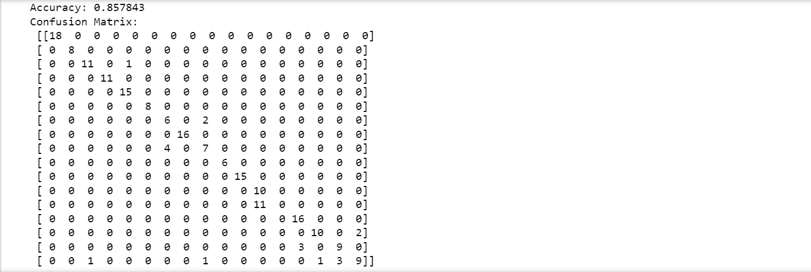

**Case 11:**

[START] Pre-training step:

>> Epoch 1 finished RBM Reconstruction error 41.792308

>> Epoch 2 finished RBM Reconstruction error 40.697907

>> Epoch 3 finished RBM Reconstruction error 40.745301

>> Epoch 4 finished RBM Reconstruction error 40.877579

>> Epoch 5 finished RBM Reconstruction error 41.123398

>> Epoch 6 finished RBM Reconstruction error 41.327932

>> Epoch 7 finished RBM Reconstruction error 41.602009

>> Epoch 8 finished RBM Reconstruction error 41.763390

>> Epoch 9 finished RBM Reconstruction error 42.133638

>> Epoch 10 finished RBM Reconstruction error 41.999716

>> Epoch 1 finished RBM Reconstruction error 13.749287

>> Epoch 2 finished RBM Reconstruction error 10.896676

>> Epoch 3 finished RBM Reconstruction error 10.036325

>> Epoch 4 finished RBM Reconstruction error 9.319138

>> Epoch 5 finished RBM Reconstruction error 8.862726

>> Epoch 6 finished RBM Reconstruction error 8.321328

>> Epoch 7 finished RBM Reconstruction error 7.879983

>> Epoch 8 finished RBM Reconstruction error 7.386158

>> Epoch 9 finished RBM Reconstruction error 7.215208

>> Epoch 10 finished RBM Reconstruction error 6.832676

>> Epoch 1 finished RBM Reconstruction error 6.196856

>> Epoch 2 finished RBM Reconstruction error 4.699625

>> Epoch 3 finished RBM Reconstruction error 3.261836

>> Epoch 4 finished RBM Reconstruction error 2.646699

>> Epoch 5 finished RBM Reconstruction error 2.082705

>> Epoch 6 finished RBM Reconstruction error 1.679480

>> Epoch 7 finished RBM Reconstruction error 1.360283

>> Epoch 8 finished RBM Reconstruction error 1.247703

>> Epoch 9 finished RBM Reconstruction error 1.059702

>> Epoch 10 finished RBM Reconstruction error 0.925052

>> Epoch 1 finished RBM Reconstruction error 3.949530

>> Epoch 2 finished RBM Reconstruction error 2.221192

>> Epoch 3 finished RBM Reconstruction error 1.842948

>> Epoch 4 finished RBM Reconstruction error 1.674798

>> Epoch 5 finished RBM Reconstruction error 1.392542

>> Epoch 6 finished RBM Reconstruction error 1.244112

>> Epoch 7 finished RBM Reconstruction error 1.069062

>> Epoch 8 finished RBM Reconstruction error 0.922722

>> Epoch 9 finished RBM Reconstruction error 0.873899

>> Epoch 10 finished RBM Reconstruction error 0.741341

[END] Pre-training step

[START] Fine tuning step:

>> Epoch 0 finished ANN training loss 2.303955

>> Epoch 1 finished ANN training loss 1.943863

>> Epoch 2 finished ANN training loss 2.000633

>> Epoch 3 finished ANN training loss 1.531922

>> Epoch 4 finished ANN training loss 1.559560

>> Epoch 5 finished ANN training loss 1.439424

>> Epoch 6 finished ANN training loss 1.793061

>> Epoch 7 finished ANN training loss 1.361017

>> Epoch 8 finished ANN training loss 1.248379

>> Epoch 9 finished ANN training loss 1.297007

>> Epoch 10 finished ANN training loss 1.270400

>> Epoch 11 finished ANN training loss 1.072484

>> Epoch 12 finished ANN training loss 1.065917

>> Epoch 13 finished ANN training loss 1.206617

>> Epoch 14 finished ANN training loss 0.970444

>> Epoch 15 finished ANN training loss 1.100040

>> Epoch 16 finished ANN training loss 0.990905

>> Epoch 17 finished ANN training loss 0.926904

>> Epoch 18 finished ANN training loss 0.989692

>> Epoch 19 finished ANN training loss 0.954614

>> Epoch 20 finished ANN training loss 0.921462

>> Epoch 21 finished ANN training loss 0.916566

>> Epoch 22 finished ANN training loss 0.789039

>> Epoch 23 finished ANN training loss 0.955643

>> Epoch 24 finished ANN training loss 0.683763

>> Epoch 25 finished ANN training loss 1.111770

>> Epoch 26 finished ANN training loss 0.810240

>> Epoch 27 finished ANN training loss 0.802449

>> Epoch 28 finished ANN training loss 0.831219

>> Epoch 29 finished ANN training loss 0.703080

>> Epoch 30 finished ANN training loss 0.751760

>> Epoch 31 finished ANN training loss 0.987825

>> Epoch 32 finished ANN training loss 0.728653

>> Epoch 33 finished ANN training loss 0.605071

>> Epoch 34 finished ANN training loss 0.819282

>> Epoch 35 finished ANN training loss 0.716283

>> Epoch 36 finished ANN training loss 0.839047

>> Epoch 37 finished ANN training loss 0.659773

>> Epoch 38 finished ANN training loss 0.572167

>> Epoch 39 finished ANN training loss 0.534373

>> Epoch 40 finished ANN training loss 0.544591

>> Epoch 41 finished ANN training loss 0.573683

>> Epoch 42 finished ANN training loss 0.520078

>> Epoch 43 finished ANN training loss 0.724189

>> Epoch 44 finished ANN training loss 0.870827

>> Epoch 45 finished ANN training loss 0.642290

>> Epoch 46 finished ANN training loss 0.502335

>> Epoch 47 finished ANN training loss 0.575561

>> Epoch 48 finished ANN training loss 0.479302

>> Epoch 49 finished ANN training loss 0.470576

>> Epoch 50 finished ANN training loss 0.510612

>> Epoch 51 finished ANN training loss 0.571177

>> Epoch 52 finished ANN training loss 0.502410

>> Epoch 53 finished ANN training loss 0.601242

>> Epoch 54 finished ANN training loss 0.475851

>> Epoch 55 finished ANN training loss 0.661030

>> Epoch 56 finished ANN training loss 0.400963

>> Epoch 57 finished ANN training loss 0.525064

>> Epoch 58 finished ANN training loss 0.421402

>> Epoch 59 finished ANN training loss 0.568796

>> Epoch 60 finished ANN training loss 0.512244

>> Epoch 61 finished ANN training loss 0.463851

>> Epoch 62 finished ANN training loss 0.402834

>> Epoch 63 finished ANN training loss 0.513126

>> Epoch 64 finished ANN training loss 0.670645

>> Epoch 65 finished ANN training loss 1.002682

>> Epoch 66 finished ANN training loss 0.373528

>> Epoch 67 finished ANN training loss 0.464029

>> Epoch 68 finished ANN training loss 0.445517

>> Epoch 69 finished ANN training loss 0.511435

>> Epoch 70 finished ANN training loss 0.706556

>> Epoch 71 finished ANN training loss 0.391917

>> Epoch 72 finished ANN training loss 0.424611

>> Epoch 73 finished ANN training loss 0.362159

>> Epoch 74 finished ANN training loss 0.381115

>> Epoch 75 finished ANN training loss 0.321061

>> Epoch 76 finished ANN training loss 0.338619

>> Epoch 77 finished ANN training loss 0.424649

>> Epoch 78 finished ANN training loss 0.333186

>> Epoch 79 finished ANN training loss 0.335362

>> Epoch 80 finished ANN training loss 0.375474

>> Epoch 81 finished ANN training loss 0.392937

>> Epoch 82 finished ANN training loss 0.351414

>> Epoch 83 finished ANN training loss 0.320896

>> Epoch 84 finished ANN training loss 0.374062

>> Epoch 85 finished ANN training loss 0.313674

>> Epoch 86 finished ANN training loss 0.330555

>> Epoch 87 finished ANN training loss 0.304709

>> Epoch 88 finished ANN training loss 0.310597

>> Epoch 89 finished ANN training loss 0.318290

>> Epoch 90 finished ANN training loss 0.359511

>> Epoch 91 finished ANN training loss 0.328263

>> Epoch 92 finished ANN training loss 0.311251

>> Epoch 93 finished ANN training loss 0.362394

>> Epoch 94 finished ANN training loss 0.302975

>> Epoch 95 finished ANN training loss 0.317551

>> Epoch 96 finished ANN training loss 0.351703

>> Epoch 97 finished ANN training loss 0.329673

>> Epoch 98 finished ANN training loss 0.299616

>> Epoch 99 finished ANN training loss 0.285132

[END] Fine tuning step

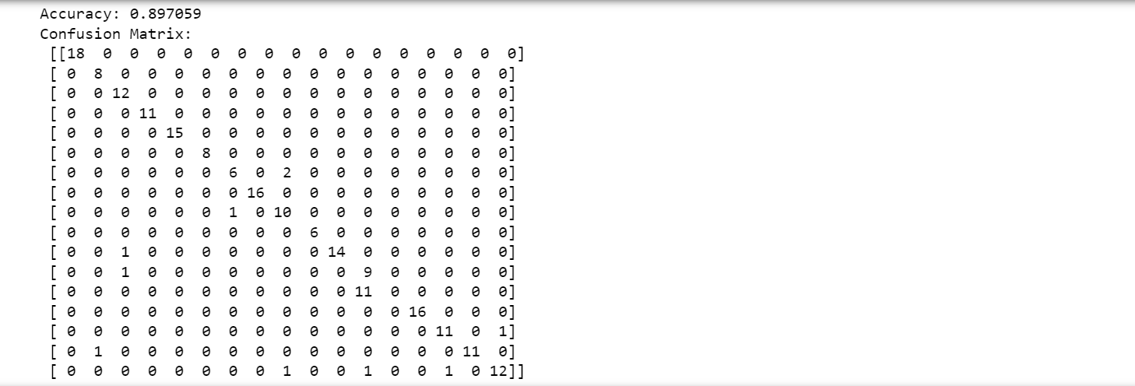

**Case 12:**

[START] Pre-training step:

>> Epoch 1 finished RBM Reconstruction error 41.928273

>> Epoch 2 finished RBM Reconstruction error 41.062688

>> Epoch 3 finished RBM Reconstruction error 41.101849

>> Epoch 4 finished RBM Reconstruction error 41.365208

>> Epoch 5 finished RBM Reconstruction error 41.580365

>> Epoch 6 finished RBM Reconstruction error 41.780221

>> Epoch 7 finished RBM Reconstruction error 41.989691

>> Epoch 8 finished RBM Reconstruction error 42.163667

>> Epoch 9 finished RBM Reconstruction error 42.410279

>> Epoch 10 finished RBM Reconstruction error 42.337359

>> Epoch 1 finished RBM Reconstruction error 14.425925

>> Epoch 2 finished RBM Reconstruction error 10.897882

>> Epoch 3 finished RBM Reconstruction error 9.837923

>> Epoch 4 finished RBM Reconstruction error 9.177402

>> Epoch 5 finished RBM Reconstruction error 8.672123

>> Epoch 6 finished RBM Reconstruction error 8.027297

>> Epoch 7 finished RBM Reconstruction error 7.678715

>> Epoch 8 finished RBM Reconstruction error 7.128404

>> Epoch 9 finished RBM Reconstruction error 7.032723

>> Epoch 10 finished RBM Reconstruction error 6.574803

>> Epoch 1 finished RBM Reconstruction error 6.645475

>> Epoch 2 finished RBM Reconstruction error 4.554062

>> Epoch 3 finished RBM Reconstruction error 3.460196

>> Epoch 4 finished RBM Reconstruction error 2.608315

>> Epoch 5 finished RBM Reconstruction error 2.176655

>> Epoch 6 finished RBM Reconstruction error 1.982105

>> Epoch 7 finished RBM Reconstruction error 1.601931

>> Epoch 8 finished RBM Reconstruction error 1.270529

>> Epoch 9 finished RBM Reconstruction error 1.165354

>> Epoch 10 finished RBM Reconstruction error 0.980679

>> Epoch 1 finished RBM Reconstruction error 4.217915

>> Epoch 2 finished RBM Reconstruction error 2.180746

>> Epoch 3 finished RBM Reconstruction error 1.848991

>> Epoch 4 finished RBM Reconstruction error 1.479886

>> Epoch 5 finished RBM Reconstruction error 1.336478

>> Epoch 6 finished RBM Reconstruction error 1.159839

>> Epoch 7 finished RBM Reconstruction error 0.973260

>> Epoch 8 finished RBM Reconstruction error 0.918541

>> Epoch 9 finished RBM Reconstruction error 0.740847

>> Epoch 10 finished RBM Reconstruction error 0.671451

[END] Pre-training step

[START] Fine tuning step:

>> Epoch 0 finished ANN training loss 2.299225

>> Epoch 1 finished ANN training loss 2.094565

>> Epoch 2 finished ANN training loss 2.055731

>> Epoch 3 finished ANN training loss 2.129252

>> Epoch 4 finished ANN training loss 1.651600

>> Epoch 5 finished ANN training loss 1.491005

>> Epoch 6 finished ANN training loss 1.797554

>> Epoch 7 finished ANN training loss 1.563263

>> Epoch 8 finished ANN training loss 1.392459

>> Epoch 9 finished ANN training loss 1.443025

>> Epoch 10 finished ANN training loss 1.463212

>> Epoch 11 finished ANN training loss 1.301476

>> Epoch 12 finished ANN training loss 1.207085

>> Epoch 13 finished ANN training loss 1.442973

>> Epoch 14 finished ANN training loss 1.239788

>> Epoch 15 finished ANN training loss 1.191382

>> Epoch 16 finished ANN training loss 1.172073

>> Epoch 17 finished ANN training loss 1.092896

>> Epoch 18 finished ANN training loss 1.051139

>> Epoch 19 finished ANN training loss 1.121554

>> Epoch 20 finished ANN training loss 1.149510

>> Epoch 21 finished ANN training loss 1.085826

>> Epoch 22 finished ANN training loss 0.965453

>> Epoch 23 finished ANN training loss 0.944914

>> Epoch 24 finished ANN training loss 0.970495

>> Epoch 25 finished ANN training loss 0.902461

>> Epoch 26 finished ANN training loss 0.856993

>> Epoch 27 finished ANN training loss 0.955770

>> Epoch 28 finished ANN training loss 1.027274

>> Epoch 29 finished ANN training loss 0.857773

>> Epoch 30 finished ANN training loss 0.852348

>> Epoch 31 finished ANN training loss 0.889136

>> Epoch 32 finished ANN training loss 0.859254

>> Epoch 33 finished ANN training loss 0.787451

>> Epoch 34 finished ANN training loss 0.823568

>> Epoch 35 finished ANN training loss 0.880880

>> Epoch 36 finished ANN training loss 0.783373

>> Epoch 37 finished ANN training loss 0.878841

>> Epoch 38 finished ANN training loss 0.762410

>> Epoch 39 finished ANN training loss 0.925957

>> Epoch 40 finished ANN training loss 0.836307

>> Epoch 41 finished ANN training loss 0.707972

>> Epoch 42 finished ANN training loss 0.768072

>> Epoch 43 finished ANN training loss 0.729777

>> Epoch 44 finished ANN training loss 0.858946

>> Epoch 45 finished ANN training loss 0.731328

>> Epoch 46 finished ANN training loss 0.702854

>> Epoch 47 finished ANN training loss 0.747056

>> Epoch 48 finished ANN training loss 0.682895

>> Epoch 49 finished ANN training loss 0.818870

>> Epoch 50 finished ANN training loss 0.665726

>> Epoch 51 finished ANN training loss 0.716408

>> Epoch 52 finished ANN training loss 0.625661

>> Epoch 53 finished ANN training loss 0.659843

>> Epoch 54 finished ANN training loss 0.663048

>> Epoch 55 finished ANN training loss 0.585904

>> Epoch 56 finished ANN training loss 0.637196

>> Epoch 57 finished ANN training loss 0.667233

>> Epoch 58 finished ANN training loss 0.584763

>> Epoch 59 finished ANN training loss 0.752489

>> Epoch 60 finished ANN training loss 0.657930

>> Epoch 61 finished ANN training loss 0.616332

>> Epoch 62 finished ANN training loss 0.654013

>> Epoch 63 finished ANN training loss 0.616264

>> Epoch 64 finished ANN training loss 0.688015

>> Epoch 65 finished ANN training loss 0.565256

>> Epoch 66 finished ANN training loss 0.541758

>> Epoch 67 finished ANN training loss 0.529538

>> Epoch 68 finished ANN training loss 0.518958

>> Epoch 69 finished ANN training loss 0.608546

>> Epoch 70 finished ANN training loss 0.854384

>> Epoch 71 finished ANN training loss 0.542631

>> Epoch 72 finished ANN training loss 0.629748

>> Epoch 73 finished ANN training loss 0.549381

>> Epoch 74 finished ANN training loss 0.554504

>> Epoch 75 finished ANN training loss 0.643439

>> Epoch 76 finished ANN training loss 0.545011

>> Epoch 77 finished ANN training loss 0.509667

>> Epoch 78 finished ANN training loss 0.625169

>> Epoch 79 finished ANN training loss 0.559927

>> Epoch 80 finished ANN training loss 0.629732

>> Epoch 81 finished ANN training loss 0.535591

>> Epoch 82 finished ANN training loss 0.512410

>> Epoch 83 finished ANN training loss 0.521489

>> Epoch 84 finished ANN training loss 0.478122

>> Epoch 85 finished ANN training loss 0.445746

>> Epoch 86 finished ANN training loss 0.481189

>> Epoch 87 finished ANN training loss 0.467566

>> Epoch 88 finished ANN training loss 0.516752

>> Epoch 89 finished ANN training loss 0.448772

>> Epoch 90 finished ANN training loss 0.580619

>> Epoch 91 finished ANN training loss 0.514983

>> Epoch 92 finished ANN training loss 0.485222

>> Epoch 93 finished ANN training loss 0.448501

>> Epoch 94 finished ANN training loss 0.578910

>> Epoch 95 finished ANN training loss 0.402924

>> Epoch 96 finished ANN training loss 0.465109

>> Epoch 97 finished ANN training loss 0.477062

>> Epoch 98 finished ANN training loss 0.492936

>> Epoch 99 finished ANN training loss 0.441270

[END] Fine tuning step

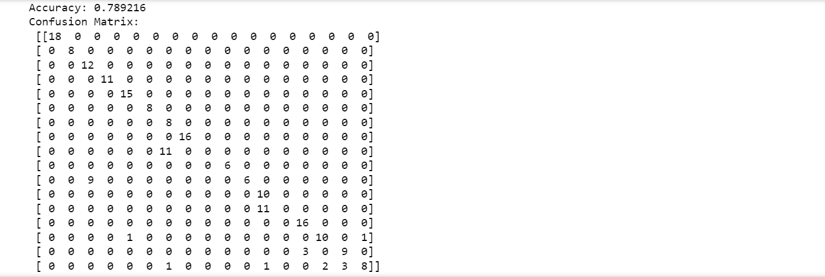

**Case 13:**

[START] Pre-training step:

>> Epoch 1 finished RBM Reconstruction error 43.996420

>> Epoch 2 finished RBM Reconstruction error 42.872291

>> Epoch 3 finished RBM Reconstruction error 42.578621

>> Epoch 4 finished RBM Reconstruction error 42.563326

>> Epoch 5 finished RBM Reconstruction error 42.745222

>> Epoch 6 finished RBM Reconstruction error 42.918616

>> Epoch 7 finished RBM Reconstruction error 43.089202

>> Epoch 8 finished RBM Reconstruction error 43.303874

>> Epoch 9 finished RBM Reconstruction error 43.557284

>> Epoch 10 finished RBM Reconstruction error 43.464297

>> Epoch 1 finished RBM Reconstruction error 9.802981

>> Epoch 2 finished RBM Reconstruction error 6.206737

>> Epoch 3 finished RBM Reconstruction error 4.927590

>> Epoch 4 finished RBM Reconstruction error 4.479526

>> Epoch 5 finished RBM Reconstruction error 4.279783

>> Epoch 6 finished RBM Reconstruction error 4.175113

>> Epoch 7 finished RBM Reconstruction error 3.988726

>> Epoch 8 finished RBM Reconstruction error 3.847451

>> Epoch 9 finished RBM Reconstruction error 3.718203

>> Epoch 10 finished RBM Reconstruction error 3.574889

>> Epoch 1 finished RBM Reconstruction error 3.725893

>> Epoch 2 finished RBM Reconstruction error 1.769416

>> Epoch 3 finished RBM Reconstruction error 0.991826

>> Epoch 4 finished RBM Reconstruction error 0.793316

>> Epoch 5 finished RBM Reconstruction error 0.805093

>> Epoch 6 finished RBM Reconstruction error 0.699267

>> Epoch 7 finished RBM Reconstruction error 0.685677

>> Epoch 8 finished RBM Reconstruction error 0.630998

>> Epoch 9 finished RBM Reconstruction error 0.595160

>> Epoch 10 finished RBM Reconstruction error 0.570329

>> Epoch 1 finished RBM Reconstruction error 2.900568

>> Epoch 2 finished RBM Reconstruction error 1.137552

>> Epoch 3 finished RBM Reconstruction error 0.497561

>> Epoch 4 finished RBM Reconstruction error 0.333553

>> Epoch 5 finished RBM Reconstruction error 0.268621

>> Epoch 6 finished RBM Reconstruction error 0.253052

>> Epoch 7 finished RBM Reconstruction error 0.232243

>> Epoch 8 finished RBM Reconstruction error 0.229902

>> Epoch 9 finished RBM Reconstruction error 0.215756

>> Epoch 10 finished RBM Reconstruction error 0.214141

>> Epoch 1 finished RBM Reconstruction error 2.834458

>> Epoch 2 finished RBM Reconstruction error 0.821829

>> Epoch 3 finished RBM Reconstruction error 0.406224

>> Epoch 4 finished RBM Reconstruction error 0.247149

>> Epoch 5 finished RBM Reconstruction error 0.241908

>> Epoch 6 finished RBM Reconstruction error 0.182438

>> Epoch 7 finished RBM Reconstruction error 0.159523

>> Epoch 8 finished RBM Reconstruction error 0.169832

>> Epoch 9 finished RBM Reconstruction error 0.142858

>> Epoch 10 finished RBM Reconstruction error 0.134254

>> Epoch 1 finished RBM Reconstruction error 2.700932

>> Epoch 2 finished RBM Reconstruction error 0.854578

>> Epoch 3 finished RBM Reconstruction error 0.315472

>> Epoch 4 finished RBM Reconstruction error 0.200918

>> Epoch 5 finished RBM Reconstruction error 0.143773

>> Epoch 6 finished RBM Reconstruction error 0.135846

>> Epoch 7 finished RBM Reconstruction error 0.137077

>> Epoch 8 finished RBM Reconstruction error 0.114108

>> Epoch 9 finished RBM Reconstruction error 0.114964

>> Epoch 10 finished RBM Reconstruction error 0.091172

[END] Pre-training step

[START] Fine tuning step:

>> Epoch 0 finished ANN training loss 2.248294

>> Epoch 1 finished ANN training loss 2.072932

>> Epoch 2 finished ANN training loss 2.177604

>> Epoch 3 finished ANN training loss 1.989425

>> Epoch 4 finished ANN training loss 2.022398

>> Epoch 5 finished ANN training loss 1.861591

>> Epoch 6 finished ANN training loss 1.825949

>> Epoch 7 finished ANN training loss 1.931408

>> Epoch 8 finished ANN training loss 1.775237

>> Epoch 9 finished ANN training loss 1.752228

>> Epoch 10 finished ANN training loss 1.689339

>> Epoch 11 finished ANN training loss 1.613612

>> Epoch 12 finished ANN training loss 1.703737

>> Epoch 13 finished ANN training loss 1.566033

>> Epoch 14 finished ANN training loss 1.588562

>> Epoch 15 finished ANN training loss 1.563155

>> Epoch 16 finished ANN training loss 1.535912

>> Epoch 17 finished ANN training loss 1.854164

>> Epoch 18 finished ANN training loss 1.730469

>> Epoch 19 finished ANN training loss 1.503639

>> Epoch 20 finished ANN training loss 1.513533

>> Epoch 21 finished ANN training loss 1.482442

>> Epoch 22 finished ANN training loss 1.592499

>> Epoch 23 finished ANN training loss 1.431135

>> Epoch 24 finished ANN training loss 1.594574

>> Epoch 25 finished ANN training loss 1.630303

>> Epoch 26 finished ANN training loss 1.389851

>> Epoch 27 finished ANN training loss 1.451792

>> Epoch 28 finished ANN training loss 1.393417

>> Epoch 29 finished ANN training loss 1.366777

>> Epoch 30 finished ANN training loss 1.457555

>> Epoch 31 finished ANN training loss 1.434905

>> Epoch 32 finished ANN training loss 1.512418

>> Epoch 33 finished ANN training loss 1.322252

>> Epoch 34 finished ANN training loss 1.457784

>> Epoch 35 finished ANN training loss 1.296240

>> Epoch 36 finished ANN training loss 1.328582

>> Epoch 37 finished ANN training loss 1.401475

>> Epoch 38 finished ANN training loss 1.319411

>> Epoch 39 finished ANN training loss 1.239302

>> Epoch 40 finished ANN training loss 1.657244

>> Epoch 41 finished ANN training loss 1.344938

>> Epoch 42 finished ANN training loss 1.279983

>> Epoch 43 finished ANN training loss 1.812382

>> Epoch 44 finished ANN training loss 1.229697

>> Epoch 45 finished ANN training loss 1.176625

>> Epoch 46 finished ANN training loss 1.331004

>> Epoch 47 finished ANN training loss 1.203512

>> Epoch 48 finished ANN training loss 1.235551

>> Epoch 49 finished ANN training loss 1.219181

>> Epoch 50 finished ANN training loss 1.153909

>> Epoch 51 finished ANN training loss 1.154788

>> Epoch 52 finished ANN training loss 1.156716

>> Epoch 53 finished ANN training loss 1.271531

>> Epoch 54 finished ANN training loss 1.212051

>> Epoch 55 finished ANN training loss 1.099769

>> Epoch 56 finished ANN training loss 1.109878

>> Epoch 57 finished ANN training loss 1.106008

>> Epoch 58 finished ANN training loss 1.098744

>> Epoch 59 finished ANN training loss 1.164668

>> Epoch 60 finished ANN training loss 1.085275

>> Epoch 61 finished ANN training loss 1.223306

>> Epoch 62 finished ANN training loss 1.091146

>> Epoch 63 finished ANN training loss 1.078929

>> Epoch 64 finished ANN training loss 1.088696

>> Epoch 65 finished ANN training loss 1.043728

>> Epoch 66 finished ANN training loss 1.021376

>> Epoch 67 finished ANN training loss 1.420218

>> Epoch 68 finished ANN training loss 1.066512

>> Epoch 69 finished ANN training loss 1.283128

>> Epoch 70 finished ANN training loss 0.975086

>> Epoch 71 finished ANN training loss 1.003711

>> Epoch 72 finished ANN training loss 0.966193

>> Epoch 73 finished ANN training loss 1.474280

>> Epoch 74 finished ANN training loss 1.036891

>> Epoch 75 finished ANN training loss 1.074170

>> Epoch 76 finished ANN training loss 0.990111

>> Epoch 77 finished ANN training loss 0.979931

>> Epoch 78 finished ANN training loss 1.038214

>> Epoch 79 finished ANN training loss 0.936215

>> Epoch 80 finished ANN training loss 0.914436

>> Epoch 81 finished ANN training loss 0.909277

>> Epoch 82 finished ANN training loss 0.932924

>> Epoch 83 finished ANN training loss 0.943851

>> Epoch 84 finished ANN training loss 1.005406

>> Epoch 85 finished ANN training loss 0.935902

>> Epoch 86 finished ANN training loss 0.969766

>> Epoch 87 finished ANN training loss 0.866467

>> Epoch 88 finished ANN training loss 0.918294

>> Epoch 89 finished ANN training loss 0.896709

>> Epoch 90 finished ANN training loss 0.962043

>> Epoch 91 finished ANN training loss 0.983880

>> Epoch 92 finished ANN training loss 0.892380

>> Epoch 93 finished ANN training loss 0.881656

>> Epoch 94 finished ANN training loss 0.856115

>> Epoch 95 finished ANN training loss 0.951613

>> Epoch 96 finished ANN training loss 0.970311

>> Epoch 97 finished ANN training loss 0.841004

>> Epoch 98 finished ANN training loss 0.827221

>> Epoch 99 finished ANN training loss 0.894456

[END] Fine tuning step

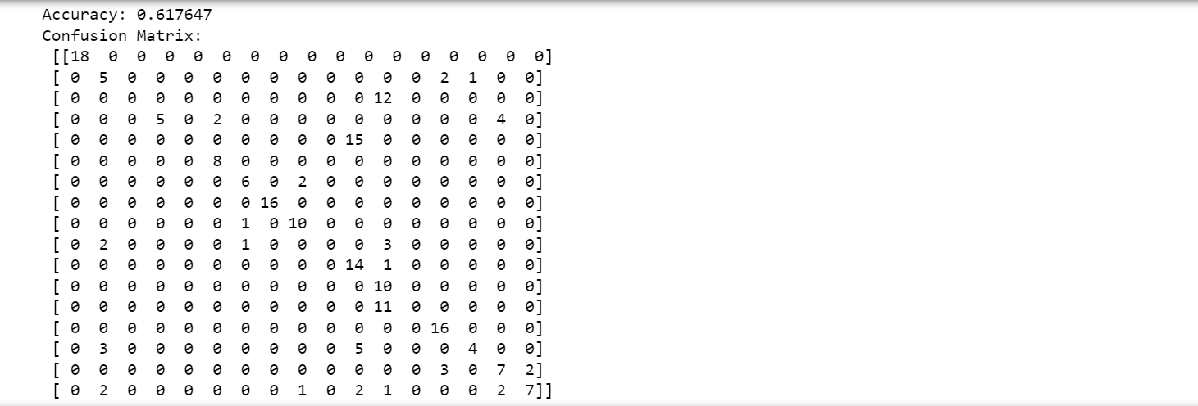

**Case 14:**

[START] Pre-training step:

>> Epoch 1 finished RBM Reconstruction error 43.609389

>> Epoch 2 finished RBM Reconstruction error 42.852918

>> Epoch 3 finished RBM Reconstruction error 42.818830

>> Epoch 4 finished RBM Reconstruction error 42.948735

>> Epoch 5 finished RBM Reconstruction error 43.098784

>> Epoch 6 finished RBM Reconstruction error 43.210891

>> Epoch 7 finished RBM Reconstruction error 43.344079

>> Epoch 8 finished RBM Reconstruction error 43.456196

>> Epoch 9 finished RBM Reconstruction error 43.823303

>> Epoch 10 finished RBM Reconstruction error 43.657357

>> Epoch 1 finished RBM Reconstruction error 10.006001

>> Epoch 2 finished RBM Reconstruction error 6.766770

>> Epoch 3 finished RBM Reconstruction error 5.402900

>> Epoch 4 finished RBM Reconstruction error 4.843395

>> Epoch 5 finished RBM Reconstruction error 4.601433

>> Epoch 6 finished RBM Reconstruction error 4.367920

>> Epoch 7 finished RBM Reconstruction error 4.198896

>> Epoch 8 finished RBM Reconstruction error 4.049663

>> Epoch 9 finished RBM Reconstruction error 3.886069

>> Epoch 10 finished RBM Reconstruction error 3.772066

>> Epoch 1 finished RBM Reconstruction error 3.487273

>> Epoch 2 finished RBM Reconstruction error 1.489269

>> Epoch 3 finished RBM Reconstruction error 0.965596

>> Epoch 4 finished RBM Reconstruction error 0.761787

>> Epoch 5 finished RBM Reconstruction error 0.755818

>> Epoch 6 finished RBM Reconstruction error 0.702527

>> Epoch 7 finished RBM Reconstruction error 0.681450

>> Epoch 8 finished RBM Reconstruction error 0.645232

>> Epoch 9 finished RBM Reconstruction error 0.620193

>> Epoch 10 finished RBM Reconstruction error 0.605889

>> Epoch 1 finished RBM Reconstruction error 2.788723

>> Epoch 2 finished RBM Reconstruction error 1.098556

>> Epoch 3 finished RBM Reconstruction error 0.495889

>> Epoch 4 finished RBM Reconstruction error 0.348530

>> Epoch 5 finished RBM Reconstruction error 0.273225

>> Epoch 6 finished RBM Reconstruction error 0.247271

>> Epoch 7 finished RBM Reconstruction error 0.262507

>> Epoch 8 finished RBM Reconstruction error 0.231410

>> Epoch 9 finished RBM Reconstruction error 0.226878

>> Epoch 10 finished RBM Reconstruction error 0.212868

>> Epoch 1 finished RBM Reconstruction error 3.120102

>> Epoch 2 finished RBM Reconstruction error 1.230270

>> Epoch 3 finished RBM Reconstruction error 0.503536

>> Epoch 4 finished RBM Reconstruction error 0.382528

>> Epoch 5 finished RBM Reconstruction error 0.297488

>> Epoch 6 finished RBM Reconstruction error 0.287956

>> Epoch 7 finished RBM Reconstruction error 0.242032

>> Epoch 8 finished RBM Reconstruction error 0.209689

>> Epoch 9 finished RBM Reconstruction error 0.192010

>> Epoch 10 finished RBM Reconstruction error 0.166104

>> Epoch 1 finished RBM Reconstruction error 2.667175

>> Epoch 2 finished RBM Reconstruction error 1.017357

>> Epoch 3 finished RBM Reconstruction error 0.393063

>> Epoch 4 finished RBM Reconstruction error 0.240559

>> Epoch 5 finished RBM Reconstruction error 0.184447

>> Epoch 6 finished RBM Reconstruction error 0.168247

>> Epoch 7 finished RBM Reconstruction error 0.141622

>> Epoch 8 finished RBM Reconstruction error 0.118455

>> Epoch 9 finished RBM Reconstruction error 0.120852

>> Epoch 10 finished RBM Reconstruction error 0.107916

[END] Pre-training step

[START] Fine tuning step:

>> Epoch 0 finished ANN training loss 2.286046

>> Epoch 1 finished ANN training loss 2.084279

>> Epoch 2 finished ANN training loss 2.157613

>> Epoch 3 finished ANN training loss 2.015646

>> Epoch 4 finished ANN training loss 2.010698

>> Epoch 5 finished ANN training loss 1.912616

>> Epoch 6 finished ANN training loss 1.890512

>> Epoch 7 finished ANN training loss 1.973773

>> Epoch 8 finished ANN training loss 1.834459

>> Epoch 9 finished ANN training loss 1.795783

>> Epoch 10 finished ANN training loss 1.751677

>> Epoch 11 finished ANN training loss 1.680129

>> Epoch 12 finished ANN training loss 1.654729

>> Epoch 13 finished ANN training loss 1.668286

>> Epoch 14 finished ANN training loss 1.675589

>> Epoch 15 finished ANN training loss 1.626807

>> Epoch 16 finished ANN training loss 1.581257

>> Epoch 17 finished ANN training loss 1.908555

>> Epoch 18 finished ANN training loss 1.614903

>> Epoch 19 finished ANN training loss 1.657209

>> Epoch 20 finished ANN training loss 1.570308

>> Epoch 21 finished ANN training loss 1.585315

>> Epoch 22 finished ANN training loss 1.629024

>> Epoch 23 finished ANN training loss 1.539175

>> Epoch 24 finished ANN training loss 1.502236

>> Epoch 25 finished ANN training loss 1.625121

>> Epoch 26 finished ANN training loss 1.487644

>> Epoch 27 finished ANN training loss 1.466213

>> Epoch 28 finished ANN training loss 1.513992

>> Epoch 29 finished ANN training loss 1.480664

>> Epoch 30 finished ANN training loss 1.477660

>> Epoch 31 finished ANN training loss 1.549744

>> Epoch 32 finished ANN training loss 1.477133

>> Epoch 33 finished ANN training loss 1.463639

>> Epoch 34 finished ANN training loss 1.516390

>> Epoch 35 finished ANN training loss 1.440364

>> Epoch 36 finished ANN training loss 1.453493

>> Epoch 37 finished ANN training loss 1.365522

>> Epoch 38 finished ANN training loss 1.392066

>> Epoch 39 finished ANN training loss 1.317458

>> Epoch 40 finished ANN training loss 1.436495

>> Epoch 41 finished ANN training loss 1.336759

>> Epoch 42 finished ANN training loss 1.448644

>> Epoch 43 finished ANN training loss 1.331624

>> Epoch 44 finished ANN training loss 1.371016

>> Epoch 45 finished ANN training loss 1.263318

>> Epoch 46 finished ANN training loss 1.311395

>> Epoch 47 finished ANN training loss 1.299449

>> Epoch 48 finished ANN training loss 1.294016

>> Epoch 49 finished ANN training loss 1.300636

>> Epoch 50 finished ANN training loss 1.297210

>> Epoch 51 finished ANN training loss 1.262365

>> Epoch 52 finished ANN training loss 1.318717

>> Epoch 53 finished ANN training loss 1.319631

>> Epoch 54 finished ANN training loss 1.300252

>> Epoch 55 finished ANN training loss 1.481310

>> Epoch 56 finished ANN training loss 1.233731

>> Epoch 57 finished ANN training loss 1.255174

>> Epoch 58 finished ANN training loss 1.205952

>> Epoch 59 finished ANN training loss 1.225810

>> Epoch 60 finished ANN training loss 1.235041

>> Epoch 61 finished ANN training loss 1.273451

>> Epoch 62 finished ANN training loss 1.195080

>> Epoch 63 finished ANN training loss 1.179816

>> Epoch 64 finished ANN training loss 1.168583

>> Epoch 65 finished ANN training loss 1.278595

>> Epoch 66 finished ANN training loss 1.193485

>> Epoch 67 finished ANN training loss 1.285697

>> Epoch 68 finished ANN training loss 1.193301

>> Epoch 69 finished ANN training loss 1.252163

>> Epoch 70 finished ANN training loss 1.155391

>> Epoch 71 finished ANN training loss 1.159760

>> Epoch 72 finished ANN training loss 1.127603

>> Epoch 73 finished ANN training loss 1.147693

>> Epoch 74 finished ANN training loss 1.227342

>> Epoch 75 finished ANN training loss 1.210005

>> Epoch 76 finished ANN training loss 1.137557

>> Epoch 77 finished ANN training loss 1.136181

>> Epoch 78 finished ANN training loss 1.228256

>> Epoch 79 finished ANN training loss 1.145252

>> Epoch 80 finished ANN training loss 1.105463

>> Epoch 81 finished ANN training loss 1.142132

>> Epoch 82 finished ANN training loss 1.055376

>> Epoch 83 finished ANN training loss 1.085218

>> Epoch 84 finished ANN training loss 1.096447

>> Epoch 85 finished ANN training loss 1.071598

>> Epoch 86 finished ANN training loss 1.101200

>> Epoch 87 finished ANN training loss 1.055888

>> Epoch 88 finished ANN training loss 1.063743

>> Epoch 89 finished ANN training loss 1.150140

>> Epoch 90 finished ANN training loss 1.135835

>> Epoch 91 finished ANN training loss 1.130028

>> Epoch 92 finished ANN training loss 1.025904

>> Epoch 93 finished ANN training loss 1.014976

>> Epoch 94 finished ANN training loss 0.994553

>> Epoch 95 finished ANN training loss 1.050592

>> Epoch 96 finished ANN training loss 0.994025

>> Epoch 97 finished ANN training loss 1.067141

>> Epoch 98 finished ANN training loss 1.025416

>> Epoch 99 finished ANN training loss 1.061215

[END] Fine tuning step

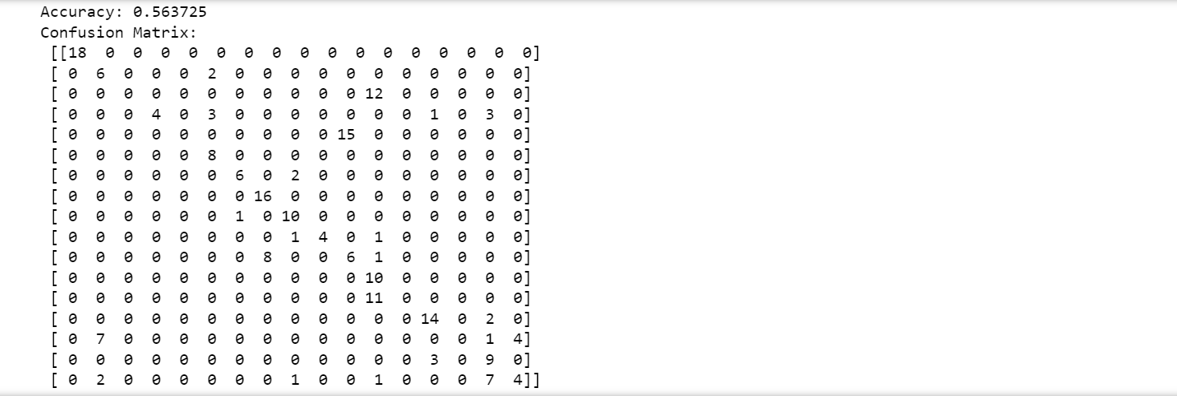

**Case 15:**

[START] Pre-training step:

>> Epoch 1 finished RBM Reconstruction error 43.886352

>> Epoch 2 finished RBM Reconstruction error 43.046046

>> Epoch 3 finished RBM Reconstruction error 42.805803

>> Epoch 4 finished RBM Reconstruction error 42.905842

>> Epoch 5 finished RBM Reconstruction error 43.020510

>> Epoch 6 finished RBM Reconstruction error 43.075038

>> Epoch 7 finished RBM Reconstruction error 43.240156

>> Epoch 8 finished RBM Reconstruction error 43.335682

>> Epoch 9 finished RBM Reconstruction error 43.542940

>> Epoch 10 finished RBM Reconstruction error 43.468387

>> Epoch 1 finished RBM Reconstruction error 11.087082

>> Epoch 2 finished RBM Reconstruction error 7.220903

>> Epoch 3 finished RBM Reconstruction error 5.597691

>> Epoch 4 finished RBM Reconstruction error 4.919397

>> Epoch 5 finished RBM Reconstruction error 4.708293

>> Epoch 6 finished RBM Reconstruction error 4.420802

>> Epoch 7 finished RBM Reconstruction error 4.239472

>> Epoch 8 finished RBM Reconstruction error 4.014754

>> Epoch 9 finished RBM Reconstruction error 3.897891

>> Epoch 10 finished RBM Reconstruction error 3.698362

>> Epoch 1 finished RBM Reconstruction error 3.981275

>> Epoch 2 finished RBM Reconstruction error 1.527598

>> Epoch 3 finished RBM Reconstruction error 0.938647

>> Epoch 4 finished RBM Reconstruction error 0.803073

>> Epoch 5 finished RBM Reconstruction error 0.766450

>> Epoch 6 finished RBM Reconstruction error 0.764909

>> Epoch 7 finished RBM Reconstruction error 0.676009

>> Epoch 8 finished RBM Reconstruction error 0.634078

>> Epoch 9 finished RBM Reconstruction error 0.605052

>> Epoch 10 finished RBM Reconstruction error 0.580835

>> Epoch 1 finished RBM Reconstruction error 3.501202

>> Epoch 2 finished RBM Reconstruction error 1.214631

>> Epoch 3 finished RBM Reconstruction error 0.583485

>> Epoch 4 finished RBM Reconstruction error 0.412185

>> Epoch 5 finished RBM Reconstruction error 0.345668

>> Epoch 6 finished RBM Reconstruction error 0.322766

>> Epoch 7 finished RBM Reconstruction error 0.293792

>> Epoch 8 finished RBM Reconstruction error 0.280508

>> Epoch 9 finished RBM Reconstruction error 0.277080

>> Epoch 10 finished RBM Reconstruction error 0.272022

>> Epoch 1 finished RBM Reconstruction error 2.793688

>> Epoch 2 finished RBM Reconstruction error 0.819042

>> Epoch 3 finished RBM Reconstruction error 0.394557

>> Epoch 4 finished RBM Reconstruction error 0.271191

>> Epoch 5 finished RBM Reconstruction error 0.231584

>> Epoch 6 finished RBM Reconstruction error 0.207396

>> Epoch 7 finished RBM Reconstruction error 0.212356

>> Epoch 8 finished RBM Reconstruction error 0.178923

>> Epoch 9 finished RBM Reconstruction error 0.188060

>> Epoch 10 finished RBM Reconstruction error 0.161279

>> Epoch 1 finished RBM Reconstruction error 2.781979

>> Epoch 2 finished RBM Reconstruction error 0.931701

>> Epoch 3 finished RBM Reconstruction error 0.361872

>> Epoch 4 finished RBM Reconstruction error 0.241981

>> Epoch 5 finished RBM Reconstruction error 0.219268

>> Epoch 6 finished RBM Reconstruction error 0.174720

>> Epoch 7 finished RBM Reconstruction error 0.179576

>> Epoch 8 finished RBM Reconstruction error 0.164090

>> Epoch 9 finished RBM Reconstruction error 0.149542

>> Epoch 10 finished RBM Reconstruction error 0.121886

[END] Pre-training step

[START] Fine tuning step:

>> Epoch 0 finished ANN training loss 2.251842

>> Epoch 1 finished ANN training loss 2.067681

>> Epoch 2 finished ANN training loss 2.108968

>> Epoch 3 finished ANN training loss 1.943238

>> Epoch 4 finished ANN training loss 1.871515

>> Epoch 5 finished ANN training loss 1.776626

>> Epoch 6 finished ANN training loss 1.771562

>> Epoch 7 finished ANN training loss 1.891889

>> Epoch 8 finished ANN training loss 1.765934

>> Epoch 9 finished ANN training loss 1.759462

>> Epoch 10 finished ANN training loss 1.697486

>> Epoch 11 finished ANN training loss 1.698179

>> Epoch 12 finished ANN training loss 1.636817

>> Epoch 13 finished ANN training loss 1.638686

>> Epoch 14 finished ANN training loss 1.680025

>> Epoch 15 finished ANN training loss 1.598380

>> Epoch 16 finished ANN training loss 1.583075

>> Epoch 17 finished ANN training loss 1.835029

>> Epoch 18 finished ANN training loss 1.595403

>> Epoch 19 finished ANN training loss 1.576131

>> Epoch 20 finished ANN training loss 1.572081

>> Epoch 21 finished ANN training loss 1.550265

>> Epoch 22 finished ANN training loss 1.630539

>> Epoch 23 finished ANN training loss 1.517986

>> Epoch 24 finished ANN training loss 1.480456

>> Epoch 25 finished ANN training loss 1.493541

>> Epoch 26 finished ANN training loss 1.467597

>> Epoch 27 finished ANN training loss 1.464341

>> Epoch 28 finished ANN training loss 1.458393

>> Epoch 29 finished ANN training loss 1.442560

>> Epoch 30 finished ANN training loss 1.494634

>> Epoch 31 finished ANN training loss 1.434536

>> Epoch 32 finished ANN training loss 1.433157

>> Epoch 33 finished ANN training loss 1.609621

>> Epoch 34 finished ANN training loss 1.469514

>> Epoch 35 finished ANN training loss 1.380108

>> Epoch 36 finished ANN training loss 1.633837

>> Epoch 37 finished ANN training loss 1.370612

>> Epoch 38 finished ANN training loss 1.365816

>> Epoch 39 finished ANN training loss 1.344026

>> Epoch 40 finished ANN training loss 1.375883

>> Epoch 41 finished ANN training loss 1.355031

>> Epoch 42 finished ANN training loss 1.492809

>> Epoch 43 finished ANN training loss 1.329049

>> Epoch 44 finished ANN training loss 1.351697

>> Epoch 45 finished ANN training loss 1.316906

>> Epoch 46 finished ANN training loss 1.345269

>> Epoch 47 finished ANN training loss 1.360189

>> Epoch 48 finished ANN training loss 1.317899

>> Epoch 49 finished ANN training loss 1.409497

>> Epoch 50 finished ANN training loss 1.341151

>> Epoch 51 finished ANN training loss 1.331371

>> Epoch 52 finished ANN training loss 1.301675

>> Epoch 53 finished ANN training loss 1.343287

>> Epoch 54 finished ANN training loss 1.298209

>> Epoch 55 finished ANN training loss 1.341437

>> Epoch 56 finished ANN training loss 1.310105

>> Epoch 57 finished ANN training loss 1.331626

>> Epoch 58 finished ANN training loss 1.313174

>> Epoch 59 finished ANN training loss 1.327456

>> Epoch 60 finished ANN training loss 1.289324

>> Epoch 61 finished ANN training loss 1.295377

>> Epoch 62 finished ANN training loss 1.290536

>> Epoch 63 finished ANN training loss 1.249636

>> Epoch 64 finished ANN training loss 1.244046

>> Epoch 65 finished ANN training loss 1.317548

>> Epoch 66 finished ANN training loss 1.246024

>> Epoch 67 finished ANN training loss 1.270822

>> Epoch 68 finished ANN training loss 1.260268

>> Epoch 69 finished ANN training loss 1.262222

>> Epoch 70 finished ANN training loss 1.244859

>> Epoch 71 finished ANN training loss 1.258458

>> Epoch 72 finished ANN training loss 1.256479

>> Epoch 73 finished ANN training loss 1.226517

>> Epoch 74 finished ANN training loss 1.266147

>> Epoch 75 finished ANN training loss 1.279248

>> Epoch 76 finished ANN training loss 1.301465

>> Epoch 77 finished ANN training loss 1.341313

>> Epoch 78 finished ANN training loss 1.226209

>> Epoch 79 finished ANN training loss 1.211712

>> Epoch 80 finished ANN training loss 1.219206

>> Epoch 81 finished ANN training loss 1.246858

>> Epoch 82 finished ANN training loss 1.205429

>> Epoch 83 finished ANN training loss 1.220340

>> Epoch 84 finished ANN training loss 1.229771

>> Epoch 85 finished ANN training loss 1.239241

>> Epoch 86 finished ANN training loss 1.228428

>> Epoch 87 finished ANN training loss 1.298715

>> Epoch 88 finished ANN training loss 1.234928

>> Epoch 89 finished ANN training loss 1.221309

>> Epoch 90 finished ANN training loss 1.199273

>> Epoch 91 finished ANN training loss 1.204976

>> Epoch 92 finished ANN training loss 1.188726

>> Epoch 93 finished ANN training loss 1.275268

>> Epoch 94 finished ANN training loss 1.214669

>> Epoch 95 finished ANN training loss 1.225007

>> Epoch 96 finished ANN training loss 1.195816

>> Epoch 97 finished ANN training loss 1.239328

>> Epoch 98 finished ANN training loss 1.193926

>> Epoch 99 finished ANN training loss 1.222696

[END] Fine tuning step

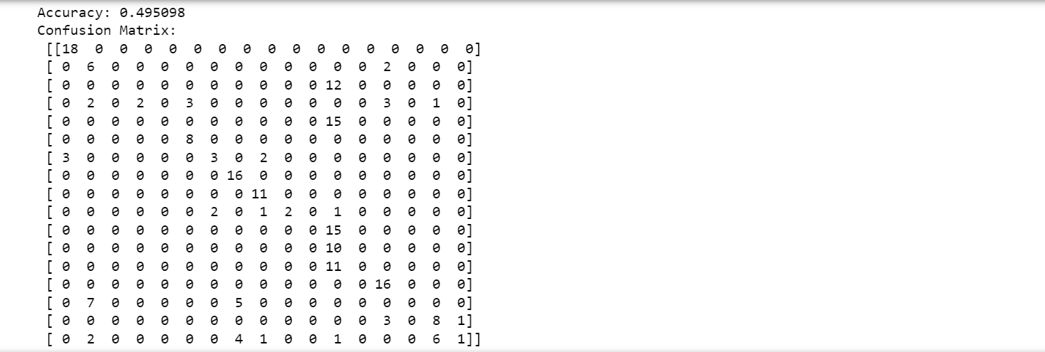

**Case 16:**

[START] Pre-training step:

>> Epoch 1 finished RBM Reconstruction error 41.881581

>> Epoch 2 finished RBM Reconstruction error 41.257958

>> Epoch 3 finished RBM Reconstruction error 41.323386

>> Epoch 4 finished RBM Reconstruction error 41.571337

>> Epoch 5 finished RBM Reconstruction error 41.877749

>> Epoch 6 finished RBM Reconstruction error 42.132660

>> Epoch 7 finished RBM Reconstruction error 42.289599

>> Epoch 8 finished RBM Reconstruction error 42.371411

>> Epoch 9 finished RBM Reconstruction error 42.527196

>> Epoch 10 finished RBM Reconstruction error 42.431652

>> Epoch 1 finished RBM Reconstruction error 14.721472

>> Epoch 2 finished RBM Reconstruction error 11.279943

>> Epoch 3 finished RBM Reconstruction error 10.174998

>> Epoch 4 finished RBM Reconstruction error 9.224299

>> Epoch 5 finished RBM Reconstruction error 8.430844

>> Epoch 6 finished RBM Reconstruction error 7.848715

>> Epoch 7 finished RBM Reconstruction error 7.580234

>> Epoch 8 finished RBM Reconstruction error 7.079891

>> Epoch 9 finished RBM Reconstruction error 6.873018

>> Epoch 10 finished RBM Reconstruction error 6.571279

>> Epoch 1 finished RBM Reconstruction error 6.626338

>> Epoch 2 finished RBM Reconstruction error 4.557794

>> Epoch 3 finished RBM Reconstruction error 3.496681

>> Epoch 4 finished RBM Reconstruction error 2.939007

>> Epoch 5 finished RBM Reconstruction error 2.444906

>> Epoch 6 finished RBM Reconstruction error 1.816902

>> Epoch 7 finished RBM Reconstruction error 1.533974

>> Epoch 8 finished RBM Reconstruction error 1.238105

>> Epoch 9 finished RBM Reconstruction error 1.138116

>> Epoch 10 finished RBM Reconstruction error 1.063996

>> Epoch 1 finished RBM Reconstruction error 4.074636

>> Epoch 2 finished RBM Reconstruction error 2.436015

>> Epoch 3 finished RBM Reconstruction error 2.064846

>> Epoch 4 finished RBM Reconstruction error 1.778906

>> Epoch 5 finished RBM Reconstruction error 1.386577

>> Epoch 6 finished RBM Reconstruction error 1.185548

>> Epoch 7 finished RBM Reconstruction error 0.935022

>> Epoch 8 finished RBM Reconstruction error 0.821247

>> Epoch 9 finished RBM Reconstruction error 0.633960

>> Epoch 10 finished RBM Reconstruction error 0.610639

>> Epoch 1 finished RBM Reconstruction error 4.347401

>> Epoch 2 finished RBM Reconstruction error 2.228135

>> Epoch 3 finished RBM Reconstruction error 1.711066

>> Epoch 4 finished RBM Reconstruction error 1.380954

>> Epoch 5 finished RBM Reconstruction error 1.191205

>> Epoch 6 finished RBM Reconstruction error 1.002162

>> Epoch 7 finished RBM Reconstruction error 0.756898

>> Epoch 8 finished RBM Reconstruction error 0.572574

>> Epoch 9 finished RBM Reconstruction error 0.480395

>> Epoch 10 finished RBM Reconstruction error 0.358597

>> Epoch 1 finished RBM Reconstruction error 3.600170

>> Epoch 2 finished RBM Reconstruction error 1.776046

>> Epoch 3 finished RBM Reconstruction error 1.509164

>> Epoch 4 finished RBM Reconstruction error 1.334722

>> Epoch 5 finished RBM Reconstruction error 1.169990

>> Epoch 6 finished RBM Reconstruction error 0.935144

>> Epoch 7 finished RBM Reconstruction error 0.775750

>> Epoch 8 finished RBM Reconstruction error 0.712667

>> Epoch 9 finished RBM Reconstruction error 0.503954

>> Epoch 10 finished RBM Reconstruction error 0.437597

[END] Pre-training step

[START] Fine tuning step:

>> Epoch 0 finished ANN training loss 2.441036

>> Epoch 1 finished ANN training loss 1.792657

>> Epoch 2 finished ANN training loss 1.928725

>> Epoch 3 finished ANN training loss 1.599205

>> Epoch 4 finished ANN training loss 1.821750

>> Epoch 5 finished ANN training loss 1.534096

>> Epoch 6 finished ANN training loss 1.407854

>> Epoch 7 finished ANN training loss 1.712880

>> Epoch 8 finished ANN training loss 1.307491

>> Epoch 9 finished ANN training loss 1.267714

>> Epoch 10 finished ANN training loss 1.383784

>> Epoch 11 finished ANN training loss 1.331258

>> Epoch 12 finished ANN training loss 1.227321

>> Epoch 13 finished ANN training loss 1.125127

>> Epoch 14 finished ANN training loss 1.212347

>> Epoch 15 finished ANN training loss 1.048481

>> Epoch 16 finished ANN training loss 1.222216

>> Epoch 17 finished ANN training loss 1.127892

>> Epoch 18 finished ANN training loss 1.123433

>> Epoch 19 finished ANN training loss 1.256029

>> Epoch 20 finished ANN training loss 0.910242

>> Epoch 21 finished ANN training loss 0.917687

>> Epoch 22 finished ANN training loss 0.915742

>> Epoch 23 finished ANN training loss 0.994854

>> Epoch 24 finished ANN training loss 1.141139

>> Epoch 25 finished ANN training loss 1.167651

>> Epoch 26 finished ANN training loss 0.777356

>> Epoch 27 finished ANN training loss 0.789659

>> Epoch 28 finished ANN training loss 1.395347

>> Epoch 29 finished ANN training loss 0.911472

>> Epoch 30 finished ANN training loss 0.820440

>> Epoch 31 finished ANN training loss 0.774344

>> Epoch 32 finished ANN training loss 1.065869

>> Epoch 33 finished ANN training loss 0.790273

>> Epoch 34 finished ANN training loss 0.645244

>> Epoch 35 finished ANN training loss 0.853284

>> Epoch 36 finished ANN training loss 0.643309

>> Epoch 37 finished ANN training loss 0.657322

>> Epoch 38 finished ANN training loss 0.608522

>> Epoch 39 finished ANN training loss 0.771529

>> Epoch 40 finished ANN training loss 0.633999

>> Epoch 41 finished ANN training loss 0.637887

>> Epoch 42 finished ANN training loss 0.621865

>> Epoch 43 finished ANN training loss 0.574590

>> Epoch 44 finished ANN training loss 0.576875

>> Epoch 45 finished ANN training loss 0.799400

>> Epoch 46 finished ANN training loss 0.647421

>> Epoch 47 finished ANN training loss 0.547465

>> Epoch 48 finished ANN training loss 0.509092

>> Epoch 49 finished ANN training loss 0.594612

>> Epoch 50 finished ANN training loss 0.574606

>> Epoch 51 finished ANN training loss 0.569939

>> Epoch 52 finished ANN training loss 0.476568

>> Epoch 53 finished ANN training loss 0.539329

>> Epoch 54 finished ANN training loss 0.499898

>> Epoch 55 finished ANN training loss 0.544789

>> Epoch 56 finished ANN training loss 0.647368

>> Epoch 57 finished ANN training loss 0.969598

>> Epoch 58 finished ANN training loss 0.475547

>> Epoch 59 finished ANN training loss 0.454910

>> Epoch 60 finished ANN training loss 0.437104

>> Epoch 61 finished ANN training loss 0.424194

>> Epoch 62 finished ANN training loss 0.490134

>> Epoch 63 finished ANN training loss 0.397937

>> Epoch 64 finished ANN training loss 0.394233

>> Epoch 65 finished ANN training loss 0.392327

>> Epoch 66 finished ANN training loss 0.393688

>> Epoch 67 finished ANN training loss 0.492650

>> Epoch 68 finished ANN training loss 0.519179

>> Epoch 69 finished ANN training loss 0.419632

>> Epoch 70 finished ANN training loss 0.352470

>> Epoch 71 finished ANN training loss 0.350642

>> Epoch 72 finished ANN training loss 0.356442

>> Epoch 73 finished ANN training loss 0.337871

>> Epoch 74 finished ANN training loss 0.550652

>> Epoch 75 finished ANN training loss 0.502454

>> Epoch 76 finished ANN training loss 0.367960

>> Epoch 77 finished ANN training loss 0.311995

>> Epoch 78 finished ANN training loss 0.391720

>> Epoch 79 finished ANN training loss 0.340036

>> Epoch 80 finished ANN training loss 0.363924

>> Epoch 81 finished ANN training loss 0.345140

>> Epoch 82 finished ANN training loss 0.525064

>> Epoch 83 finished ANN training loss 0.409130

>> Epoch 84 finished ANN training loss 0.274633

>> Epoch 85 finished ANN training loss 0.299966

>> Epoch 86 finished ANN training loss 0.304363

>> Epoch 87 finished ANN training loss 0.264791

>> Epoch 88 finished ANN training loss 0.644932

>> Epoch 89 finished ANN training loss 0.233666

>> Epoch 90 finished ANN training loss 0.232599

>> Epoch 91 finished ANN training loss 0.279451

>> Epoch 92 finished ANN training loss 0.240310

>> Epoch 93 finished ANN training loss 0.241849

>> Epoch 94 finished ANN training loss 0.280076

>> Epoch 95 finished ANN training loss 0.206140

>> Epoch 96 finished ANN training loss 0.284892

>> Epoch 97 finished ANN training loss 0.316268

>> Epoch 98 finished ANN training loss 0.262847

>> Epoch 99 finished ANN training loss 0.204403

[END] Fine tuning step

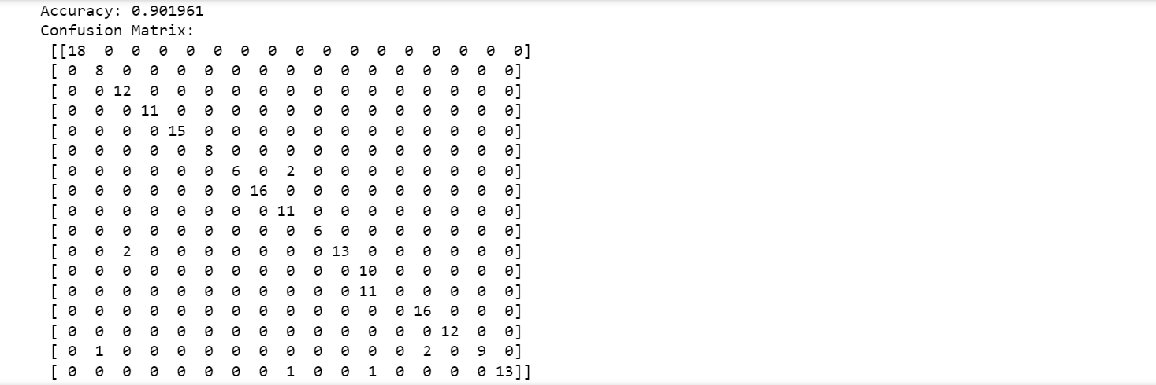

**Case 17:**

[START] Pre-training step:

>> Epoch 1 finished RBM Reconstruction error 41.792575

>> Epoch 2 finished RBM Reconstruction error 40.771735

>> Epoch 3 finished RBM Reconstruction error 40.879275

>> Epoch 4 finished RBM Reconstruction error 41.065100

>> Epoch 5 finished RBM Reconstruction error 41.151779

>> Epoch 6 finished RBM Reconstruction error 41.341957

>> Epoch 7 finished RBM Reconstruction error 41.493800

>> Epoch 8 finished RBM Reconstruction error 41.654394

>> Epoch 9 finished RBM Reconstruction error 41.835950

>> Epoch 10 finished RBM Reconstruction error 41.851513

>> Epoch 1 finished RBM Reconstruction error 14.581966

>> Epoch 2 finished RBM Reconstruction error 11.285711

>> Epoch 3 finished RBM Reconstruction error 10.320870

>> Epoch 4 finished RBM Reconstruction error 9.670917

>> Epoch 5 finished RBM Reconstruction error 9.090603

>> Epoch 6 finished RBM Reconstruction error 8.423300

>> Epoch 7 finished RBM Reconstruction error 8.043951

>> Epoch 8 finished RBM Reconstruction error 7.458773

>> Epoch 9 finished RBM Reconstruction error 7.287279

>> Epoch 10 finished RBM Reconstruction error 6.902758

>> Epoch 1 finished RBM Reconstruction error 6.242695

>> Epoch 2 finished RBM Reconstruction error 4.327269

>> Epoch 3 finished RBM Reconstruction error 3.471997

>> Epoch 4 finished RBM Reconstruction error 2.576168

>> Epoch 5 finished RBM Reconstruction error 2.113276

>> Epoch 6 finished RBM Reconstruction error 1.711740

>> Epoch 7 finished RBM Reconstruction error 1.451078

>> Epoch 8 finished RBM Reconstruction error 1.233816

>> Epoch 9 finished RBM Reconstruction error 1.042880

>> Epoch 10 finished RBM Reconstruction error 0.993318

>> Epoch 1 finished RBM Reconstruction error 4.023333

>> Epoch 2 finished RBM Reconstruction error 2.284643

>> Epoch 3 finished RBM Reconstruction error 1.906831

>> Epoch 4 finished RBM Reconstruction error 1.619697

>> Epoch 5 finished RBM Reconstruction error 1.306064

>> Epoch 6 finished RBM Reconstruction error 1.113005

>> Epoch 7 finished RBM Reconstruction error 1.012125

>> Epoch 8 finished RBM Reconstruction error 0.831073

>> Epoch 9 finished RBM Reconstruction error 0.770455

>> Epoch 10 finished RBM Reconstruction error 0.684564

>> Epoch 1 finished RBM Reconstruction error 4.326503

>> Epoch 2 finished RBM Reconstruction error 2.405709

>> Epoch 3 finished RBM Reconstruction error 1.889086

>> Epoch 4 finished RBM Reconstruction error 1.370159

>> Epoch 5 finished RBM Reconstruction error 1.126078

>> Epoch 6 finished RBM Reconstruction error 0.913198

>> Epoch 7 finished RBM Reconstruction error 0.778626

>> Epoch 8 finished RBM Reconstruction error 0.592356

>> Epoch 9 finished RBM Reconstruction error 0.489031

>> Epoch 10 finished RBM Reconstruction error 0.438090

>> Epoch 1 finished RBM Reconstruction error 3.242160

>> Epoch 2 finished RBM Reconstruction error 1.408722

>> Epoch 3 finished RBM Reconstruction error 1.224882

>> Epoch 4 finished RBM Reconstruction error 0.925179

>> Epoch 5 finished RBM Reconstruction error 0.891026

>> Epoch 6 finished RBM Reconstruction error 0.704861

>> Epoch 7 finished RBM Reconstruction error 0.677794

>> Epoch 8 finished RBM Reconstruction error 0.593075

>> Epoch 9 finished RBM Reconstruction error 0.470849

>> Epoch 10 finished RBM Reconstruction error 0.411954

[END] Pre-training step

[START] Fine tuning step:

>> Epoch 0 finished ANN training loss 2.356841

>> Epoch 1 finished ANN training loss 1.889281

>> Epoch 2 finished ANN training loss 1.999467

>> Epoch 3 finished ANN training loss 1.702392

>> Epoch 4 finished ANN training loss 1.827894

>> Epoch 5 finished ANN training loss 1.534763

>> Epoch 6 finished ANN training loss 1.445119

>> Epoch 7 finished ANN training loss 1.779731

>> Epoch 8 finished ANN training loss 1.435609

>> Epoch 9 finished ANN training loss 1.403093

>> Epoch 10 finished ANN training loss 1.479311

>> Epoch 11 finished ANN training loss 1.348117

>> Epoch 12 finished ANN training loss 1.240289

>> Epoch 13 finished ANN training loss 1.413820

>> Epoch 14 finished ANN training loss 1.278798

>> Epoch 15 finished ANN training loss 1.160457

>> Epoch 16 finished ANN training loss 1.304313

>> Epoch 17 finished ANN training loss 1.144585

>> Epoch 18 finished ANN training loss 1.564302

>> Epoch 19 finished ANN training loss 1.122434

>> Epoch 20 finished ANN training loss 1.042869

>> Epoch 21 finished ANN training loss 1.183307

>> Epoch 22 finished ANN training loss 1.011542

>> Epoch 23 finished ANN training loss 1.055059

>> Epoch 24 finished ANN training loss 0.980324

>> Epoch 25 finished ANN training loss 0.842002

>> Epoch 26 finished ANN training loss 0.889686

>> Epoch 27 finished ANN training loss 0.988484

>> Epoch 28 finished ANN training loss 0.934812

>> Epoch 29 finished ANN training loss 0.891558

>> Epoch 30 finished ANN training loss 0.910291

>> Epoch 31 finished ANN training loss 0.785123

>> Epoch 32 finished ANN training loss 0.937582

>> Epoch 33 finished ANN training loss 0.728772

>> Epoch 34 finished ANN training loss 0.936973

>> Epoch 35 finished ANN training loss 0.762139

>> Epoch 36 finished ANN training loss 1.126121

>> Epoch 37 finished ANN training loss 0.665719

>> Epoch 38 finished ANN training loss 0.764321

>> Epoch 39 finished ANN training loss 0.691168

>> Epoch 40 finished ANN training loss 0.750967

>> Epoch 41 finished ANN training loss 0.808434

>> Epoch 42 finished ANN training loss 0.637628

>> Epoch 43 finished ANN training loss 0.754839

>> Epoch 44 finished ANN training loss 0.626977

>> Epoch 45 finished ANN training loss 0.561007

>> Epoch 46 finished ANN training loss 0.571904

>> Epoch 47 finished ANN training loss 0.574662

>> Epoch 48 finished ANN training loss 0.675314

>> Epoch 49 finished ANN training loss 0.540991

>> Epoch 50 finished ANN training loss 0.591618

>> Epoch 51 finished ANN training loss 0.667402

>> Epoch 52 finished ANN training loss 0.539540

>> Epoch 53 finished ANN training loss 0.634333

>> Epoch 54 finished ANN training loss 0.537280

>> Epoch 55 finished ANN training loss 0.536804

>> Epoch 56 finished ANN training loss 0.838150

>> Epoch 57 finished ANN training loss 0.619662

>> Epoch 58 finished ANN training loss 0.477288

>> Epoch 59 finished ANN training loss 0.541670

>> Epoch 60 finished ANN training loss 0.413264

>> Epoch 61 finished ANN training loss 0.478297

>> Epoch 62 finished ANN training loss 0.581394

>> Epoch 63 finished ANN training loss 0.444393

>> Epoch 64 finished ANN training loss 0.449002

>> Epoch 65 finished ANN training loss 0.554134

>> Epoch 66 finished ANN training loss 0.442626

>> Epoch 67 finished ANN training loss 0.521845

>> Epoch 68 finished ANN training loss 0.569024

>> Epoch 69 finished ANN training loss 0.399609

>> Epoch 70 finished ANN training loss 0.587007

>> Epoch 71 finished ANN training loss 0.453110

>> Epoch 72 finished ANN training loss 0.401042

>> Epoch 73 finished ANN training loss 0.480804

>> Epoch 74 finished ANN training loss 0.414249

>> Epoch 75 finished ANN training loss 0.371734

>> Epoch 76 finished ANN training loss 0.498519

>> Epoch 77 finished ANN training loss 0.400970

>> Epoch 78 finished ANN training loss 0.369111

>> Epoch 79 finished ANN training loss 0.349084

>> Epoch 80 finished ANN training loss 0.396247

>> Epoch 81 finished ANN training loss 0.417670

>> Epoch 82 finished ANN training loss 0.709744

>> Epoch 83 finished ANN training loss 0.351304

>> Epoch 84 finished ANN training loss 0.470447

>> Epoch 85 finished ANN training loss 0.330241

>> Epoch 86 finished ANN training loss 0.369712

>> Epoch 87 finished ANN training loss 0.404151

>> Epoch 88 finished ANN training loss 0.366452

>> Epoch 89 finished ANN training loss 0.327789

>> Epoch 90 finished ANN training loss 0.299704

>> Epoch 91 finished ANN training loss 0.388818

>> Epoch 92 finished ANN training loss 0.315336

>> Epoch 93 finished ANN training loss 0.521408

>> Epoch 94 finished ANN training loss 0.468917

>> Epoch 95 finished ANN training loss 0.313262

>> Epoch 96 finished ANN training loss 0.447776

>> Epoch 97 finished ANN training loss 0.357050

>> Epoch 98 finished ANN training loss 0.296343

>> Epoch 99 finished ANN training loss 0.333221

[END] Fine tuning step

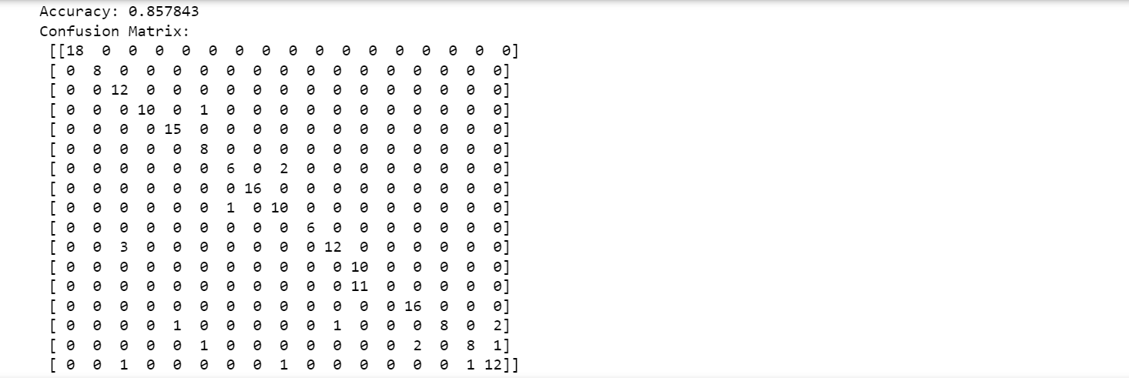

**Case 18:**

[START] Pre-training step:

>> Epoch 1 finished RBM Reconstruction error 41.372756

>> Epoch 2 finished RBM Reconstruction error 40.476467

>> Epoch 3 finished RBM Reconstruction error 40.702153

>> Epoch 4 finished RBM Reconstruction error 41.071466

>> Epoch 5 finished RBM Reconstruction error 41.296782

>> Epoch 6 finished RBM Reconstruction error 41.597052

>> Epoch 7 finished RBM Reconstruction error 41.837017

>> Epoch 8 finished RBM Reconstruction error 42.108080

>> Epoch 9 finished RBM Reconstruction error 42.290347

>> Epoch 10 finished RBM Reconstruction error 42.388742

>> Epoch 1 finished RBM Reconstruction error 14.298517

>> Epoch 2 finished RBM Reconstruction error 11.045434

>> Epoch 3 finished RBM Reconstruction error 9.978397

>> Epoch 4 finished RBM Reconstruction error 9.239408

>> Epoch 5 finished RBM Reconstruction error 8.596379

>> Epoch 6 finished RBM Reconstruction error 7.899508

>> Epoch 7 finished RBM Reconstruction error 7.500735

>> Epoch 8 finished RBM Reconstruction error 6.909717

>> Epoch 9 finished RBM Reconstruction error 6.811239

>> Epoch 10 finished RBM Reconstruction error 6.425774

>> Epoch 1 finished RBM Reconstruction error 6.294147

>> Epoch 2 finished RBM Reconstruction error 3.999786

>> Epoch 3 finished RBM Reconstruction error 3.082825

>> Epoch 4 finished RBM Reconstruction error 2.855599

>> Epoch 5 finished RBM Reconstruction error 2.173448

>> Epoch 6 finished RBM Reconstruction error 1.733197

>> Epoch 7 finished RBM Reconstruction error 1.338001

>> Epoch 8 finished RBM Reconstruction error 1.153471

>> Epoch 9 finished RBM Reconstruction error 0.995697

>> Epoch 10 finished RBM Reconstruction error 0.872445

>> Epoch 1 finished RBM Reconstruction error 4.564561

>> Epoch 2 finished RBM Reconstruction error 2.602133

>> Epoch 3 finished RBM Reconstruction error 2.189684

>> Epoch 4 finished RBM Reconstruction error 1.826993

>> Epoch 5 finished RBM Reconstruction error 1.576019

>> Epoch 6 finished RBM Reconstruction error 1.354075

>> Epoch 7 finished RBM Reconstruction error 1.128998

>> Epoch 8 finished RBM Reconstruction error 0.916909

>> Epoch 9 finished RBM Reconstruction error 0.799442

>> Epoch 10 finished RBM Reconstruction error 0.650493

>> Epoch 1 finished RBM Reconstruction error 3.881838

>> Epoch 2 finished RBM Reconstruction error 2.328367

>> Epoch 3 finished RBM Reconstruction error 1.997225

>> Epoch 4 finished RBM Reconstruction error 1.697622

>> Epoch 5 finished RBM Reconstruction error 1.325599

>> Epoch 6 finished RBM Reconstruction error 1.037129

>> Epoch 7 finished RBM Reconstruction error 0.861931

>> Epoch 8 finished RBM Reconstruction error 0.751085

>> Epoch 9 finished RBM Reconstruction error 0.636184

>> Epoch 10 finished RBM Reconstruction error 0.554327

>> Epoch 1 finished RBM Reconstruction error 3.110528

>> Epoch 2 finished RBM Reconstruction error 1.473014

>> Epoch 3 finished RBM Reconstruction error 1.174214

>> Epoch 4 finished RBM Reconstruction error 0.989583

>> Epoch 5 finished RBM Reconstruction error 0.941347

>> Epoch 6 finished RBM Reconstruction error 0.749563

>> Epoch 7 finished RBM Reconstruction error 0.567083

>> Epoch 8 finished RBM Reconstruction error 0.489073

>> Epoch 9 finished RBM Reconstruction error 0.457342

>> Epoch 10 finished RBM Reconstruction error 0.397526

[END] Pre-training step

[START] Fine tuning step:

>> Epoch 0 finished ANN training loss 2.533912

>> Epoch 1 finished ANN training loss 1.912662

>> Epoch 2 finished ANN training loss 2.138717

>> Epoch 3 finished ANN training loss 1.712893

>> Epoch 4 finished ANN training loss 1.925005

>> Epoch 5 finished ANN training loss 1.608649

>> Epoch 6 finished ANN training loss 1.566926

>> Epoch 7 finished ANN training loss 1.772526

>> Epoch 8 finished ANN training loss 1.534930

>> Epoch 9 finished ANN training loss 1.583749

>> Epoch 10 finished ANN training loss 1.472319

>> Epoch 11 finished ANN training loss 1.528329

>> Epoch 12 finished ANN training loss 1.366386

>> Epoch 13 finished ANN training loss 1.360620

>> Epoch 14 finished ANN training loss 1.489842

>> Epoch 15 finished ANN training loss 1.419135

>> Epoch 16 finished ANN training loss 1.276041

>> Epoch 17 finished ANN training loss 1.331768

>> Epoch 18 finished ANN training loss 1.273733

>> Epoch 19 finished ANN training loss 1.292297

>> Epoch 20 finished ANN training loss 1.261607

>> Epoch 21 finished ANN training loss 1.203192

>> Epoch 22 finished ANN training loss 1.264314

>> Epoch 23 finished ANN training loss 1.126404

>> Epoch 24 finished ANN training loss 1.070546

>> Epoch 25 finished ANN training loss 1.009856

>> Epoch 26 finished ANN training loss 1.154775

>> Epoch 27 finished ANN training loss 1.033245

>> Epoch 28 finished ANN training loss 1.028367

>> Epoch 29 finished ANN training loss 1.117733

>> Epoch 30 finished ANN training loss 1.101441

>> Epoch 31 finished ANN training loss 0.978223

>> Epoch 32 finished ANN training loss 1.043937

>> Epoch 33 finished ANN training loss 0.928538

>> Epoch 34 finished ANN training loss 0.919770

>> Epoch 35 finished ANN training loss 0.917674

>> Epoch 36 finished ANN training loss 0.898565

>> Epoch 37 finished ANN training loss 0.925438

>> Epoch 38 finished ANN training loss 0.904800

>> Epoch 39 finished ANN training loss 0.904152

>> Epoch 40 finished ANN training loss 0.818319

>> Epoch 41 finished ANN training loss 0.825659

>> Epoch 42 finished ANN training loss 0.835696

>> Epoch 43 finished ANN training loss 0.792625

>> Epoch 44 finished ANN training loss 0.844598

>> Epoch 45 finished ANN training loss 0.833484

>> Epoch 46 finished ANN training loss 0.889358

>> Epoch 47 finished ANN training loss 0.768787

>> Epoch 48 finished ANN training loss 0.791587

>> Epoch 49 finished ANN training loss 0.765142

>> Epoch 50 finished ANN training loss 0.845533

>> Epoch 51 finished ANN training loss 0.788608

>> Epoch 52 finished ANN training loss 0.728863

>> Epoch 53 finished ANN training loss 0.947965

>> Epoch 54 finished ANN training loss 0.817560

>> Epoch 55 finished ANN training loss 0.887742

>> Epoch 56 finished ANN training loss 0.787665

>> Epoch 57 finished ANN training loss 0.929358

>> Epoch 58 finished ANN training loss 0.829298

>> Epoch 59 finished ANN training loss 0.786177

>> Epoch 60 finished ANN training loss 0.722860

>> Epoch 61 finished ANN training loss 0.798352

>> Epoch 62 finished ANN training loss 0.775610

>> Epoch 63 finished ANN training loss 0.687135

>> Epoch 64 finished ANN training loss 0.740055

>> Epoch 65 finished ANN training loss 0.640857

>> Epoch 66 finished ANN training loss 0.623001

>> Epoch 67 finished ANN training loss 0.669290

>> Epoch 68 finished ANN training loss 0.640343

>> Epoch 69 finished ANN training loss 0.657516

>> Epoch 70 finished ANN training loss 0.752479

>> Epoch 71 finished ANN training loss 0.640654

>> Epoch 72 finished ANN training loss 0.590965

>> Epoch 73 finished ANN training loss 0.652863

>> Epoch 74 finished ANN training loss 0.683715

>> Epoch 75 finished ANN training loss 0.626392

>> Epoch 76 finished ANN training loss 0.625947

>> Epoch 77 finished ANN training loss 0.628208

>> Epoch 78 finished ANN training loss 0.580186

>> Epoch 79 finished ANN training loss 0.620502

>> Epoch 80 finished ANN training loss 0.785973

>> Epoch 81 finished ANN training loss 0.571416

>> Epoch 82 finished ANN training loss 0.705353

>> Epoch 83 finished ANN training loss 0.579118

>> Epoch 84 finished ANN training loss 0.630101

>> Epoch 85 finished ANN training loss 0.548272

>> Epoch 86 finished ANN training loss 0.559437

>> Epoch 87 finished ANN training loss 0.541931

>> Epoch 88 finished ANN training loss 0.663547

>> Epoch 89 finished ANN training loss 0.570517

>> Epoch 90 finished ANN training loss 0.529368

>> Epoch 91 finished ANN training loss 0.550965

>> Epoch 92 finished ANN training loss 0.508707

>> Epoch 93 finished ANN training loss 0.563552

>> Epoch 94 finished ANN training loss 0.550841

>> Epoch 95 finished ANN training loss 0.530294

>> Epoch 96 finished ANN training loss 0.535948

>> Epoch 97 finished ANN training loss 0.535212

>> Epoch 98 finished ANN training loss 0.518781

>> Epoch 99 finished ANN training loss 0.551749

[END] Fine tuning step

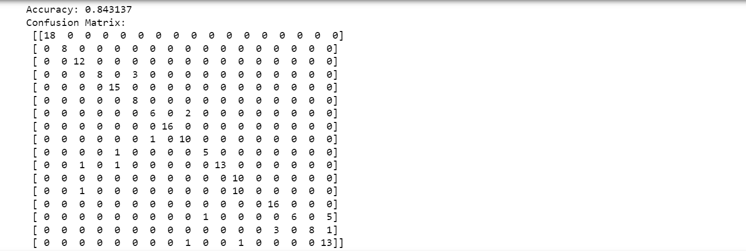

**INFERENCES FOR DEEP BELIEF NETWORK**

The following inferences can be made from the above obtained results:

* Number of layers in the network is inversely proportional to the accuracy.
* Dropout in the network is inversely proportional to the accuracy. In most DBN models, accuracy increases when dropout value is decreased.
* Number of RBMs in the layers in the network is directly proportional to the accuracy.

**DISCUSSION:**

The CNN is found to be more accurate when it comes to classifying audio files according to their instruments used than LSTM and DBN.

**REFERENCES**

[1] Y. Han, J. Kim and K. Lee. Deep Convolutional Neural Networks for Predominant Instrument Recognition in Polyphonic Music. IEEE/ACM Transactions on Audio, Speech, and Language Processing, vol. 25, no. 1, pp. 208-221, Jan. 2017

[2] Sally M. Elghamrawy, Shehab Edin Ibrahim. Audio Signal Processing and Musical Instrument Detection using Deep Learning Techniques. JAC-ECC 2021

[3] Xu, K. (2021). Recognition and classification model of music genres and Chinese traditional musical instruments based on deep neural networks. Scientific Programming, 2021.